PBS Explores the Wonder and Science Behind the Power of Flight in SUPERNATURE – WILD FLYERS

Three-Part PBS & BBC Co-Production Premieres June 29 at 8:00 p.m. ET

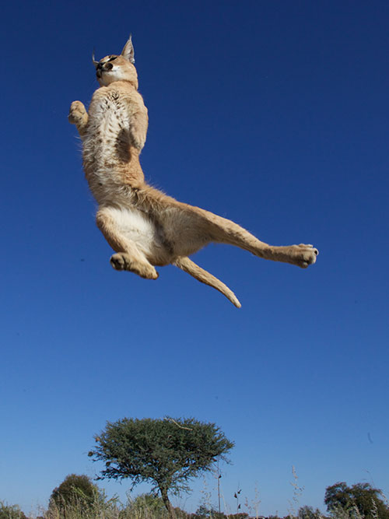
ARLINGTON, VA; June 1, 2016 – The sky is one of the world’s most challenging places to thrive, but across the planet an extraordinary and unexpected range of animals does something we can only dream of – takes to the air. This phenomenon is captured in greater detail than ever before in SUPERNATURE – WILD FLYERS (watch a clip), which premieres Wednesday, June 29, 2016, at 8:00 p.m. ET on PBS and airs Wednesdays through July 13 (check local listings).

Through the use of cutting-edge camera technologies and filming techniques, the series details incredible physical adaptations and makes new discoveries that reveal how these animals have mastered the sky, as well as how taking flight is used as a survival mechanism.
Caracal demonstrates her incredible vertical leap. Courtesyof BBC/Simon Bell.

“SUPERNATURE – WILD FLYERS is an innovative new series that brings the lives of flying animals to life in incredible detail and provides a spectacular new perspective,” said Bill Gardner, Vice President, Programming and Development for PBS. “Utilizing new filming, editing and composite CGI techniques, the series is an engaging, fun and insightful example of how nature programming is an innovative and evolving genre.”

Below are descriptions for each of SUPERNATURE – WILD FLYERS’ three episodes. For images and screeners, please visit PBS PressRoom.

“Defying Gravity”
Premieres June 29, 2016 at 8:00 p.m. ET
Explore the basic principles of flight to see how animals become airborne in the first place. From leapers to gliders and those that effortlessly fly, each creature has special techniques. But all must overcome a powerful force — gravity. Animals featured in this episode include caracals, wood duck chicks, vultures, flying squirrels, paradise tree snakes, flying fish and many more.

“Masters of the Sky”
Premieres July 6, 2016 at 8:00 p.m. ET
Many animals take to the skies for a split second, but to stay there, the planet’s strongest flyers push the laws of physics to the limit. Explore the extremes of true flight: power, acceleration, top speed, maneuverability and endurance. Animals that appear in this episode include the peregrine falcon, Japanese rhinoceros beetle, sparrowhawk and the booted racket-tailed hummingbird, among others.

“Crowded Skies”
Premieres July 13, 2016 at 8:00 p.m. ET
The sky is a crowded world where mammals, birds and insects hunt, escape, mate, defend territory, sleep and even die on the wing. Survival up there depends not just on beating gravity or mastering flight, but also out-flying the competition. Animals featured in the final episode include the gannet bird, African skimmer, kingbird, glasswing butterfly and many more.

SUPERNATURE – WILD FLYERS is presented as part of a multi-title co-production deal among PBS, BBC and BBC Worldwide North America. The partnership provides a pipeline of the high-quality, entertaining factual programs that PBS and BBC audiences have come to expect.

About PBS Science
SUPERNATURE – WILD FLYERS airs as part of PBS’ summer programming lineup of science, nature and technology programming that includes ongoing acclaimed series NATURE and NOVA, offering new perspectives on life in the universe to keep viewers both curious and wanting more. Also airing as part of PBS’ summer science lineup are 9 MONTHS THAT MADE YOU on June 29 at 10:00 p.m. ET and KOKO − THE GORILLA WHO TALKS on August 3 at 8:00 p.m. ET. For more information on each program, please visit PBS PressRoom.

About PBS
PBS, with 350 member stations, offers all Americans the opportunity to explore new ideas and new worlds through television and online content. Each month, PBS reaches more than 100 million people through television and over 33 million people online, inviting them to experience the worlds of science, history, nature and public affairs; to hear diverse viewpoints; and to take front row seats to world-class drama and performances. PBS’ broad array of programs has been consistently honored by the industry’s most coveted award competitions. Teachers of children from pre-K through 12th grade turn to PBS for digital content and services that help bring classroom lessons to life. PBS’ premier children’s TV programming and its website, pbskids.org, are parents’ and teachers’ most trusted partners in inspiring and nurturing curiosity and love of learning in children. More information about PBS is available at www.pbs.org, one of the leading dot-org websites on the Internet, or by following PBS on Twitter, Facebook or through our apps for mobile devices. Specific program information and updates for press are available at pbs.org/pressroom or by following PBS Pressroom on Twitter.

About BBC
The BBC has an unrivalled global reputation for the factual content it produces across arts, history, documentaries and natural history, and broadcasts some 7,000 hours of high-quality, distinctive factual programs a year on television. The BBC is recognized as an industry leader in terms of innovation, consistently pushing the boundaries of its productions, delivered to our audience by the most engaging and inspirational experts.

– PBS –

For additional information, photos, interviews and more, contact:

David Nadler/Meghan Newton Colleen Flanagan/Atiya Frederick
Goodman Media for PBS PBS
212-576-2700 703-739-8130; 703-739-5147
PBSProgramming@goodmanmedia.com crflanagan@pbs.org; anfrederick@pbs.org

For images and additional up-to-date information on this and other PBS programs, visit PBS PressRoom at pbs.org/pressroom.

