PBS Recognizes the Many Contributions of African Americans This Black History Month and All Year Long

Featured Programming Includes New Documentaries from Professor Henry Louis Gates, Jr. and INDEPENDENT LENS as well as Offerings from PBS Digital Studios

New PBS Chief Programming Executive and General Manager Sylvia Bugg Reinforces Her Commitment to Programming that Amplifies Representation and Sparks Meaningful Conversations

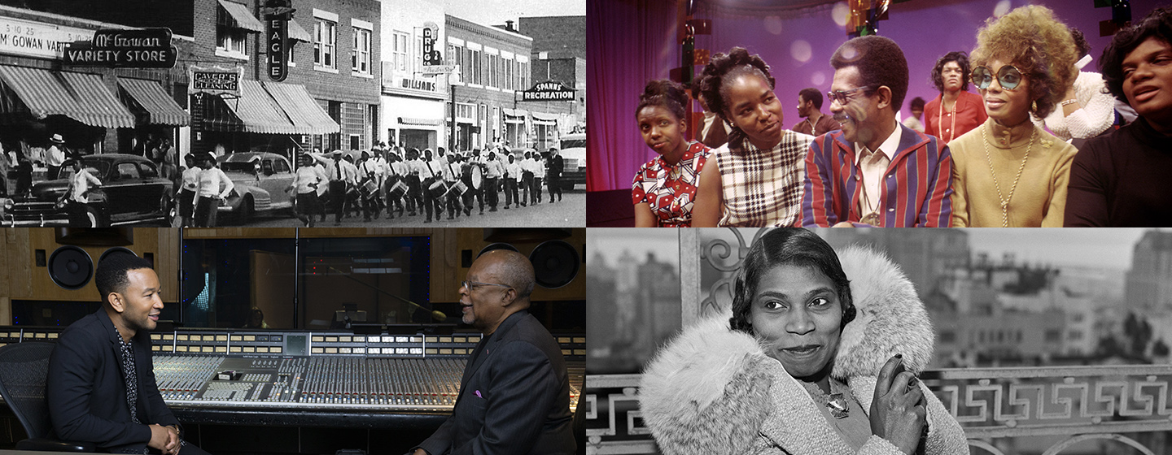

The programs featured are, clockwise from top left: AMERICAN EXPERIENCE “Goin' Back to T-Town” (Courtesy of Greenwood Cultural Center); INDEPENDENT LENS “Mr. Soul!” (Courtesy of Alex Harsley); AMERICAN EXPERIENCE "Voice of Freedom" (Courtesy of From Original Negative / Alamy Stock Photo); and THE BLACK CHURCH: THIS IS OUR STORY, THIS IS OUR SONG (Courtesy of McGee Media)

ARLINGTON, VA— PBS announced today new programming to commemorate and celebrate African American achievement. Through powerful documentaries and thought-provoking specials designed to inspire and represent the full range of the American experience, PBS remains committed to showcasing Black excellence, struggles and triumphs this February and all year long.

“PBS will continue to honor the impact and legacy that Black culture has had on our country by offering content that provides historical context to the Black experience, celebrates the achievements of African Americans, and sparks meaningful conversations about race and equality,” said Sylvia Bugg, PBS Chief Programming Executive and General Manager, General Audience Programming. “At PBS, we believe that every part of the story matters, and we are committed to airing content from diverse filmmakers that serves the American public and honors the diversity of our country throughout the year on all of our platforms.”

On Tuesday, February 16 and 17, 9:00-11:00 p.m. ET, PBS will premiere an intimate series, THE BLACK CHURCH: THIS IS OUR STORY, THIS IS OUR SONG, from executive producer, host and writer Professor Henry Louis Gates, Jr. Featuring interviews from Oprah Winfrey, John Legend, Jennifer Hudson and Bishop Michael Curry, this moving two-part series examines the role of the Church as the site of African American organizing, resilience, autonomy, freedom and solidarity, and uses song to highlight the beliefs and actions that drew African Americans from the violent margins of society to the front lines of change.

And on Monday, February 22, 10:00-11:00 p.m. ET, audiences will travel back in time to 1968 with “Mr. SOUL!,” a vibrant documentary from INDEPENDENT LENS that chronicles the public television variety show “SOUL!” The film takes a close look at developer and host Ellis Haizlip and the show that celebrated all facets of Black culture and earned critical praise and public support as one of the first platforms to expand the image of African Americans on television.

In addition, PBS will offer new programming examining the fundamental questions of race, segregation and the American spirit. On Monday, February 15, 9:00-11:00 p.m. ET, explore the fascinating life of Marian Anderson, the celebrated singer who triumphed at the Lincoln Memorial after being barred from performing at Constitution Hall because she was Black, in AMERICAN EXPERIENCE “Voice of Freedom.” In FINDING YOUR ROOTS “Write My Name in the Book of Life,” airing Tuesday, February 16, 2021, 8:00-9:00 p.m. ET, Professor Henry Louis Gates, Jr. helps musician Pharrell Williams and filmmaker Kasi Lemons uncover extraordinarily rare first-person accounts of their enslaved ancestors.

SAY IT LOUD, from PBS Digital Studios, will also return for a second season this February. Hosted by Evelyn Ngugi of “Evelyn from the Internets,” SAY IT LOUD explores the complexity of the Black experience and finds joy in the many ways Black Americans have influenced American life. The show gives viewers a comedic take on everything from identity and pop culture to Black pride movements and Black Twitter. Also premiering from PBS Digital Studios in February are new episodes from music education series SOUND FIELD, delving into the life of Nigerian musician and activist, Fela Kuti, and “Redlining & Generational Wealth Gap (w.t.),” from the personal finance show TWO CENTS. PBS DIGITAL STUDIOS will also curate a Black History themed playlist featuring wide-ranging topics from some of its most popular series.

On its website, PBS offers a collection of videos that delve into race and racism in the United States, to educate audiences, as part of its commitment to tell every part of the story. This curated playlist seeks to add historical context on race, to reveal the impact of racism on Black Americans, and to educate Americans on how inequality permeates through society.

PBS Black History Month programming will be available for streaming on all station-branded PBS platforms, including PBS.org and the PBS Video app, available on iOS, Android, Roku, Apple TV, Amazon Fire TV and Chromecast. PBS station members will be able to view all episodes via Passport (contact your local PBS station for details).
The full Black History Month programming lineup of premieres and encores is below in airdate order:

THE JAZZ AMBASSADORS
Encore - Tuesday, February 2, 2021, 9:00-10:00 p.m. ET
The Cold War and civil rights collide in this remarkable story of music, diplomacy and race. While traveling the world as cultural ambassadors, America's jazz greats faced a dilemma: representing a country that still practiced Jim Crow segregation.

AMERICAN EXPERIENCE “Goin’ Back to T-Town”
Encore - Monday, February 8, 2021, 9:00 - 10:00 p.m. ET
Revisit Greenwood, a Black community in Tulsa. Torn apart in 1921 by a racially- motivated massacre, the neighborhood rose again but could not survive integration and urban renewal. A bittersweet portrait of small-town life told by those who lived it.

AMERICAN EXPERIENCE “Voice of Freedom”
Monday, February 15, 2021, 9:00 - 11:00 p.m. ET
Explore the fascinating life of celebrated singer Marian Anderson. In 1939, after being barred from performing at Constitution Hall because she was Black, she triumphed at the Lincoln Memorial in what became a landmark moment in American history.

FINDING YOUR ROOTS “Write My Name in the Book of Life”
Tuesday, February 16, 2021, 8:00-9:00 p.m. ET
Henry Louis Gates, Jr. helps musician Pharrell Williams and filmmaker Kasi Lemmons uncover extraordinarily rare first-person accounts of their enslaved ancestors.

THE BLACK CHURCH: THIS IS OUR STORY, THIS IS OUR SONG
Tuesday, February 16 & 17, 2021, 9:00-11:00 p.m. ET
Retrace the 400-year-old-story of the Black church in America with Henry Louis Gates, Jr., exploring its role as the site of African American organizing, resilience, autonomy, freedom and solidarity.

DRIVING WHILE BLACK: RACE, SPACE AND MOBILITY IN AMERICA
Encore - Friday, February 19, 2021, 9:00-11:00 p.m. ET
Discover how the advent of the automobile brought new freedoms and new perils for African Americans on the road in this deep look into the dynamics of race, space and mobility in America over time.

INDEPENDENT LENS “Mr. SOUL!”
Monday, February 22, 2021, 10:00-11:00 p.m. ET
Celebrate SOUL!, the public television variety show that shared Black culture with the nation. Ellis Haizlip developed SOUL! in 1968 as one of the first platforms to promote the vibrancy of the Black Arts Movement. Its impact continues to this day.

Additional programs will encore on PBS member stations at any time throughout the year, such as Black America Since MLK: And Still I Rise, The African Americans: Many Rivers to Cross, Reconstruction: America After the Civil War, John Lewis – Get in the Way, and more. Please check local listings.

About PBS
PBS, with more than 330 member stations, offers all Americans the opportunity to explore new ideas and new worlds through television and digital content. Each month, PBS reaches over 120 million people through television and 26 million people online, inviting them to experience the worlds of science, history, nature and public affairs; to hear diverse viewpoints; and to take front row seats to world-class drama and performances. PBS’ broad array of programs has been consistently honored by the industry’s most coveted award competitions. Teachers of children from pre-K through 12th grade turn to PBS for digital content and services that help bring classroom lessons to life. Decades of research confirms that PBS’ premier children’s media service, PBS KIDS, helps children build critical literacy, math and social-emotional skills, enabling them to find success in school and life. Delivered through member stations, PBS KIDS offers high-quality educational content on TV – including a 24/7 channel, online at pbskids.org, via an array of mobile apps and in communities across America. More information about PBS is available at www.pbs.org, one of the leading dot-org websites on the internet, or by following PBS on Twitter, Facebook or through our apps for mobile and connected devices. Specific program information and updates for press are available at pbs.org/pressroom or by following PBS Pressroom on Twitter.

– PBS –

CONTACTS:

Liza Pluto
PBS
ljpluto@pbs.org

For images and additional up-to-date information on this and other PBS programs, visit PBS PressRoom at pbs.org/pressroom.

