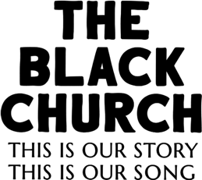

TCA Biographies

Henry Louis Gates, Jr., Series Writer, Host and Executive Producer
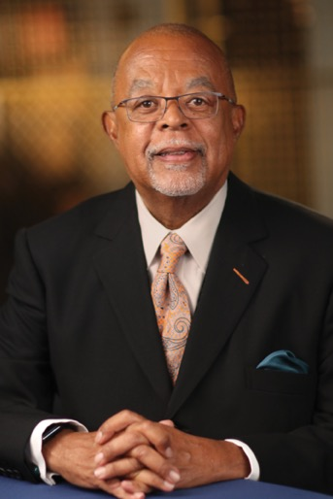
Henry Louis Gates, Jr. is the Alphonse Fletcher University Professor and Director of the Hutchins Center for African & African American Research at Harvard University. Emmy Award-winning filmmaker, literary scholar, journalist, cultural critic, and institution builder, Professor Gates has authored or co-authored twenty-four books and created twenty-one documentary films, including Wonders of the African World, African American Lives, Faces of America, Black in Latin America, Black America since MLK: And Still I Rise, and Africa’s Great Civilizations. Finding Your Roots, his groundbreaking genealogy series now in its sixth season on PBS, has been called “one of the deepest and wisest series ever on television,” leveraging “the inherent entertainment capacity of the medium to educate millions of Americans about the histories and cultures of our nation and the world.”

Professor Gates’s six-part PBS documentary series, The African Americans: Many Rivers to Cross (2013), which he wrote, executive produced, and hosted, earned the Emmy Award for Outstanding Historical Program—Long Form, as well as the Peabody Award, Alfred I. duPont-Columbia University Award, and NAACP Image Award. His latest projects are the history series, Reconstruction: America after the Civil War (PBS, 2019), winner of the Alfred I. duPont-Columbia University Award, and the related books, Dark Sky Rising: Reconstruction and the Dawn of Jim Crow, with Tonya Bolden (Scholastic, 2019), and Stony the Road: Reconstruction, White Supremacy, and the Rise of Jim Crow (Penguin Random House, 2019), a New York Times Notable Book of 2019.

Having written for such leading publications as The New Yorker, The New York Times, and Time, Professor Gates serves as chairman of TheRoot.com, a daily online magazine he co-founded in 2008, and chair of the Creative Board of FUSION TV. He oversees the Oxford African American Studies Center, the first comprehensive scholarly online resource in the field, and has received grant funding to develop a Finding Your Roots curriculum to teach students science through genetics and genealogy. In 2012, The Henry Louis Gates, Jr. Reader, a collection of his writings edited by Abby Wolf, was published.

The recipient of fifty-six honorary degrees and numerous prizes, Professor Gates was a member of the first class awarded “genius grants” by the MacArthur Foundation in 1981, and in 1998, he became the first African American scholar to be awarded the National Humanities Medal. He was named to Time’s 25 Most Influential Americans list in 1997, to Ebony’s Power 150 list in 2009, and to Ebony’s Power 100 list in 2010 and 2012. He earned his B.A. in History, summa cum laude, from Yale University in 1973, and his M.A. and Ph.D. in English Literature from Clare College at the University of Cambridge in 1979. In 2018, he was one of 15 alumni of African descent honored in the exhibition, Black Cantabs: History Makers, at the Cambridge University Library. He also is an Honorary Fellow, Clare College, at the University of Cambridge.

Professor Gates has directed the W. E. B. Du Bois Institute for African and African American Research—now the Hutchins Center—since arriving at Harvard in 1991, and during his first fifteen years on campus, he chaired the Department of Afro-American Studies as it expanded into the Department of African and African American Studies with a full-fledged doctoral program. He is a member of the American Academy of Arts and Letters and serves on a wide array of boards, including the New York Public Library, the NAACP Legal Defense Fund, the Aspen Institute, Jazz at Lincoln Center, the Whitney Museum of American Art, Library of America, and the Brookings Institution. He also is the former chair of the Pulitzer Prize board. In 2017, the Organization of American States named Gates a Goodwill Ambassador for the Rights of People of African Descent in the Americas. In 2011, his portrait, by Yuqi Wang, was hung in the National Portrait Gallery in Washington, D.C.

Stacey Holman, Series Producer and Director
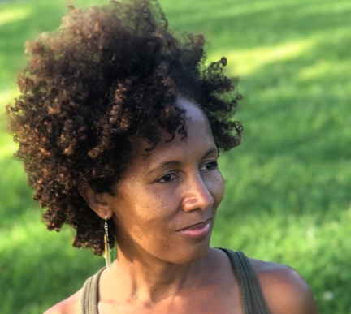
Stacey L. Holman is a Harlem-based filmmaker who’s directed/produced several award-winning projects including episode three of the 2018 PBS series Reconstruction: America After the Civil War hosted by Henry Louis Gates, Jr. She was a producer on the critically acclaimed documentary Tell Them We Are Rising: The Story of Black Colleges and Universities and served as Associate Producer on the Emmy award-winning film Freedom Riders produced/directed by Stanley Nelson. Additionally, Stacey was Coordinating Producer for Nelson’s Peabody Award-winning documentary Freedom Summer, and she was Co-Producer on Mary Lou Williams: The Lady Who Swings the Band.

Stacey’s short film Dressed Like Kings garnered the Tribeca Film Festival All Access Award and aired on the WORLD Channel as part of the AfroPoP Shorts Program. She was the Series Producer/Director of Henry Louis Gates, Jr’s Black Church series The Black Church: This Is Our Story. This Is Our Song scheduled to broadcast on PBS in February 2021 and she is currently one of the producers/directors on Gates’ Making Black America: African American Social Networks airing on PBS in the fall of 2021.

John Legend, Series Participant and Executive Producer
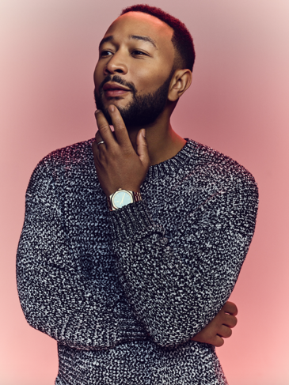
EGOT-winning, critically acclaimed, multiplatinum singer-songwriter John Legend has garnered 11 Grammy Awards, an Academy Award, a Golden Globe Award, a Tony Award, and an Emmy Award, among others.

Legend is the first African-American man to earn an EGOT and one of only fifteen people in the prestigious EGOT club. Legend has released seven celebrated albums over the course of his career, including, Get Lifted (2004), Once Again (2006), Evolver (2008), Love in the Future (2013), Darkness and Light (2016), A Legendary Christmas Deluxe (2019), and Bigger Love (2020). Currently, Legend’s “All of Me” ties with Luis Fonsi, Daddy Yankee and Justin Bieber’s ”Despacito” as the highest certified track in Recording Industry Association of America’s history.

Legend starred as Jesus in NBC’s JESUS CHRIST SUPERSTAR LIVE IN CONCERT in April 2018. That year, he was nominated for an Emmy Award for Outstanding Lead Actor in a Limited Series or Movie and won an Emmy as a producer in the category of Outstanding Variety Special (Live) for the show.

Legend joined THE VOICE for Season 16 (2019) and is currently a coach on Season 19. In October 2018, Legend released his first Christmas album, A Legendary Christmas, and closed out the year with his A Legendary Christmas tour. He released a special A Legendary Christmas Deluxe version in 2019.

Beyond his music career, John, along with partners Mike Jackson and Ty Stiklorius, is a principal in the Get Lifted Film Co. Most recently, Get Lifted produced David E. Talbert’s acclaimed holiday film JINGLE JANGLE: A CHRISTMAS JOURNEY for Netflix, the HBO docu-series ATLANTA’S MISSING AND MURDERED: THE LOST CHILDREN, the IFC and AMC comedy series SHERMAN’S SHOWCASE and SHERMAN’S SHOWCASE: BLACK HISTORY MONTH SPECTACULAR, and RHYTHM + FLOW for Netflix. Their other recent projects include the documentary 40 YEARS A PRISONER on HBO Max and the documentary GIVING VOICE, which premiered at the 2020 Sundance Film Festival and is available for streaming on Netflix. Their forthcoming projects include the film MONSTER, which was recently acquired by Netflix, the sports drama SIGNING DAY in partnership with Steph Curry’s Unanimous Media for Sony Pictures, a female-fronted film written by Adam Hoff about a modern-day Jerry Maguire, the film adaptation of S.A. Cosby’s novel BLACKTOP WASTELAND, and PAPER GODS with Sony Pictures Television for ABC.

As a philanthropist, Legend initiated the #FREEAMERICA campaign in 2015 to change the national conversation surrounding our country’s misguided criminal justice policies and to end mass incarceration. In addition to Legend’s signature initiatives, he serves on the Board of Directors of Harlem Village Academies and Management Leadership for Tomorrow, and on the Advisory Board for The Quattrone Center for the Fair Administration of Justice at the University of Pennsylvania Carey Law School and Teach for All.

Yolanda Adams, Gospel Legend and Series Participant
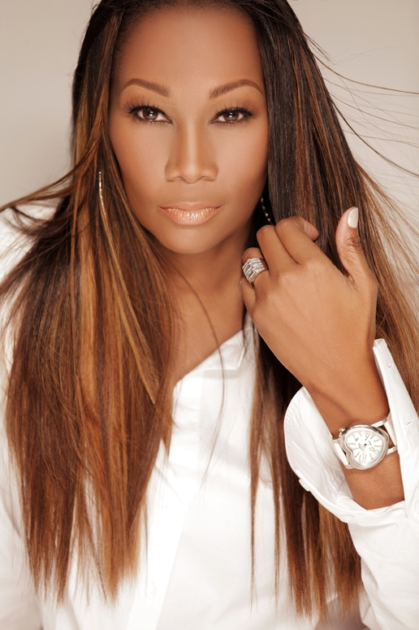
Gospel legend Yolanda Yvette Adams is a world-renowned singer, record producer, actress, entrepreneur, philanthropist, radio host of her own nationally syndicated morning gospel show and the proud mother of daughter, Taylor Ayanna Crawford. Yolanda Adams, the eldest of six siblings was born in Houston, Texas. She graduated from Sterling High School in Houston, Texas in 1979. After graduating from Texas Southern University where she earned her degree in Radio and Television Broadcasting, she began a career as a schoolteacher and part-time model in Houston. Yolanda began singing at the age of 16 with the Houston’s Southeast Inspirational Choir affiliated with Outreach Missionary Baptist Church as a lead vocalist. In 1986, Ms. Adams was featured on the Edwin Hawkins Music and Arts Seminar Choir release “Give Us Peace,” with a performance entitled "My Trust Lies in You." During one of Adams’ spectacular performances, she was discovered by Thomas Whitfield and later signed with Sounds of Gospel in which yielded her first album “Just As I Am” in 1987. In 1990, she signed with producer/keyboardist Ben Tankard, and signed to his independent label, Tribute Records and released “Through the Storm.”

The exceptionally educated and talented Ms. Adams has triumphantly carried the torch for contemporary gospel and inspirational music via 15 glorious albums and has one of the most powerful voices in any genre of music. She has earned numerous accolades for her shining efforts, including the first American Music Award for Contemporary Gospel Artist, four Gospel Music Association Dove Awards, five Grammy Awards, sixteen Stellar Gospel Music Awards, seven NAACP Image Awards, three Soul Train Music Award, and five BET Awards.

In 2007, Ms. Adams embarked on a radio career with “The Yolanda Adams Morning Show,” a program of her creation and ownership that can currently be heard on radio stations across the country. Adams was the first female nationally syndicated radio host with Radio One/Reach Media covering over 50 markets for 10 years. On December 25, 2009, Ms. Adams made her acting debut performing on BET's “The Mo'Nique Show.”

Faith, Love, Forgiveness, Protection and PRAISE. These are just five of the ten gifts explored in Yolanda Adams’ new power-filled inaugural book, “Points of Power.” Inspired by the Points of Power segment from The Morning Show, Adams reveals her own personal experiences to show how the Bible will enlighten readers and provide them with insight and understanding to respond positively to life’s challenges.

Ms. Adams served as a spokesperson for the FILA Corporation's Operation Rebound, a program that addressed the concern of inner-city school children. Additionally, she has supported the following charities and foundations: Julia F. Thompson (Alpha Kappa Alpha Sorority, Incorporated – Mu Kappa Omega chapter’s charitable foundation), NAACP, United Negro College Fund, MusiCares and National Park Foundation. She used The Yolanda Adams Morning Show as a platform to promote causes and charities such as the 50 Million Pound Challenge, a health initiative geared toward African Americans, and the Houston-based Escape Center. In addition, Adams partnered with St. Jude’s Children’s Hospital and raised more than 1 million dollars via a telethon. She has also worked with the U.S. Department of Health and Human Services' Office of Minority Health to bring attention to the health challenges facing black children, including lack of proper vaccinations and juvenile diabetes. Her own charity, the Voice of an Angel Foundation, Incorporated was founded in 2005, with a mission of establishing mentoring programs for underprivileged youth. Through her non-profit, she sponsored three Houston students to go to college affording them tuition for both their undergraduate and graduate degrees. She also donated $20,000 to the Shape Community Center and to the Imani School to fund their playground. In 2012, her non-profit sponsored and hosted The First Ladies Forum where she contributed over $100,000 honoring women across the United States for their significant contributions to their communities. Adams also partners with the Disney Dreamers Academy along with Steve Harvey and Walt Disney Co. where 100 select high school students are inspired to dream big and get a jump-start on making their dreams come true. Adams was also a part of the Get Out and Vote campaign for the past 16 years through President Clinton, President G. W. Bush and President Obama. In addition, she toured with Michelle Obama with the Let’s Move Campaign. Adams also contributed over $25,000 to both Hurricane Katrina and Hurricane Harvey relief efforts.”

In addition to the above noted ventures and charities, Ms. Adams has also pursued her own fashion line for taller women, called Yolanda's Clozet, and is a spokeswoman for the Columbia Card, a debit card marketed to church going African Americans.

