TCA Panelist Biographies

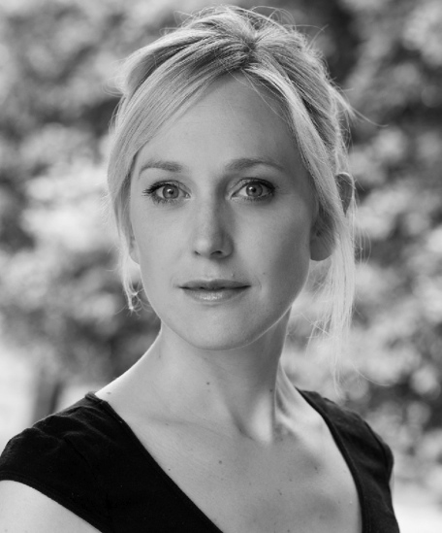
Hattie Morahan – Alice Merren

Hattie Morahan is a multiple award-winning actress whose accolades include the Evening Standard Theatre Award 2012 and the Critics Circle Best Actress Award 2013 for her performance as “Nora” in A Doll’s House, and a 2007 Ian Charleson Award for her role in The Seagull.
Morahan has appeared in a number of theater productions, television series and films. Stage productions include Plenty (Sheffield Crucible); The City (Royal Court); See How They Run (West End); and Twelfth Night (West Yorkshire Playhouse). Television shows include Midsomer Murders; Eternal Law; Outnumbered; Lewis; Sense and Sensibility; Bodies; and New Tricks. She has appeared in films such as Nora; Summer in February; Having You; The Bank Job; and The Golden Compass.

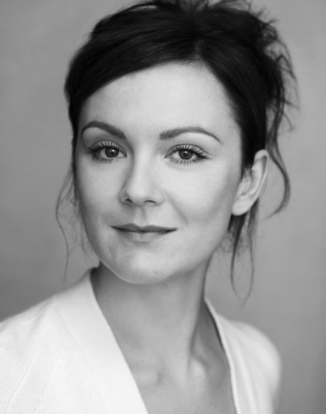
Rachael Stirling – Millie

Rachael Stirling is a two-time Olivier Award nominee for her work as Lady Chiltern in the 2010 stage production of An Ideal Husband (West End) and for her work as Rebecca in the 2009 stage production of The Priory (Royal Court).

Stirling’s first screen appearance was in the 1998 British comedy film Still Crazy. She later appeared in Maybe Baby, Redemption Road, Complicity, Another Life and The Triumph of Love with Mira Sorvino. Stirling also played Mary Jones in Salmon Fishing in the Yemen and Anna in Snow White and the Huntsman.

In 2011, Stirling starred as Ursula Brangwen in the BBC Four adaptation of D.H. Lawrence’s Women in Love. She has also appeared in a Doctor Who episode, titled “The Crimson Horror,” alongside her mother Dame Diana Rigg, marking the first appearance of the two actresses together professionally. Stirling’s additional credits include Sixteen; Tipping the Velvet; and Boy Meets Girl.

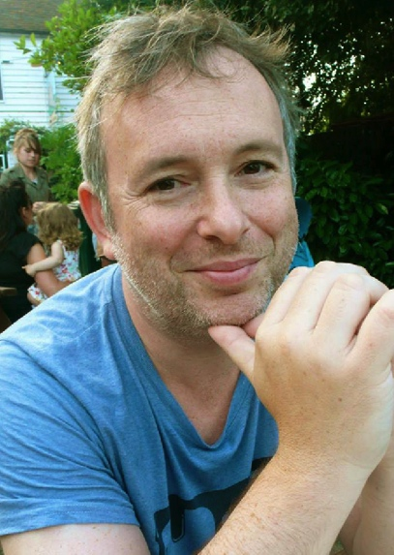
Jake Lushington – Executive Producer

Jake Lushington began his career as a theatre director working at the Manchester Royal Exchange, the Royal Court and The Bush.

In 1995 he became a script editor on EastEnders and first joined World Productions in 1997 as a script editor on This Life before returning to EastEnders for another year as head storyliner, where, among other storylines, he killed Tiffany.

Lushington came back to World in 1998 as a development producer. Over the next two-and-a-half years he developed and produced Black Cab for BBC2, Men Only for C4 and Table Twelve for BBC2.

In late 2000, Lushington joined BoxTV, where he worked for three years, eventually becoming Head of Drama. During that time he produced Trust for BBC1, Reversals for ITV and Old Street for Film Four. He was also development producer on BBC1’s The Last Enemy.

Going freelance in 2004, Lushington produced Secret Smile for Granada and ITV, Mysterious Creatures for Leopard and ITV (Winner, Best Single Drama Mental Health Awards) and Bon Voyage for Box and ITV (Winner, Best International Mini Series at the Monte Carlo International Television Awards).

Lushington produced the pilot and the two subsequent films for the now long-running George Gently detective series for Company and BBC1. He then produced Peter Flannery’s Civil War epic, The Devil’s Whore, for Company and C4 (Winner, South Bank Show, RTS, Press Guild awards and also BAFTA nominated).

Lushington was then invited by Roger Charteris at KMA to start a drama slate at Marcus Evans Entertainment. This year he rejoined World Productions as Head of Drama after an 11-year absence, when they were acquired by Marcus Evans. He is currently developing and executive producing the second series of The Bletchley Circle for ITV.

