THE FARTHEST – VOYAGER IN SPACE Will Premiere
August 23 on PBS
In Celebration of 40th Anniversary of the Voyager Launch

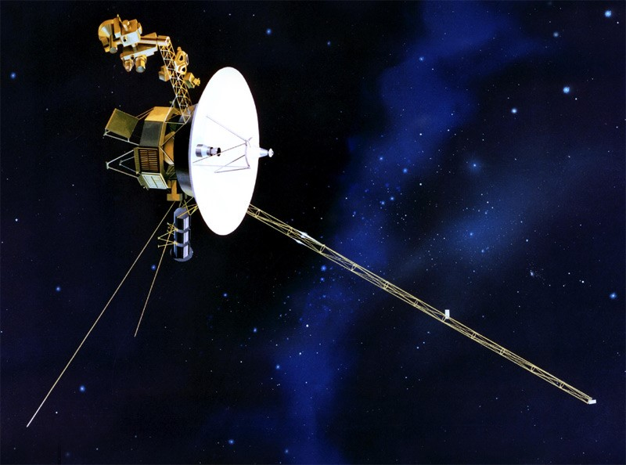
Caption: Rendering of the Voyager 2
Credit: NASA/JPL-Caltech
NEW YORK, NY; MAY 2, 2017 – PBS announced today that THE FARTHEST – VOYAGER IN SPACE, a two-hour special about NASA’s historic Voyager mission to explore our solar system and beyond, will premiere nationally on August 23 at 9:00 p.m. ET on PBS stations, in conjunction with the 40th anniversary of the first Voyager launch. The documentary was an official selection in the 2017 Tribeca Film Festival as part of the festival’s Viewpoints program. (Watch the trailer here.)

With participation from more than 20 of the original and current mission scientists, engineers and team members, THE FARTHEST – VOYAGER IN SPACE tells captivating tales of one of humanity’s greatest achievements in exploration. From supermarket aluminum foil added at the last minute to protect the craft from radiation; to the near disasters at launch; to the emergency maneuvers to fix a crucial frozen instrument platform, viewers get a sense of how difficult—and rewarding—space exploration can be.

Featuring a soundtrack of evocative period music including songs from Pink Floyd, stunning cinematography, vivid CGI animations of Voyager traversing the solar system, and original groundbreaking photographs taken by the twin spacecraft, the film tells the story of one of humanity’s most ambitious scientific endeavors. Voyager revolutionized planetary science, resolved key questions about the outer planets and raised intriguing new ones about the evolution of our solar system. Originally approved to travel only to Saturn and Jupiter, the spacecraft used gravity-assisted slingshot trajectories to take advantage of a once-in-176-year planetary alignment to extend their missions, with Voyager 2 also extending its mission to visit Uranus and Neptune.

After completing its mission to Jupiter and Saturn, Voyager 1 turned its camera inward and, at the insistence of the eloquent and insightful astronomer Carl Sagan, took one of the most famous images of Earth ever captured. As described by Sagan in the film, the image showed Earth as a pale blue dot on which “everyone you love, everyone you know, everyone you ever heard of, every human being who ever was, lived out their lives …on a mote of dust suspended in a sunbeam.”

The spacecraft, equipped with a fraction of the computing power of a modern cell phone, sent back unprecedented images and data from all four outer planets and many of their moons. As they continue their journey into interstellar space, they carry with them a literal record of our existence that may outlive us all. Sagan was one of the masterminds behind perhaps Voyager’s most iconic feature, The Golden Record, which carries greetings, music and images from Earth to intelligent beings they may one day encounter. THE FARTHEST – VOYAGER IN SPACE reveals how this famous record was created and how it presents humanity to any creatures that may find it.

“We’re living in an exciting time for space exploration, with new Earth-like exoplanets being discovered, manned missions to Mars on the horizon, and the search for extraterrestrial life being taken ever more seriously,” says executive producer Sean B. Carroll of HHMI Tangled Bank Studios. “And even though it launched 40 years ago, Voyager laid the foundation for so much of what we know about the outer planets and beyond. It’s an incredible scientific achievement, but also inspires us to reflect on our place in the universe and to imagine the implications of finding life on other worlds.”

“The men and women who gave birth to the Voyager mission are an extraordinary group of people whose passion and sense of curiosity are as eternal as the Voyager journey itself,” says producer John Murray of Crossing The Line Films. “We are incredibly grateful to them for sharing their stories with us and for bringing to life what it was like to create a scientific mission of literally cosmic proportions. This story is more than 40 years in the making, and there have been—and continue to be—so many firsts that Voyager remains as relevant now as it was when it was launched. The spacecraft are still inspiring people, still forging new frontiers of discovery and still sending back data that is changing our understanding of our solar system and beyond.”

Four decades after they left Earth, Voyager 1 has traveled more than 12 billion miles and Voyager 2 more than 10 billion. Both nuclear-powered spacecraft continue to send back data. In 2012, Voyager 1, which is traveling at more than 320 million miles per year, became the first human-made object to enter interstellar space—leaving our solar system behind and ushering humanity into the interstellar age.

Leading up to the broadcast in August, HHMI Tangled Bank Studios will develop a series of public screenings and discussions featuring scientists and engineers who appear in the film and who worked on the Voyager mission. Information on the location and dates of screening events will be available later this spring at pbs.org/farthest. The events will coincide with a rich summer of astronomical events and news: for the first time in nearly 40 years, a complete solar eclipse will be visible across the continental United States, to be chronicled in NOVA “Eclipse Over America” on August 21; and after a nearly 20-year mission exploring Saturn and its moons, NASA’s Cassini spacecraft will end its mission by plunging into Saturn’s atmosphere, burning up like a meteor. NOVA will explore this mission in “Death Dive to Saturn” on September 13.

“As America turns its attention to the stars and sky this summer, THE FARTHEST – VOYAGER IN SPACE will be a wonderful way to revisit how this incredible journey began, and to celebrate the men and women whose extraordinary vision will take us to the furthest reaches of the universe,” said Beth Hoppe, Chief Programming Executive and General Manager, General Audience Programming, PBS. “We hope it will encourage the next generation of scientists to continue to push the boundaries of what seems possible.”

THE FARTHEST – VOYAGER IN SPACE is a Crossing The Line film presented by HHMI Tangled Bank Studios in association with the Irish Film Board, ZDF, ARTE and the BBC. The film is written and directed by Emer Reynolds and produced by John Murray and Clare Stronge. Executive producers are John Rubin, Sean B. Carroll and Dennis Liu (HHMI Tangled Bank Studios) and Keith Potter (Irish Film Board). Executive in Charge for PBS is Bill Gardner.

Continue your space exploration with additional new PBS specials that offer an in-depth look at the solar system and beyond! Coming up on August 21, NOVA “Eclipse Over America” invites you to observe a total solar eclipse traversing the US mainland for the first time in more than a generation. Two more NOVA specials, “Death Dive to Saturn” on September 13 and “Black Holes” (w.t.) date TBD, explore the Cassini space probe’s mission to Saturn and the frontiers of black hole research, respectively. In November, BEYOND A YEAR IN SPACE chronicles Scott Kelly’s return home after a year in space and provides a glimpse of a new generation of astronauts training for mankind’s greatest leap yet: the journey to Mars. PBS KIDS’ hit space-themed series READY JET GO! takes young viewers on far-flung learning adventures through astronomy, technology, scientific exploration, innovation and invention. PBS Digital Studios’ SPACE TIME explores the outer reaches of space, the craziness of astrophysics, the possibilities of sci-fi and anything else imaginable beyond planet Earth.
About PBS
PBS, with nearly 350 member stations, offers all Americans the opportunity to explore new ideas and new worlds through television and digital content. Each month, PBS reaches nearly 100 million people through television and nearly 28 million people online, inviting them to experience the worlds of science, history, nature and public affairs; to hear diverse viewpoints; and to take front row seats to world-class drama and performances. PBS’ broad array of programs has been consistently honored by the industry’s most coveted award competitions. Teachers of children from pre-K through 12th grade turn to PBS for digital content and services that help bring classroom lessons to life. Decades of research confirms that PBS’ premier children’s media service, PBS KIDS, helps children build critical literacy, math and social-emotional skills, enabling them to find success in school and life. Delivered through member stations, PBS KIDS offers high-quality educational content on TV – including a new 24/7 channel, online at pbskids.org, via an array of mobile apps and in communities across America. More information about PBS is available at www.pbs.org, one of the leading dot-org websites on the internet, or by following PBS on Twitter, Facebook or through our apps for mobile and connected devices. Specific program information and updates for press are available at pbs.org/pressroom or by following PBS Pressroom on Twitter

About HHMI Tangled Bank Studios
HHMI Tangled Bank Studios is a production company established and funded by the Howard Hughes Medical Institute (HHMI) as an extension of its longstanding science education mission. Dedicated to the creation of original science documentaries for broadcast, theatrical and digital distribution, the company’s award-winning programs address important contemporary issues and capture compelling stories of discovery across all branches of scientific inquiry. For more information, please visit www.tangledbankstudios.org. HHMI is a science philanthropy whose mission is to advance basic biomedical research and science education for the benefit of humanity. The institute is the largest private supporter of science education in the country.

About Crossing The Line Productions
Crossing the Line is an Irish based production company producing authored wildlife and science documentaries for theatrical release and many of the world’s leading television broadcasters and documentary financiers. In the last five years their films have garnered five Emmy nominations and multiple awards at the world’s most prestigious natural history film festivals including Best of Festival at the UK’s Wildscreen in 2014 and an unprecedented two Best of Festival prizes in a row at the 2011 & 2013 Jackson Hole Wildlife Film Festivals – the Oscars of the wildlife film world. Other past work includes the landmark film on the 50th anniversary of the Cuban Missile Crisis for PBS which was nominated for a Grierson Award - the UK’s most prestigious documentary prize. The Farthest is the company’s first collaboration with HHMI Tangled Bank Studios.

– PBS –

CONTACTS:
Brian Moriarty, DKC Public Relations, 212-981-5252; brian_moriarty@dkcnews.com
Missy Greenberg, DKC Public Relations, 212-981-5121; missy_greenberg@dkcnews.com

For images and additional up-to-date information on this and other PBS programs, visit PBS PressRoom at pbs.org/pressroom.

