MARGARET ATWOOD, LAUREN GRAHAM,
JOHN IRVING, BILL T. JONES, DEVON KENNARD, GAYLE KING, DIANE LANE, GEORGE R.R. MARTIN, LESLEY STAHL AND MANY MORE TO LEND THEIR VOICES TO
PBS’ THE GREAT AMERICAN READ

Groundbreaking, Multi-Platform Series From Nutopia to Launch on May 22 With Two-Hour Event; Culminates This Fall in the First-Ever National Vote to Choose “America’s Best-Loved Book”

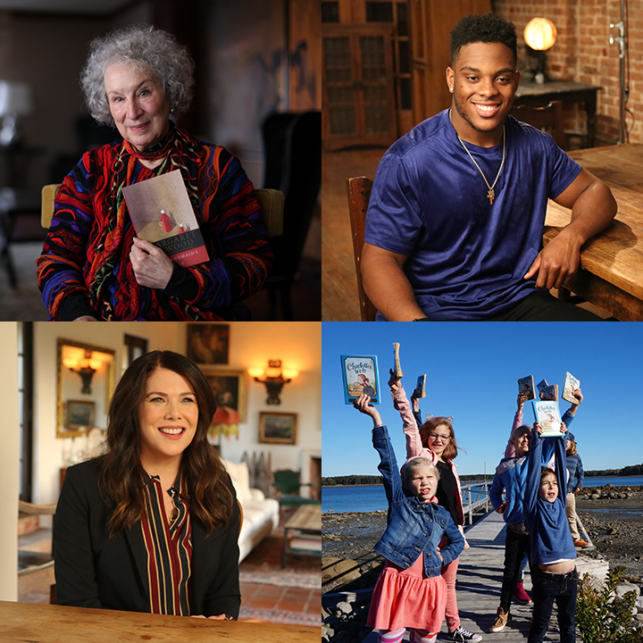
PASADENA, CA; January 16, 2018 – Today at the Television Critics Association Press Tour, PBS President and CEO Paula Kerger announced key authors, celebrities and notable figures in the entertainment, sports, news and literary worlds who will lend their voices and passion to THE GREAT AMERICAN READ, including Margaret Atwood, Lesley Stahl, Devon Kennard and many others who, throughout the series, share their personal stories and connections to their favorite titles. THE GREAT AMERICAN READ, a new eight-part television competition and nationwide campaign created in partnership with the production company Nutopia, explores the power of books and the joy of reading through the lens of America’s 100 best-loved novels, as voted on by the public. Kerger revealed that PBS will also partner with top literary organizations and its nearly 350 member stations nationwide to extend the reach of THE GREAT AMERICAN READ to every community.
Clockwise from top left: Margaret Atwood; Devon Kennard; school children visiting the farm that inspired Charlotte’s Web; Lauren Graham
Photo credits: Nutopia/PBS

THE GREAT AMERICAN READ launches with a two-hour special event on Tuesday, May 22, 2018, at 8 p.m. on PBS stations (check local listings). Over the course of 15 weeks in the summer, viewers can read and vote on favorite works of fiction; the series then returns in the fall with additional episodes exploring the nominated books through themes including “Heroes,” “Villains & Monsters,” “Who Am I?,” “What We Do for Love,” “Other Worlds,” and will conclude with an exciting finale and countdown to “America’s Best-Loved Book.” The full list of 100 titles, chosen from a demographically representative national survey conducted by YouGov, will be made available to the public prior to the launch episode in May.

THE GREAT AMERICAN READ is supported by an extensive multi-platform digital and social media campaign designed to inspire Americans to read, vote and share their personal connections to titles on the top 100 list and beyond over the course of the summer. Additionally, working with member stations and partners, PBS will develop resources and materials to extend the campaign and encourage summer reading activities.

“From exploring the nature of good and evil to discovering a world far away from our own, books have the power to transform, to inspire and to stay with you long after the final page has been turned,” said Beth Hoppe, Chief Programming Executive and General Manager, General Audience Programming, PBS. “PBS is committed to being the home for engaging, educational and inspiring content, and we hope that THE GREAT AMERICAN READ encourages a multi-generational dialogue about literacy in America through this search to identify America’s best-loved novel.”

“America’s love affair with books is the perfect jumping off point for this innovative series celebrating the power of reading,” said Jane Root, Founder and CEO, Nutopia. “We are most excited to see how this series will inspire new conversations celebrating American diversity through a literary lens.”

Kicking off with a two-hour launch event, THE GREAT AMERICAN READ will journey across America to uncover illuminating details and new reflections, sometimes from unlikely sources, about some of the titles on the top 100 book list, revealing the story behind the story from multiple perspectives. To spark conversation about the books that have inspired, moved and shaped us, both individually and as a society, viewers will hear from a variety of sources about what the novels on the top 100 list can tell us about our diverse nation, our shared values, our cultural identities and the common themes that tie us together.

Over the course of the summer, THE GREAT AMERICAN READ will roll out an unprecedented campaign across PBS digital and social platforms, inviting viewers to share the works of fiction that have touched them most and to disclose their personal connections to the stories they love. After the premiere episode of the series, the audience will have an opportunity to dive deep and engage with PBS and fellow viewers in various ways:

- Voting will open with the launch of the two-hour premiere episode and continue throughout the summer, leading up to the Grand Finale in October 2018. Over the summer, viewers will be able to vote at pbs.org/greatamericanread and through hashtag voting via Facebook and Instagram using #GreatReadPBS. In the fall, viewers will also be able to cast their votes toll-free and by utilizing SMS voting.
- An interactive website with detailed show information, links to local events, episode descriptions, interactive video content, social share features and much more will be available.
- Photographs, short-form videos, animated graphics, live streams and behind-the-scenes footage will fuel social media integration of THE GREAT AMERICAN READ to encourage reading, conversation and voting.

To complement THE GREAT AMERICAN READ, PBS KIDS will host PBS KIDS READ as part of an annual summer learning initiative for children ages 2-8 and their families. PBS KIDS READ will encourage reading and related activities through a variety of resources for kids and parents, including social media engagement, digital games and tools, and downloadable activities. PBS member stations across the country will host literacy and learning events in local communities throughout the summer months.

PBS will partner with its nearly 350 local member stations in support of THE GREAT AMERICAN READ through grants designed to support active creation, distribution and promotion of the series, as well as through the formation and strengthening of local partnerships.

All of the novels on the top 100 list were chosen by the American public in a specially commissioned, demographically representative national survey conducted by YouGov. An advisory panel, composed of 13 literary professionals, used their collective expertise to establish basic ground rules and minimally influence the final list to break ties and maximize the variety. Members of the advisory panel include: Lisa Lucas, Executive Director, National Book Foundation; Aaron Curtis, Bookseller, Quartermaster of Books&Books, Coral Cables, FL; Ron Charles, Book Editor, Washington Post; Kim Hubbard, Books Editor, People Magazine; Kevin Young, Director, Schomburg Center for Black Culture; Nancy Pearl, Librarian, Blogger and Author; Shanna Peeples, Educator, Coach, Advocate, 2015 Teacher of the Year; Calvin Reid, Senior News Editor, Publishers Weekly; Mary Rasenberger, Executive Director, Authors Guild, NY; Chandler Arnold, Chief Operating Officer, First Book; Rob Casper, Head of Poetry and Literature Center, Library of Congress; Kirk Whisler, Executive Director of Latino Literacy Now & National Latino Media Council Board Member; Gerald Maa, Editor-in-Chief, The Asian American Literary Review.
Funding for THE GREAT AMERICAN READ is provided by The Anne Ray Foundation and PBS.

THE GREAT AMERICAN READ is a production of Nutopia for PBS. Executive produced by Jane Root, Bob Kirsh and Michael Cascio. Co-executive produced by Rebecca Ratliff Cameron. Produced by Katherine Linton, Kate Chumley, Justine Simonson, Michelle Smawley, Siobhan Lockhart, Annie Wong and Tomek Gross.

Amplifying the on-air and on-line series content will be a beautifully illustrated companion book, The Great American Read: The Book of Books, which will include information about the 100 novels, author profiles, rare images of original manuscripts and more, plus an introduction by the host of THE GREAT AMERICAN READ, to be published by Black Dog & Leventhal in August 2018.

About Nutopia
Nutopia is a leading television production company creating innovative, award-winning, premium content on a global scale. Founded in 2008 by Jane Root, former President of Discovery Channel US, Controller of BBC2 and co-founder of Wall to Wall TV, Nutopia created the “mega doc” model, blending huge-scale history series and high-profile talent from the worlds of documentary and drama. In 2017, the company entered into a creative partnership with Academy Award®-nominated feature film producers Roast Beef. Nutopia has become synonymous with creating high-quality content that stands out from the crowd, working with some of the most prominent global broadcasters including Netflix, CNN, National Geographic, the BBC, PBS and A+E Networks. Critical successes include the Emmy Award-winning series HOW WE GOT TO NOW; two seasons of ratings smash FINDING JESUS. FAITH. FACT. FORGERY; and Emmy Award-winning series AMERICA THE STORY OF US and MANKIND THE STORY OF ALL OF US. Upcoming projects include National Geographic’s 10-hour flagship factual event ONE STRANGE ROCK, a collaboration with Academy Award-nominated Darren Aronofsky’s production company Protozoa Pictures, landmark art-history series CIVILIZATIONS for BBC and PBS, and BABIES for Netflix.

About PBS
PBS, with nearly 350 member stations, offers all Americans the opportunity to explore new ideas and new worlds through television and digital content. Each month, PBS reaches nearly 100 million people through television and nearly 28 million people online, inviting them to experience the worlds of science, history, nature and public affairs; to hear diverse viewpoints; and to take front row seats to world-class drama and performances. PBS’ broad array of programs has been consistently honored by the industry’s most coveted award competitions. Teachers of children from pre-K through 12th grade turn to PBS for digital content and services that help bring classroom lessons to life. Decades of research confirms that PBS’ premier children’s media service, PBS KIDS, helps children build critical literacy, math and social-emotional skills, enabling them to find success in school and life. Delivered through member stations, PBS KIDS offers high-quality educational content on TV – including a new 24/7 channel, online at pbskids.org, via an array of mobile apps and in communities across America. More information about PBS is available at www.pbs.org, one of the leading dot-org websites on the internet, or by following PBS on Twitter, Facebook or through our apps for mobile and connected devices. Specific program information and updates for press are available at pbs.org/pressroom or by following PBS Pressroom on Twitter.

CONTACTS:
Carrie Johnson, PBS, 703-739-5129, cjohnson@pbs.org
Atiya Frederick, PBS, 703-739-5147, anfrederick@pbs.org
Brian Moriarty, DKC Public Relations, 212-981-5252, brian_moriarty@dkcnews.com

