PBS’ THE GREAT POLAR BEAR FEAST Explores an Endangered Species’ Struggle for Survival and the Effects of Climate Change in the Arctic

– Premieres June 22, 2016, 8:00-9:00 p.m. ET on PBS –

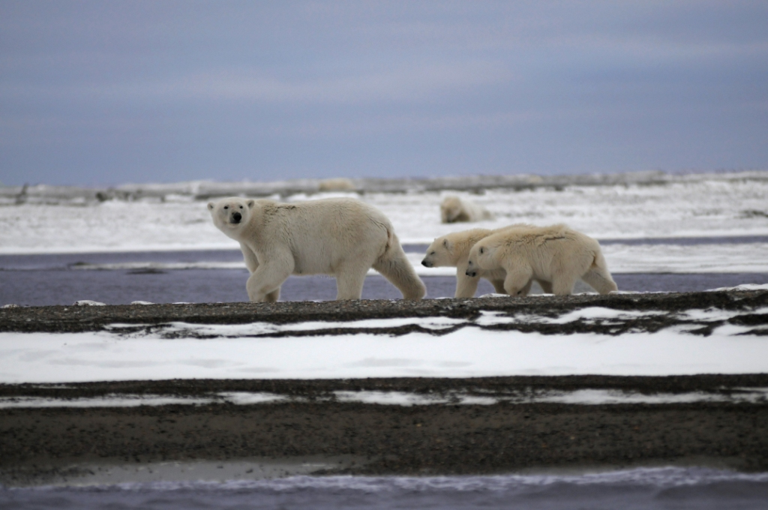
ARLINGTON, VA; May XX, 2016 – Each summer, an increasing number of polar bears are converging at Kaktovik, a tiny Alaskan town on the shores of the Southern Beaufort Sea, to feast on the remains of whales left on a nearby beach by the Inupiat tribe. This spectacle is captured in THE GREAT POLAR BEAR FEAST, premiering Wednesday, June 22, 2016, at 8:00 p.m. ET on PBS (check local listings). The film documents the immense struggle that polar bears face in the wild and how a unique relationship between the bears and the local village is shedding new light on the future of this iconic animal. The filmmakers accompanied the U.S. Geological Survey lead polar bear scientist, Dr. Todd Atwood, as he and his team fit one dozen female bears with satellite tracking collars to gather data on them over the several months and witness never-before-seen behaviors.
Mother and two cubs, Kaktovic Bay, after an early snowfall.

Credit: Courtesy of Andrew Graham Brown/Renegade Pictures (UK) Ltd

THE GREAT POLAR BEAR FEAST tells the story of Southern Beaufort Sea polar bears as they face the challenges of the Arctic summer, the time of year when the sea ice they depend on for hunting melts at an increasingly rapid pace. Using the satellite data, the film follows two female bears and their cubs as the ice begins to melt. One mother, with two cubs, travels south to Kaktovik and is able to partake in the feast of whale blubber. The other, with a single cub, stays put and then must swim several hundred miles to the north to reach the nearest ice.

“THE GREAT POLAR BEAR FEAST exemplifies the type of smart, compelling science programming that PBS is known for and provides deeper insight on complex issues in the Arctic,” said Bill Gardner, Vice President, Programming and Development for PBS.

THE GREAT POLAR BEAR FEAST is produced by Renegade Pictures for PBS.

About PBS Science
THE GREAT POLAR BEAR FEAST airs as part of PBS’ summer programming lineup of science, nature and technology programming that includes ongoing acclaimed series NATURE and NOVA, offering new perspectives on life in the universe to keep viewers both curious and wanting more. Also airing as part of PBS’ summer science lineup are SUPERNATURE – WILD FLYERS on June 29 at 8:00 p.m. ET, 9 MONTHS THAT MADE YOU on June 29 at 10:00 p.m. ET, and KOKO THE GORILLA WHO TALKS on August 3 at 8:00 p.m. ET. For more information on each program, please visit PBS PressRoom.

About Renegade Pictures
Renegade Pictures supplies broadcasters around the world with groundbreaking, high-quality television content across many genres. Productions range from the global hit “Don’t Tell the Bride” (now in series 10) to “World’s Most Dangerous Roads.” The output encompasses entertainment shows like “Popstar to Opera,” edgy factual event shows like “Drugs Live” and new formats including “The Tribe” and “Car SOS.” Renegade works with leading UK talent in shows such as “Celebrity Wedding Planner” and “Spending Dave’s Money.” The company is also one of the UK’s leading producers of 3D content, creating Britain’s first 3D comedy for Sky and the acclaimed “Safari Park Adventure” for Discovery, and has produced film documentaries, including the mischievous The Yes Men Fix the World, the thought-provoking Shock Doctrine and The Sins of My Father.

About PBS
PBS, with 350 member stations, offers all Americans the opportunity to explore new ideas and new worlds through television and online content. Each month, PBS reaches nearly 100 million people through television and nearly 33 million people online, inviting them to experience the worlds of science, history, nature and public affairs; to hear diverse viewpoints; and to take front row seats to world-class drama and performances. PBS’ broad array of programs has been consistently honored by the industry’s most coveted award competitions. Teachers of children from pre-K through 12th grade turn to PBS for digital content and services that help bring classroom lessons to life. PBS’ premier children’s TV programming and its website, pbskids.org, are parents’ and teachers’ most trusted partners in inspiring and nurturing curiosity and love of learning in children. More information about PBS is available at www.pbs.org, one of the leading dot-org websites on the Internet, or by following PBS on Twitter, Facebook or through our apps for mobile devices. Specific program information and updates for press are available at pbs.org/pressroom or by following PBS Pressroom on Twitter.

– PBS –

For additional information, photos, interviews and more, contact:

David Nadler/Meghan Newton Colleen Flanagan/Atiya Frederick
Goodman Media for PBS PBS
212-576-2700 703-739-8130; 703-739-5147
PBSProgramming@goodmanmedia.com crflanagan@pbs.org; anfrederick@pbs.org

For images and additional up-to-date information on this and other PBS programs, visit PBS PressRoom at pbs.org/pressroom.

