PBS Three-Part Series, The Kimberley: Australia’s Wild West, Reveals the Hidden Treasures of Australia’s Remote Northwest

Series Premieres Wednesday, June 17, 2026
10:00 PM ET on PBS

View The Kimberley Trailer

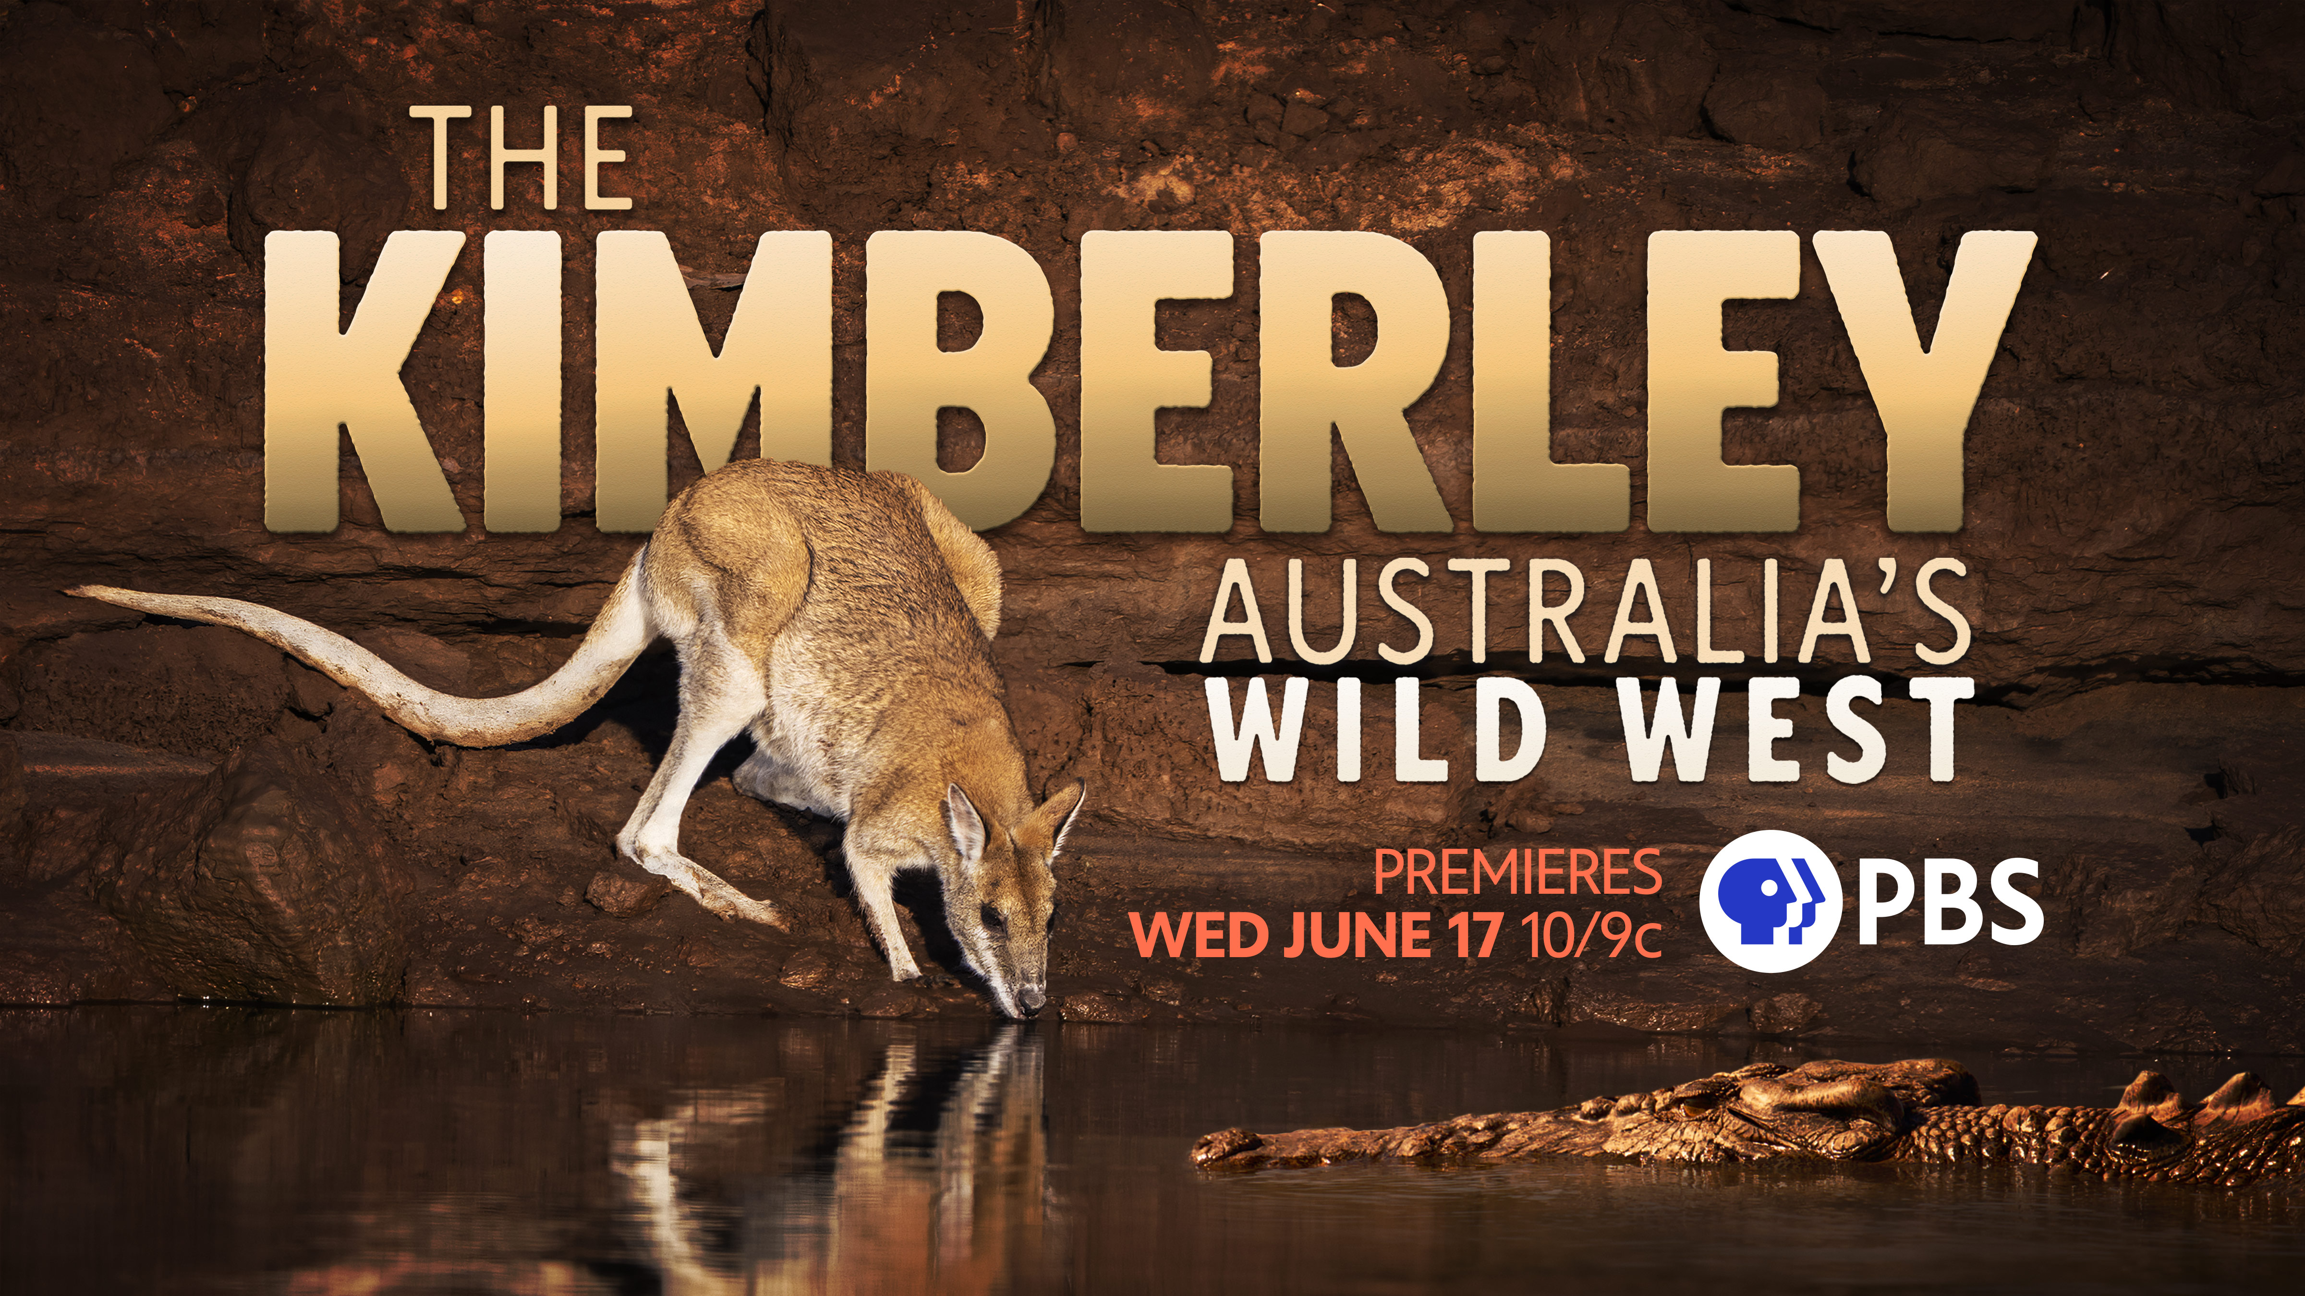
Photo Credit: Wild Pacific Media
Arlington, VA; (May 26, 2026) – PBS announced today a new three-part series, The Kimberley: Australia’s Wild West, premiering Wednesday, June 17, 2026 at 10:00 PM ET on PBS, PBS.org and the PBS App (check local listings). This landmark series captures never-before-seen footage of The Kimberley, Australia’s remote northwest region, from a First Nations perspective, chronicling a year of extreme tropical seasons to reveal the stories hidden within the rugged landscape.

The Kimberley spans over 400,000 square kilometers of tropical wilderness, including turquoise coastlines, towering gorges, sandy deserts and sprawling savanna. The harsh, inaccessible terrain hides remarkable biodiversity, from the fearsome crocodiles who rule the rivers, to the marsupial gliders who soar over the savanna, to the hundreds of thousands of migratory shorebirds who travel from all over the planet to feed on the rich coastline. This near-pristine corner of the world is vital refuge for countless creatures. It is also the frontline of biodiversity conservation, where Traditional Owners and ecologists are working together to save the species who call the Kimberley home.

From the scorching dry season of Lalin, when desperate wallabies risk “death by ancient reptile” as they brave the last water sources to drink, to the monsoon season of Wilakarra, when the annual pulse of water brings the landscape roaring to life and sparks an inter-species baby boom, each season brings new challenges and new opportunities to Kimberley. The Kimberley: Australia’s Wild West showcases a year of these animals’ lives and tracks the quests of those working to protect them.

“We are thrilled to bring this compelling series to PBS to take viewers on a journey through the hidden wonders of Australia’s remote regions,” said Diana El-Osta, Sr. Director, Multiplatform Programming & Development, PBS. “Adding this series to our summer line-up of science and nature programming is a perfect blend of what PBS does best — mixing science and storytelling, and we know it will captivate audiences.”
Episode Descriptions
Episode 1: “River of Life” (Wednesday, June 17, 2026)
At the end of Lalin, the Kimberley’s intense hot dry season, parched wallabies face peril to reach water in rivers ruled by fearsome saltwater crocodiles. When heat and humidity peak, frill-necked lizards battle for mates under skies rippling with lightning. Wilakarra (the rainy season), returns life to the Kimberley and revives the mighty Martuwarra/Fitzroy River, where Nyikina man and actor Mark Coles Smith launches a rafting expedition to explore its remote reaches. Tiny jacana chicks learn the ropes in the wetlands and frill-necked lizard hatchlings emerge, joining the host of new life born in the wet season.

Episode 2: “Tidal Territory” (Wednesday, June 24, 2026)
In the season of Koolawa, thousands of migratory shorebirds fatten up on the world’s richest intertidal mudflats. Mudskippers battle for mates and attempt to evade an ultra-rare reptilian predator. The cool dry season of Barrkana brings humpback whales to near-pristine coastal waters, where the Dambimangari Land and Sea Rangers hold back threats on their Country. Northern quolls face a cane toad invasion, and find refuge on stunning tropical islands, and the jewel in Dambimangari Country is revealed when Australia’s biggest tides draw the ocean away from hundreds of square kilometers of coral.

Episode 3: “Into the Fire” (Wednesday, July 1, 2026)
As the cool dry season of Barrkana ends, savanna gliders explore the canopies of the Kimberley’s sprawling savanna. Traditional Owners start their vital early burning regimes, using ancient knowledge to help threatened species like the colorful Gouldian Finch. When the growing heat of Wilbooroo dries the wetlands, crocs are forced into overcrowded rivers, where the close quarters spark territorial tiffs. In Wunambal Gaambera Country, an array of unique creatures survives the extreme heat of Lalin in sandstone refuges, watched over by First Nations rangers, and Jirrbal’s lightning sparks dangerous wildfires in the bone-dry savannas.

The Kimberley: Australia’s Wild West will stream Wednesdays beginning June 17, 2026 and be available on all station-branded PBS platforms, including PBS.org and the PBS app, available on iOS, Android, Roku streaming devices, Apple TV, Android TV, Amazon Fire TV, Samsung Smart TV, Chromecast and VIZIO. PBS station members can view many series, documentaries, and specials via PBS Passport. For more information about PBS Passport, visit the PBS Passport FAQ website or contact your local station.

Funding for the PBS presentation of The Kimberley: Australia’s Wild West was provided by the Anne Ray Foundation.

The Kimberley: Australia’s Wild West was produced by Wild Pacific Media in association with PBS, The Australian Broadcasting Corporation, Blue Ant International/ Love Nature and ARTE France. Investment support was provided by Screen Australia & Screen NSW.
The film is directed by Emmy Award-winning Nick Robinson and photographed by cinematographers Jack Riley, Caspar Mazzotti, Paul Bell and Alex Westover.
About PBS
PBS, with more than 330 member stations, offers all Americans the opportunity to explore new ideas and new worlds through television and digital content. Each month, PBS reaches over 36 million adults on linear primetime television, 16 million users on PBS-owned streaming platforms, 56 million viewers on YouTube, and 10 million followers on social media, inviting them to experience the worlds of science, history, nature, and public affairs and to take front-row seats to world-class drama and performances. PBS’s broad array of programs has been consistently honored by the industry’s most coveted award competitions. As the number one educational media brand, PBS KIDS helps children 2-8 build critical skills, enabling them to find success in school and life. Delivered through member stations, PBS KIDS offers high-quality content on TV — including a PBS KIDS channel — and streaming free on pbskids.org and the PBS KIDS Video app, games on the PBS KIDS Games app, and in communities across America. Teachers of children from pre-K through 12th grade turn to PBS LearningMedia for digital content and services that help bring classroom lessons to life. More information about PBS is available at PBS.org, one of the leading dot-org websites on the internet, Facebook, Instagram, or through our apps for mobile and connected devices. Specific program information and updates for press are available at pbs.org/pressroom or by following PBS Communications on X.

– PBS –

CONTACTS:

PBS
Meredith Tiger, mjtiger@pbs.org

Bullseye Communications
Lisa Dyer, lisa.dyer@bullseyecomm.com
Heather Marohn, heather.marohn@bullseyecomm.com

For images and additional up-to-date information on this and other PBS programs, visit PBS PressRoom at pbs.org/pressroom.

