OUTBACK Premieres Wednesdays,
August 1, 8 and 15 on PBS

Explore the People and Animals of Australia’s Kimberley Region, a Vast, Rugged and Remote Wilderness
as Part of the PBS Summer of Adventure

ARLINGTON, VA; May 2, 2018 –OUTBACK is a new three-part series that explores the people and animals of Australia’s Kimberley region in North West Australia, a vast, rugged and remote wilderness bursting with character. As large as California, Kimberley has a population of only about 40,000 people, who live alongside animals that have superbly adapted to the harsh and beautiful extremes of their habitat. Filmed over the course of two distinct seasons, OUTBACK premieres Wednesdays, August 1, 8 and 15, 2018 8:00-9:00 p.m. ET (check local listings) on PBS.
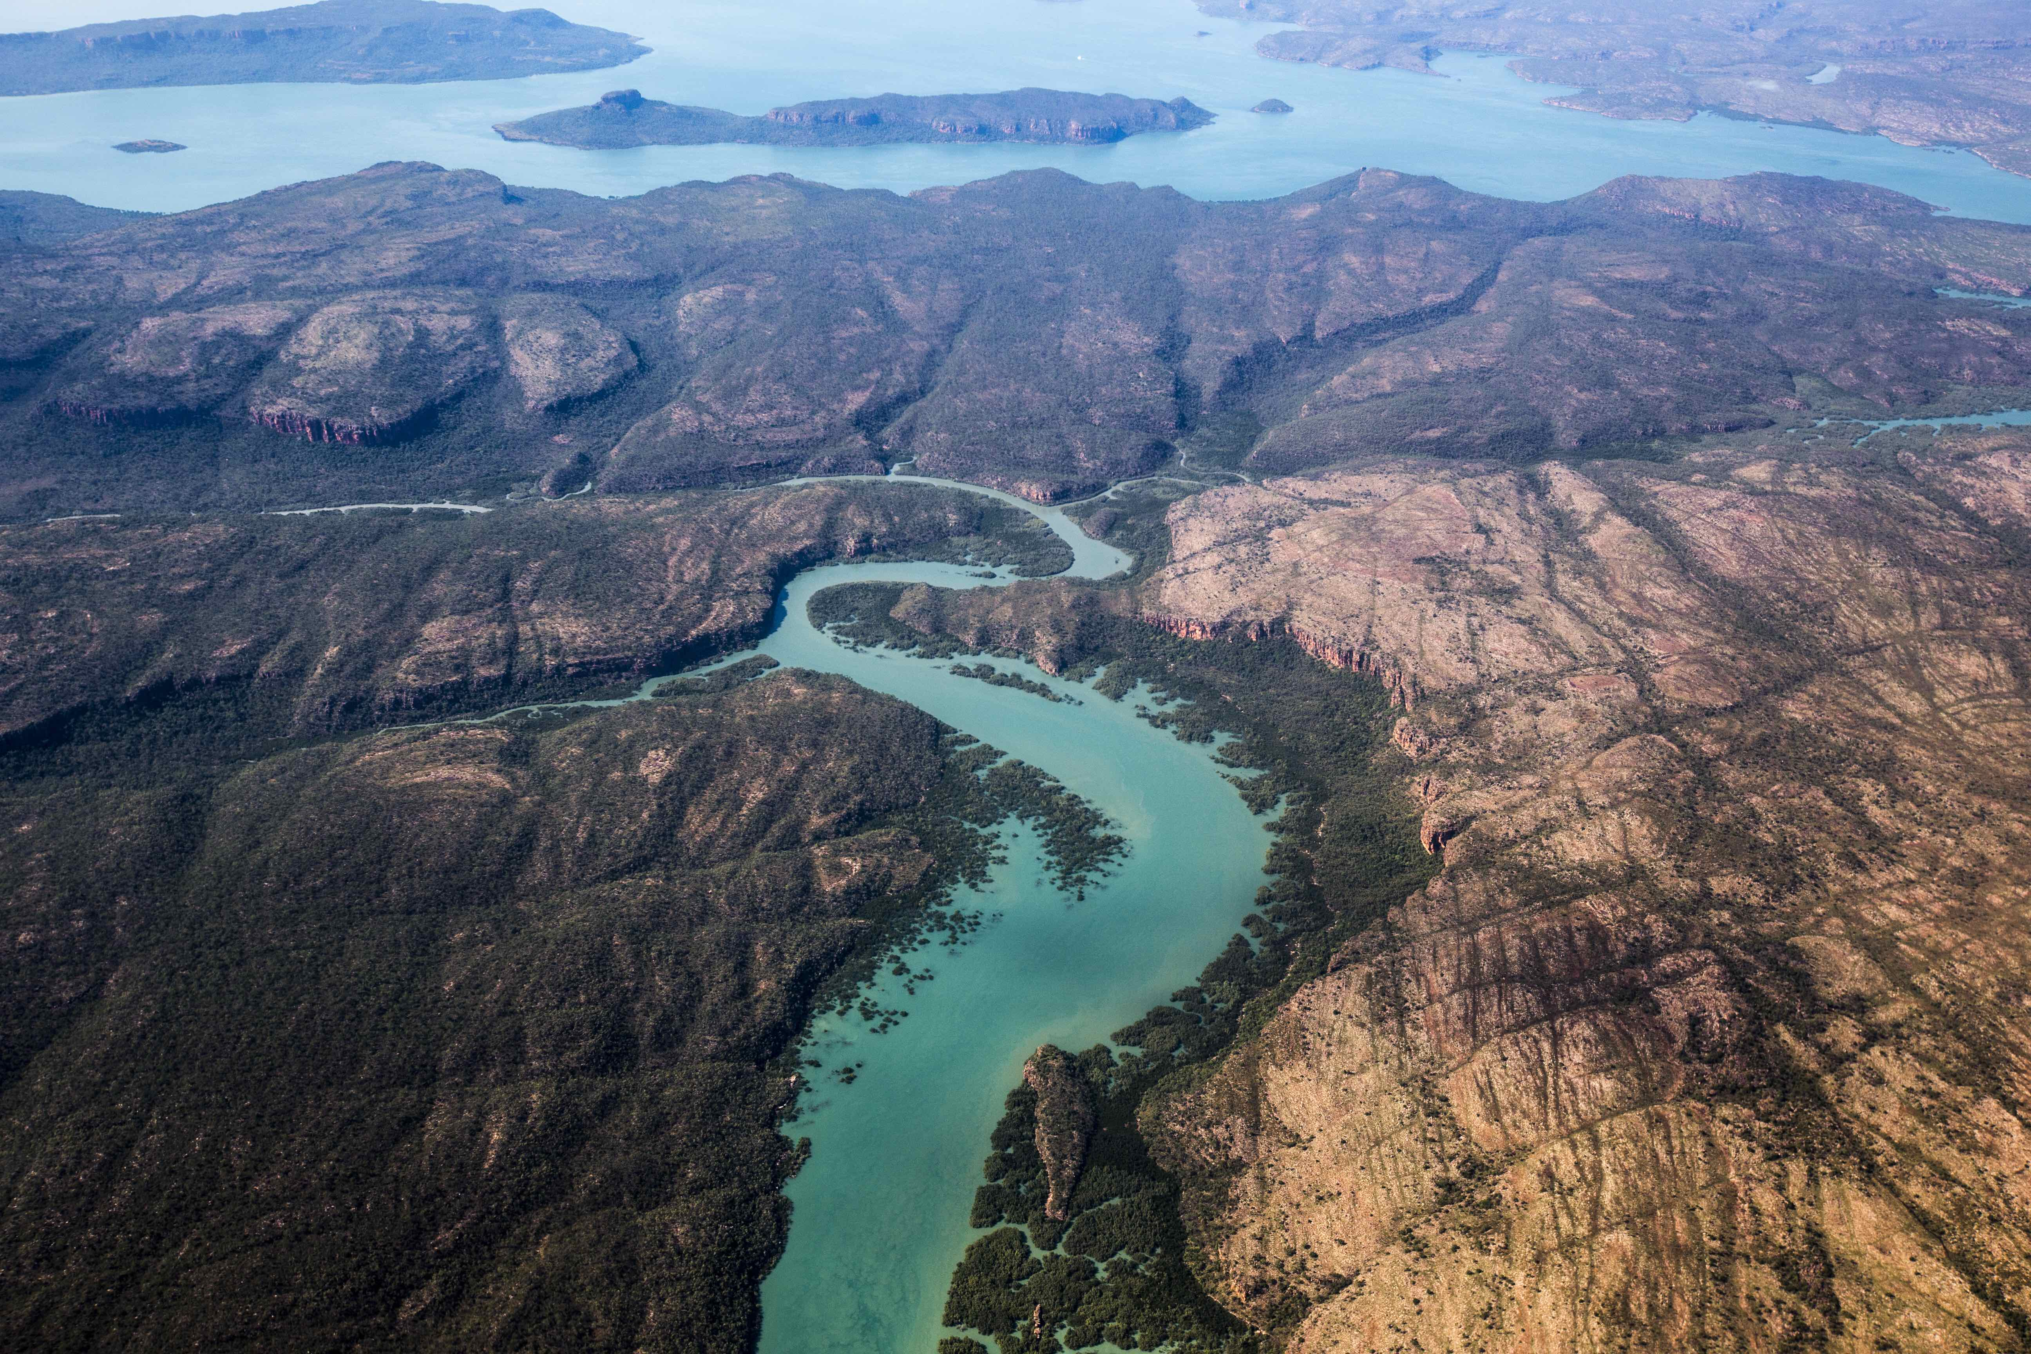
Credit: Courtesy of Northern Pictures

Australia’s vast North West corner is a startling landscape, one so ancient that, in parts, it predates life on the planet. It can appear arid and empty, but is filled with animals that have adapted to its harsh climate. Many are nocturnal, well camouflaged or prone to secrecy, from creatures reminiscent of the ancient landscape, like the saltwater crocodile, owner of the world’s most powerful jaws, to the most delicate of marsupial mice. OUTBACK captures the life of these animals over the course of the dramatic wet and dry seasons that dictate their cycles of life.

From the Outback’s red-hot heart, to its spectacular and pristine coastline, a particular breed of people also inhabits this land. OUTBACK is their story – past and present, tough and compassionate. They are the indigenous custodians whose understanding of the land, its animals and its seasons harks back to the oral storytelling and dreamtime of ancient generations. They work with and beside scientists sharing knowledge and interpretations of the land. There are the station owners and workers who live together on some of the world’s most remote cattle properties, battling heat, flies and the sheer breadth of their grazing lands. There are archaeologists stunned by rock art discoveries and “wildlife carers” who nurture orphaned animals – no matter the hour of the day. We meet the gold diggers, the ornithologists, the dedicated volunteers and the dreamers with big ideas.

It’s a spectacular adventure into the life of Australia’s unique and precious North West corner.

EPISODE 1: “The Kimberley Comes Alive”
The Kimberley region in North West Australia boasts some of the most spectacular wilderness — and tough characters — in existence. As the wet season comes to an end, the humans and the creatures begin their adventures across this diverse and surprising landscape. From tiny, orphaned joeys to majestic ospreys, survival takes guts (and sometimes even the huge hearts of humans to care for them). It’s a land where humans and animals live in dangerous, and exquisite, proximity.

EPISODE 2: “The Dry Season”
It might be the dry season but there’s no rest in the Outback: There are turtle eggs to be laid, saltwater crocodiles to dodge and young birds on maiden flights. Cattle must be mustered from the far corners of vast cattle properties and, when that is done, rodeos spring into action. More quietly, archaeologists are led through remote wilderness by traditional owners, revealing breathtaking galleries of ancient rock art. Out at sea, elite athletes dive the ocean depths in the name of the world’s most spectacular pearl, risking dangerous encounters with curious giants. While mother to marsupials, Mandy Watson, sets her babies free.

EPISODE 3: “Return of the Wet”
Inland Kimberley is now so stiflingly hot, everything and everyone moves with caution — with the exception of gold diggers Honest John and Steve. The region’s remaining waterholes are packed with animals, forced dangerously close together. Windjana Gorge is a prime example – a pristine oasis where brave humans wade into crocodile-infested water in the name of science. The coast is also a place to congregate. Thousands of shorebirds arrive from the world’s longest single migration, only to be blasted with nets by crafty bird lovers. The humidity builds until the skies finally explode with thunder and rain. Nyul Nyul ranger Albert Wiggan sings a welcome to the life it brings and arrival of a new season in his ancient land.

About PBS Summer of Adventure
OUTBACK is part of the PBS Summer of Adventure, taking viewers and their families to some of the most remarkable destinations in the U.S. and around the world. The lineup of programs includes the six-part new series NO PASSPORT REQUIRED (July 10), a culinary and cultural tour of America’s diverse communities with Chef Marcus Samuelsson, and the second season of the three-part EARTH’S NATURAL WONDERS: LIFE AT THE EXTREMES (July 11), which journeys to parts of the natural world where human survival is pushed to the limits. Also returning are three new episodes of 10 THAT CHANGED AMERICA (July 10), the popular series that takes viewers on a road trip to discover the streets, monuments and modern marvels that changed the nation. Two new three-part series explore fascinating places: KINGDOMS OF THE SKY (July 11) ascends to the top of the Rockies, the Himalaya and the Andes to reveal the animals and people who call these iconic mountain ranges home, while WONDERS OF MEXICO (August 1) explores the amazing wildlife and culture of the country, from its tropical forests to its deserts.

About PBS
PBS, with nearly 350 member stations, offers all Americans the opportunity to explore new ideas and new worlds through television and digital content. Each month, PBS reaches over 90 million people through television and 30 million people online, inviting them to experience the worlds of science, history, nature and public affairs; to hear diverse viewpoints; and to take front row seats to world-class drama and performances. PBS’ broad array of programs has been consistently honored by the industry’s most coveted award competitions. Teachers of children from pre-K through 12th grade turn to PBS for digital content and services that help bring classroom lessons to life. Decades of research confirms that PBS’ premier children’s media service, PBS KIDS, helps children build critical literacy, math and social-emotional skills, enabling them to find success in school and life. Delivered through member stations, PBS KIDS offers high-quality educational content on TV – including a 24/7 channel, online at pbskids.org, via an array of mobile apps and in communities across America. More information about PBS is available at www.pbs.org, one of the leading dot-org websites on the internet, or by following PBS on Twitter, Facebook or through our apps for mobile and connected devices. Specific program information and updates for press are available at pbs.org/pressroom or by following PBS Pressroom on Twitter.

###
CONTACTS:
Michae Godwin, PBS, mmgodwin@pbs.org, 703-739-8483
Stephanie Kennard, PBS, skkennard@pbs.org, 703-739-5454
Cara White, CaraMar Publicity, cara.white@mac.com, 843-881-1480
For additional information and photos, visit http://www.pbs.org/pressroom.

