THE RISE AND FALL OF THE BROWN BUFFALO
Premieres Friday, March 23, 2018, on PBS
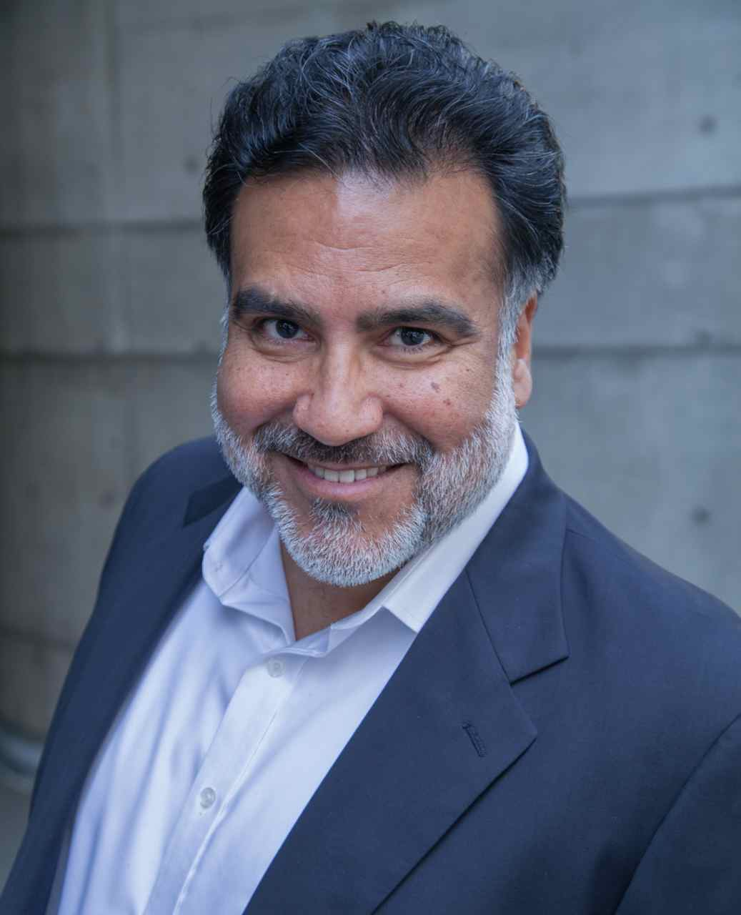
Phillip Rodriguez (Director/Producer/Writer) is an award-winning documentary filmmaker and veteran content provider for PBS. His films bring to light the complexities of Latino culture, history and identity at a time when our nation’s demographics reflect unprecedented growth in the Latino community and the concomitant demand for relevant storytelling.

Rodriguez’s investigative documentary Ruben Salazar: Man in the Middle explores the life and mysterious death of the pioneering journalist and won Best Documentary at the 2014 San Antonio CineFestival and the 2014 Denver XicanIndie Festival. RACE 2012: A Conversation About Race and Politics in America was awarded a 2013 CINE Golden Eagle Award in the Best Televised News Division – Informational/Current Issue category. Latinos ’08 received a 2009 CINE Golden Eagle Award for Best News Analysis. Brown Is the New Green: George Lopez and the American Dream was awarded the 2008 Imagen Award for Best TV Documentary. Rodriguez’s other critically acclaimed films include Los Angeles Now, Mixed Feelings: San Diego/Tijuana, Manuel Ocampo: God Is My Copilot and Pancho Villa & Other Stories.

In 2006, Rodriguez received the first annual United States Artists Broad Fellow Award. This award honors the country’s most accomplished and innovative artists. A graduate of U.C. Berkeley, he holds an M.A. in Latin American Studies (Honors) and an M.F.A. in Film and Television from UCLA. His fellowships have included Senior Fellow at The Dorothy Leavy Center for the Study of Los Angeles at Loyola Marymount University, Fellow for Documentary Filmmaking at the Institute for Justice and Journalism at the USC Annenberg School for Communication and Journalism, and Senior Fellow at the USC Annenberg School for Communication and Journalism.

