
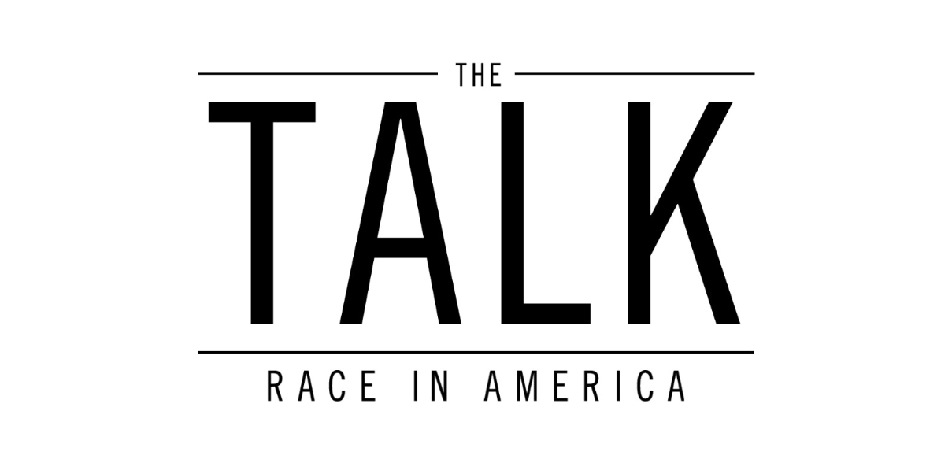


WNET Contact:
Donna Williams, 212-560-8030
Williamsd@wnet.org

Press materials: http://pressroom.pbs.org or http://www.thirteen.org/13pressroom

THIRTEEN’s The Talk – Race in America
Tackles the Issue of Young People of Color and Their Uneasy Encounters With Law Enforcement
Monday, February 20, 9 p.m. on PBS
The all-too-familiar conversation that black and Latino parents have with their children reveals the current state of race relations in America

The Talk – Race in America is a two-hour documentary about the increasingly common conversation taking place in homes and communities across the country between parents of color and their children, especially sons, about how to behave if they are ever stopped by the police. In many homes, “the talk,” as it is called, usually contains phrases like this:

If you are stopped by the police:
Always answer “yes sir, no sir”; never talk back; don’t make any sudden movements; don’t put your hands in your pockets; obey all commands; if you think you are falsely accused, save it for the police station. I would rather pick you up at the station than the morgue…

The Talk – Race in America, a multiplatform media initiative, airs Monday, February 20 at 9 p.m. on PBS. (Check local listings). The film will present six personal stories to illustrate the issue from multiple points of view: parent, child, the police and the community. Filmed across the country, in communities including Long Beach, California; Oakland, California; St. Louis, Missouri; Richland County, South Carolina; Memphis, Tennessee; and Cleveland, Ohio, the stories will include interviews with academics, police force members, community activists and family members.
Among those profiled are activist and founder of The Ethics Project, Dr. Christi Griffin, who, after living through the traumatic events of Ferguson, created “Parent 2 Parent,” a series of conversations with black parents talking with white parents about “the talk” with their black sons; Samaria Rice, mother of Tamir Rice, who was a 12-year-old boy killed by the Cleveland police while playing with a toy gun in a local park; Reverend Catherine Brown, who was assaulted by Chicago Police in front of her children in her own car; Trevena Garel, retired sergeant, New York City Police Department (NYPD), who has investigated allegations of misconduct involving both uniformed and/or civilian members of the NYPD; Eric Adams, Brooklyn Borough President and retired officer, New York City Police Department (NYPD); the Ramirez family, whose 28-year-old son, Oscar, was shot and killed by a Los Angeles County sheriff in Paramount, California, a community southeast of Los Angeles; and members of the South Carolina Criminal Justice Academy, who share the protocols for using lethal force and describe the danger from a police officer’s point of view.
In addition, sharing their own stories are Kenya Barris, creator/executive producer of Peabody Award-winning ABC series black-ish; Nas, musician/activist (Illmatic, Life Is Good, Untitled); Rosie Perez, actor/director, activist (Do the Right Thing, White Men Can’t Jump, Fearless, Pineapple Express); John Singleton, director/screenwriter/producer (Boyz N the Hood, 2 Fast 2 Furious, Baby Boy, Poetic Justice, Hustle and Flow); and Charles Blow, New York Times columnist.
Each story is produced by a different filmmaker to ensure that diverse perspectives are presented. The project’s director and supervising producer, filmmaker Sam Pollard, an Academy Award nominee and multiple Emmy Award winner, and Academy Award nominee Julie Anderson, closely oversaw the producers and managed the overall creative look, storytelling and structure.
Geeta Gandbhir, Shola Lynch, One9, Erik Parker, Llewellyn M. Smith and Jennifer Maytorena Taylor are the segment producers. Sandie Pedlow is executive producer for Latino Public Broadcasting. Sam Pollard is the director and supervising producer. Julie Anderson is the producer and executive producer. Stephen Segaller is the executive-in-charge.
The Talk – Race in America is funded by the Corporation for Public Broadcasting and produced by THIRTEEN Productions LLC for WNET, in association with Latino Public Broadcasting.
###
About WNET
WNET is America’s flagship PBS station and parent company of THIRTEEN and WLIW21. WNET also operates NJTV, the statewide public media network in New Jersey. Through its broadcast channels, three cable services (KidsThirteen, Create and World) and online streaming sites, WNET brings quality arts, education and public affairs programming to more than five million viewers each week. WNET produces and presents such acclaimed PBS series as Nature, Great Performances, American Masters, PBS NewsHour Weekend, Charlie Rose and a range of documentaries, children’s programs, and local news and cultural offerings. WNET’s groundbreaking series for children and young adults include Get the Math, Oh Noah! and Cyberchase as well as Mission US, the award-winning interactive history game. WNET highlights the tri-state’s unique culture and diverse communities through NYC-ARTS, Reel 13, NJTV News with Mary Alice Williams and MetroFocus, the daily multi-platform news magazine focusing on the New York region. In addition, WNET produces online-only programming including the award-winning series about gender identity, First Person, and an intergenerational look at tech and pop culture, The Chatterbox with Kevin and Grandma Lill. In 2015, THIRTEEN launched Passport, an online streaming service which allows members to see new and archival THIRTEEN and PBS programming anytime, anywhere: www.thirteen.org/passport.

About CPB
The Corporation for Public Broadcasting (CPB), a private, nonprofit corporation created by Congress in 1967, is the steward of the federal government’s investment in public broadcasting. It helps support the operations of nearly 1,500 locally owned and operated public television and radio stations nationwide. CPB is also the largest single source of funding for research, technology and program development for public radio, television and related online services. For more information, visit cpb.org, follow us on Twitter @CPBmedia, Facebook and LinkedIn for updates
About PBS

PBS, with nearly 350 member stations, offers all Americans the opportunity to explore new ideas and new worlds through television and online content. Each month, PBS reaches nearly 100 million people through television and nearly 33 million people online, inviting them to experience science, history, nature and public affairs; to hear diverse viewpoints; and to take front row seats to world-class drama and performances. PBS’ broad array of programs has been honored consistently by the industry’s most coveted award competitions. Teachers from pre-K through 12th grade turn to PBS for digital content and services that help bring classroom lessons to life. PBS’ premier children’s TV programming, and its website pbskids.org, are parents’ and teachers’ most-trusted partners in inspiring and nurturing curiosity and the love of learning in children. More information about PBS is available at PBS.org — one of the leading dot-org websites on the Internet — or by following PBS on Twitter, Facebook or through apps for mobile devices. Specific program information and updates for press are available at pbs.org/pressroom or by following PBS Pressroom on Twitter.

02.07.17

