PBS Presents a Robust Drama Collection This Fall
with Six New Premieres

MASTERPIECE Debuts Three Thrillers Including “Roadkill” Starring Hugh Laurie on November 1
LAST TANGO IN HALIFAX Makes Its Long-Awaited Return September 20

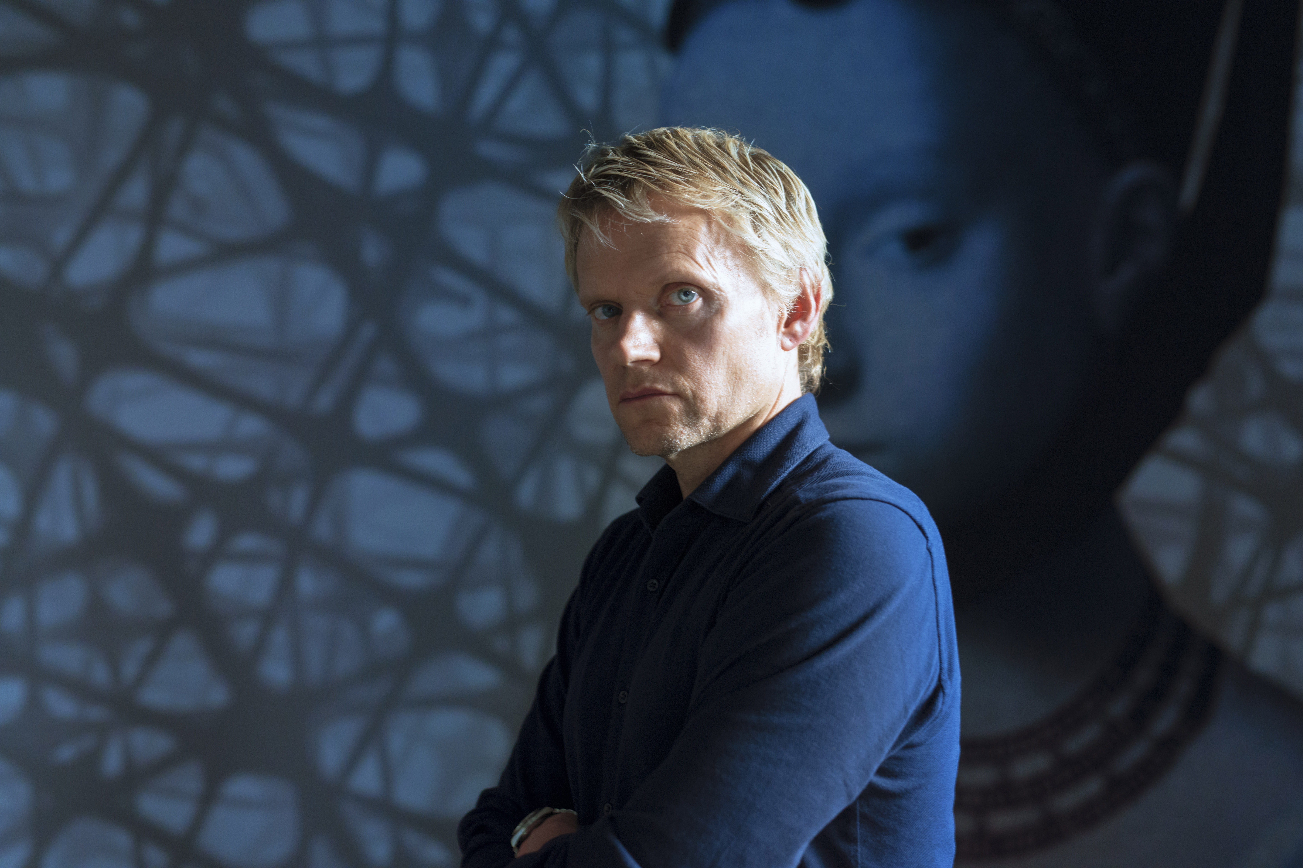
MARC WARREN as VAN DER VALK
Credit: © Company Pictures and all3media international
ARLINGTON, VA; JULY 22, 2020 -- Today, PBS announced an extensive fall Sunday night lineup of six new series packed with action, love, mystery, betrayal and, most of all, drama. MASTERPIECE debuts three new programs, including the story of a Dutch detective in VAN DER VALK, featuring Marc Warren; and political thriller ROADKILL, starring Hugh Laurie as a corrupt minister. PBS also presents the Season 4 return of the beloved LAST TANGO IN HALIFAX, and the premiere of THE TROUBLE WITH MAGGIE COLE, about a gossip-filled village with a self-appointed oracle.

Full list of programs coming to MASTERPIECE on PBS:

VAN DER VALK ON MASTERPIECE – Sundays, September 13-27, 9:00 p.m. ET
Set in Amsterdam, the series follows the work of Commisaris Van der Valk (played by Marc Warren, “The Good Wife”), a street-smart and unapologetic Dutch detective who navigates the lively and enigmatic city, solving mysterious crimes using astute human observation and inspired detection.

FLESH AND BLOOD ON MASTERPIECE – Sundays, October 4-25, 9:00 p.m. ET
The lives of three siblings (Claudie Blakley, Russell Tovey, Lydia Leonard) are disrupted when their recently widowed mother (Francesca Annis) declares she's in love with a new man (Stephen Rea). The older woman's budding romance provokes suspicion among her adult children and their inquisitive next-door neighbor (Imelda Staunton), and a detective (David Bamber) investigates whether an unfortunate incident was an accident or a heinous crime.

ROADKILL ON MASTERPIECE – Sundays, November 1-22, 9:00 p.m. ET
Ambition knows no bounds, nor does corruption in a political thriller starring Hugh Laurie as a scheming UK government minister. Scripted by two-time Academy Award nominee David Hare, “Roadkill” airs in four action-packed episodes and costars Helen McCrory, Saskia Reeves, Pip Torrens and Patricia Hodge. Crime may not pay, but
politics sure does.

L-R: CAROLINE (Sarah Lancashire), CELIA (Anne Reid), ALAN (Derek Jacobi) and GILLIAN (Nicola Walker)
Credit: Matt Squire

Additional drama programs coming to PBS:

LAST TANGO IN HALIFAX Season 4 – Sundays, September 20-October 11, 8:00 p.m. ET
After seven years of marriage, Alan and Celia discover that wedded bliss isn’t always blissful. Clashing politics, Alan’s new job and a wild local lad create tension. Caroline gets emotionally embroiled at work. Alan’s brother visits.

COBRA – Sundays, October 4-November 8, 10:00 p.m. ET
Follow the British Prime Minister and his Cabinet Office Briefing Room A (COBRA) committee, comprised of leading contingency planners and senior politicians, as they navigate the difficulties in overcoming a major national crisis.

THE TROUBLE WITH MAGGIE COLE – Sundays, October 18-November 22, 8:00 p.m. ET
See what happens when idle gossip escalates out of control and starts to affect people’s lives. Set in a picturesque fishing village, the series centers on Maggie Cole, the self-appointed oracle of this close-knit community.

Full episodes of PBS programming will stream for free following each broadcast and be available for two weeks on all station-branded PBS platforms, including PBS.org and the PBS Video App, available on iOS, Android, Roku, Apple TV, Amazon Fire TV, Samsung Smart TV and Chromecast. Following the two weeks, PBS station members can view episodes via Passport (contact your local PBS station for details).
About PBS
PBS, with more than 330 member stations, offers all Americans the opportunity to explore new ideas and new worlds through television and digital content. Each month, PBS reaches over 120 million people through television and 26 million people online, inviting them to experience the worlds of science, history, nature and public affairs; to hear diverse viewpoints; and to take front row seats to world-class drama and performances. PBS’ broad array of programs has been consistently honored by the industry’s most coveted award competitions. Teachers of children from pre-K through 12th grade turn to PBS for digital content and services that help bring classroom lessons to life. Decades of research confirms that PBS’ premier children’s media service, PBS KIDS, helps children build critical literacy, math and social-emotional skills, enabling them to find success in school and life. Delivered through member stations, PBS KIDS offers high-quality educational content on TV – including a 24/7 channel, online at pbskids.org, via an array of mobile apps and in communities across America. More information about PBS is available at www.pbs.org, one of the leading dot-org websites on the internet, or by following PBS on Twitter, Facebook or through our apps for mobile and connected devices. Specific program information and updates for press are available at pbs.org/pressroom or by following PBS Pressroom on Twitter.

– PBS –

CONTACTS:

Lara Davidson, PBS, 703-739-5115; lkdavidson@pbs.org

Ellen Dockser, MASTERPIECE, 617-300-5338; ellen_dockser@wgbh.org

Laura Garvey, MASTERPIECE, 617-300-5342; laura_garvey@wgbh.org

For images and additional up-to-date information on this and other PBS programs, visit PBS PressRoom at pbs.org/pressroom.

