PBS Announces Third and Final Season of British Crime Series
THE TUNNEL to Premiere on Sunday, July 1, 2018

– THE TUNNEL: VENGEANCE Will Be Made Available For Streaming
Simultaneously With PBS Broadcast –

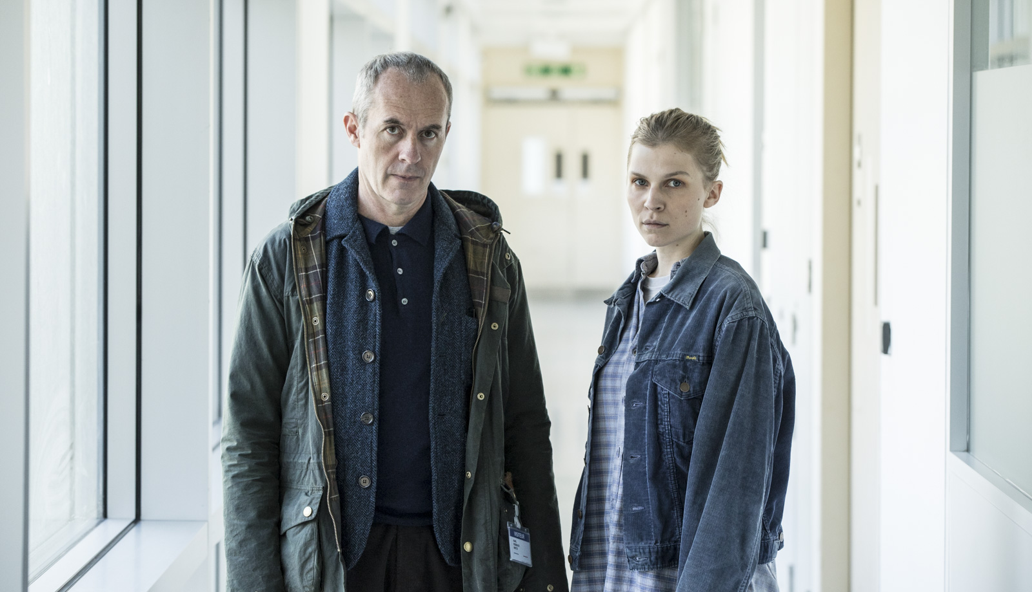
Stephen Dillane as Karl and Clémence Poésy as Elise
Courtesy of Kudos Film & Television Limited 2017
ARLINGTON, VA; May 22, 2018 – PBS announced today that the multi-award winning British crime drama THE TUNNEL will return for a third season, titled THE TUNNEL: VENGEANCE. The six-part series will air on PBS beginning Sunday, July 1, 2018, 10:30-11:30 p.m. ET and will stream nationally on PBS station platforms simultaneously (check local listings).

The emotional final season of the critically acclaimed bilingual crime thriller reunites Stephen Dillane (“Game of Thrones”) in his International Emmy Award-winning role as Karl Roebuck with Clémence Poésy (Harry Potter and the Deathly Hallows: Part II) as Elise Wassermann for the last outing of this beloved and unlikely Anglo-French partnership.

In THE TUNNEL: VENGEANCE, the investigative pair takes on a toxic and terrifying folie à deux whose mutual defining quality is an existential death wish. When the question posed by the couple – what is a life worth? – is directed straight back at Karl, he is forced to confront an utterly impossible choice that will haunt the audience long after the closing credits.

Set amidst mid-Brexit hysteria, THE TUNNEL: VENGEANCE tackles an escalating refugee crisis and examines the increasing threat of terror occasioned by disenfranchised, exiled souls on whom society has turned its back.

Last summer, season 2, THE TUNNEL: SABOTAGE, had 1.1 million streams across PBS digital platforms, making it one of the most-streamed drama limited series on PBS. (Source: Google Analytics). The season reached more than 2.8 million unique viewers on broadcast television. (Source: Nielsen Live+7 8-episode P2+ program reach estimates, 6 min. qualifier.)

THE TUNNEL: VENGEANCE is written by Emilia Di Girolamo, Louise Ironside, Jamie Crichton and John Jackson. Executive producers include Karen Wilson, Manda Levin and Emilia Di Girolamo. The series is produced by Toby Welch and directed by Anders Engström and Gilles Bannier. Music is by Ben Bartlett.The series is based on the original Swedish series “The Bridge,” created by Hans Rosenfeldt, Måns Mårlind, Björn Stein and produced by Filmlance, Nimbus Film Productions A/S, Sveriges Television AB, Film | Skåne AB, Film | Väst AB, Norsk Kringrikskastning AS and Dr Medier A/S.

Full episodes of THE TUNNEL: VENGEANCE will stream for free simultaneously with each broadcast and be available for two weeks on all station-branded PBS platforms, including PBS.org and PBS apps for iOS, Android, Roku, Apple TV, Amazon Fire TV and Chromecast. PBS station members can binge all episodes via Passport on July 1 (contact your local PBS station for details).

THE TUNNEL: VENGEANCE will be available on DVD from PBS Distribution and can be purchased at ShopPBS.org. The series will also be available for digital download.

About PBS
PBS, with nearly 350 member stations, offers all Americans the opportunity to explore new ideas and new worlds through television and digital content. Each month, PBS reaches over 90 million people through television and 30 million people online, inviting them to experience the worlds of science, history, nature and public affairs; to hear diverse viewpoints; and to take front row seats to world-class drama and performances. PBS’ broad array of programs has been consistently honored by the industry’s most coveted award competitions. Teachers of children from pre-K through 12th grade turn to PBS for digital content and services that help bring classroom lessons to life. Decades of research confirms that PBS’ premier children’s media service, PBS KIDS, helps children build critical literacy, math and social-emotional skills, enabling them to find success in school and life. Delivered through member stations, PBS KIDS offers high-quality educational content on TV – including a 24/7 channel, online at pbskids.org, via an array of mobile apps and in communities across America. More information about PBS is available at www.pbs.org, one of the leading dot-org websites on the internet, or by following PBS on Twitter, Facebook or through our apps for mobile and connected devices. Specific program information and updates for press are available at pbs.org/pressroom or by following PBS Pressroom on Twitter.
– PBS –

CONTACTS:
Missy Greenberg, DKC, 212-981-5121; Missy_Greenberg@dkcnews.com
Lara Davidson, PBS, 703-739-5115; lkdavidson@pbs.org

For images and additional up-to-date information on this and other PBS programs, visit PBS PressRoom at pbs.org/pressroom.

