TIANANMEN: THE PEOPLE VERSUS THE PARTY
Premieres Tuesday, June 25, 2019
9:00-11:00 p.m. ET on PBS

Scheduled in Conjunction with the 30th Anniversary of the Tiananmen Square Massacre, the Documentary Tells the Story of the Pro-Democracy Movement and Demonstration That Ended With Brutal Violence and Set the Stage for Modern-Day China

ARLINGTON, VA; June 5, 2019 – On the night of June 4, 1989, Chinese troops entered Tiananmen Square in Beijing, violently crushing the largest pro-democracy demonstrations in the history of the Communist regime. Images from those final bloody days still resonate today and the death toll — from the official Chinese figure of 300 to estimates as high as 15,000 — continues to be disputed. Scheduled in conjunction with the 30th anniversary of the uprising, TIANANMEN: THE PEOPLE VERSUS THE PARTY is a day-by-day account of the dramatic seven weeks during which students and ordinary Chinese citizens made a stand for more freedom — a protest with ramifications that would shape the future of the modern superpower. Directed and co-written by Ian MacMillan, the film premieres Tuesday, June 25, 9:00-11:00 p.m. ET (check local listings) on PBS, PBS.org and the PBS Video App.
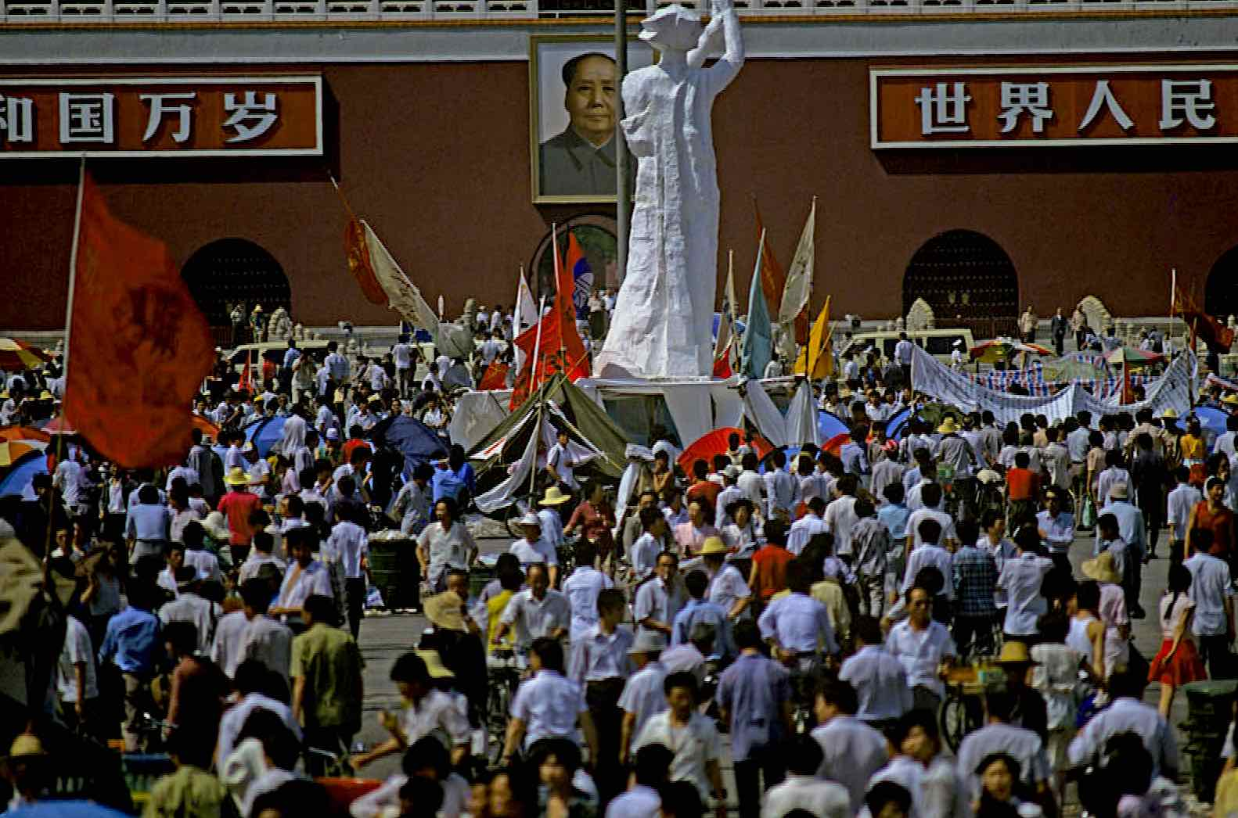
Credit: Courtesy of PBS.

Unfolding with the drama of a political thriller, the film investigates how a peaceful student protest calling for liberty ended seven weeks later in carnage, documenting the many turning points when the violence could have been avoided but tragically was not. With never-before-seen Chinese television archival footage and exclusive interviews with key insiders — from protest leaders and students to politburo members — TIANANMEN: THE PEOPLE VERSUS THE PARTY reveals the scale of the 1989 protest, its aims, the military crackdown and the aftermath.

The in-depth research includes an exclusive, secretly filmed interview with a high ranking Communist Party insider who was an eyewitness to the inner debate within the halls of power that led to the massacre; extensive access to the documents known as The Tiananmen Papers, Chinese government and Party records revealing the decisions made by increasingly-panicked leaders; and gripping and emotional testimony from a diverse range of protesters, eyewitnesses and key contributors, several of whom were in the thick of the drama on the square throughout June 3 and 4 as the massacre unfolded.

Featured interviewees include Perry Link and Andrew Nathan, editors of The Tiananmen Papers, and student leaders Shen Tong, Wuer Kaixi, Wang Dan, Rose Tang and others. Through their testimony, the film reveals the complex story of those tumultuous seven weeks that became nothing less than the battle for the soul of a nation.

TIANANMEN: THE PEOPLE VERSUS THE PARTY is directed by Ian MacMillan and written by MacMillan and Audrey Maurion. The film is produced by Christophe Nick and Ed Stobart.

About the Filmmaker
Ian MacMillan (Director/Co-Writer) is an award-winning filmmaker based in London, specializing in documentaries that reflect his passionate interest in culture and history. He most recently produced CIVILIZATIONS, the landmark nine-part survey of global art for PBS. He has been widely recognized as one of the leading filmmakers in his field, with a string of awards from the Royal Television Society in the UK, the Grierson Trust, and two BAFTAs (the UK equivalent of the Emmy Award).

About PBS
PBS, with more than 330 member stations, offers all Americans the opportunity to explore new ideas and new worlds through television and digital content. Each month, PBS reaches over 120 million people through television and 26 million people online, inviting them to experience the worlds of science, history, nature and public affairs; to hear diverse viewpoints; and to take front row seats to world-class drama and performances. PBS’ broad array of programs has been consistently honored by the industry’s most coveted award competitions. Teachers of children from pre-K through 12th grade turn to PBS for digital content and services that help bring classroom lessons to life. Decades of research confirms that PBS’ premier children’s media service, PBS KIDS, helps children build critical literacy, math and social-emotional skills, enabling them to find success in school and life. Delivered through member stations, PBS KIDS offers high-quality educational content on TV – including a 24/7 channel, online at pbskids.org, via an array of mobile apps and in communities across America. More information about PBS is available at www.pbs.org, one of the leading dot-org websites on the internet, or by following PBS on Twitter, Facebook or through our apps for mobile and connected devices. Specific program information and updates for press are available at pbs.org/pressroom or by following PBS Pressroom on Twitter.

- PBS -
PRESS CONTACTS:
Atiya Frederick, PBS
anfrederick@pbs.org

Cara White / Mary Lugo, CaraMar, Inc.
cara.white@mac.com; lugo@negia.net

PBS STATION CONTACT:
Sydney Cameron, PBS
sgcameron@pbs.org

For further information and photos visit http://www.pbs.org/pressroom.

