TIME SCANNERS to Premiere July 1, 2014 on PBS
Three-Part Series Airs Tuesdays, July 1 to 15, 8:00-9:00 p.m. ET

– Groundbreaking New Series Uncovers the Engineering Mysteries of the
Ancient World’s Most Iconic Structures for the First Time –

– Series Leads Into HISTORY DETECTIVES SPECIAL INVESTIGATIONS –

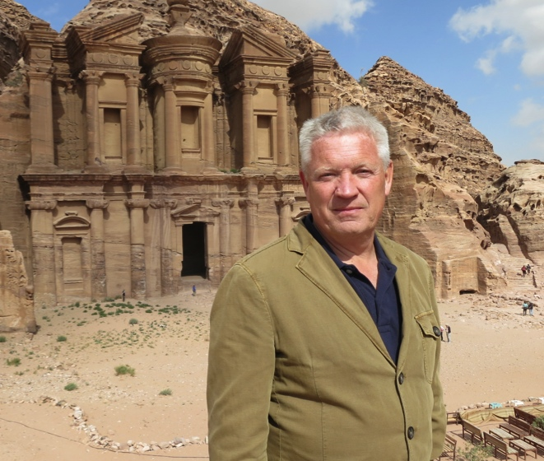
Steve Burrows in front of the Monastery at Petra. (Credit: Oliver Graham/Atlantic Productions)
With cutting-edge technology that can “read” buildings, ruins and landscapes from ancient worlds, TIME SCANNERS, a three-part series premiering July 1, 2014, at 8:00 p.m. ET on PBS, reveals physical and forensic history, allowing viewers to reach out and touch the past. Paving the way for an exciting new approach to documentary filmmaking, new laser technology explores the world’s most iconic sites in a way never before seen, surprising even the experts. Steve Burrows, one of the world’s foremost structural engineers - and the brains behind the famous Bird’s Nest Stadium in Beijing - leads a team of investigators, including pioneering laser-scanning researchers, to unlock the secrets of the world’s greatest engineering achievements. Hosted by Dallas Campbell (“Bang Goes the Theory”), each episode provides unprecedented answers to the scientific secrets behind the historical landmarks. Also debuting on July 1 is HISTORY DETECTIVES SPECIAL INVESTIGATIONS at 9:00 p.m.

TIME SCANNERS premieres with “Egyptian Pyramids” on July 1. The team travels to Egypt to scan the pyramids — the tombs of the mighty pharaohs — to find out how the necropoles evolved from simple mud-brick structures to the most impressive buildings in the ancient world. They use their laser technology to scan Djoser’s Step Pyramid at Saqqara, Meidum’s collapsed pyramid, the mysterious Bent Pyramid at Dashur and the famous Great Pyramid at Giza, and finally establish the true location of the King’s Burial Chamber in the Great Pyramid.

On July 8, Burrows takes his team of experts to “St Paul’s Cathedral” in London, famed as the location of the marriage of Prince Charles and Lady Diana Spencer. They venture inside the majestic dome to explore its groundbreaking three-part structure; determine how the cathedral’s architect, Sir Christopher Wren, overcame unstable foundations and immense structural forces to support his dome; and investigate how the cathedral survived a direct hit by a German bomb during the London Blitz. The laser scans produce genuine revelations and give the team new insight into this iconic architectural masterpiece.

The final installment “Petra” premieres on July 15 with the team of laser-scanning experts venturing to Jordan to scan the ancient desert city of Petra. Using 3D laser-scanning technology, Burrows wants to uncover the city’s construction secrets and shed new light on this architectural wonderland lost to the West for more than 1,000 years. How did Nabatean stonemasons carve Petra’s largest building – the Monastery – out of a mountainside? And what lies hidden underneath the city?

At 9:00 p.m., HISTORY DETECTIVES SPECIAL INVESTIGATIONS (HDSI) delves into the past to explore some of America’s most intriguing mysteries. Four episodes introduce the fresh perspective of a new detective and focus on a single story per hour. In each episode, veteran detectives Tukufu Zuberi and Wes Cowan join forces with new host Kaiama Glover to prove a single iconic mystery from America’s past. The reformatted eleventh season of HISTORY DETECTIVES airs Tuesdays, July 1-22, 2014, 9:00-10:00 p.m. ET.

TIME SCANNERS is produced by Atlantic Productions. Lara Acastar is the series producer. Anthony Geffen is executive producer.

About The Center for Advanced Spatial Technologies (CAST)
The Center for Advanced Spatial Technologies (CAST), located at the University of Arkansas, focuses on research, education, and outreach related to geoinformatics and geomatics. Specific areas of research in these fields include GIS, geospatial analysis and modeling, high density survey, enterprise spatial databases, remote sensing, digital photogrammetry, and geospatial data and model interoperability.

About Atlantic Productions
Atlantic is now part of a group of companies which covers television, theatrical and IMAX films, apps and computer graphics. For the last 4 years, it has been making ground breaking 4K productions and 3D films. Their films have won some of the most coveted awards and been seen in over 100 countries worldwide. Extensive television work include the BAFTA-winning “Flying Monsters 3D”; the triple Emmy-winning “First Life” series (BBC/Discovery), the BAFTA-nominated series “Kingdom of Plants” and the series “Rise of Animals” - all with David Attenborough; the Emmy-winning “Jerusalem: City of Heaven” (Discovery); the acclaimed PBS/BBC series “The Greeks: Crucible of Civilisation” and “Holy Warriors: Richard the Lionheart and Saladin”; the landmark series “The Promised Land” and “The American Dream” (BBC/Discovery); BAFTA-nominated “Munich: Mossad’s Revenge” (C4/Discovery); “Lost Worlds” series (History), “Secrets of Egypt” (National Geographic).

About PBS
PBS, with its over 350 member stations, offers all Americans the opportunity to explore new ideas and new worlds through television and online content. Each month, PBS reaches nearly 109 million people through television and over 28 million people online, inviting them to experience the worlds of science, history, nature and public affairs; to hear diverse viewpoints; and to take front row seats to world-class drama and performances. PBS’ broad array of programs has been consistently honored by the industry’s most coveted award competitions. Teachers of children from pre-K through 12th grade turn to PBS for digital content and services that help bring classroom lessons to life. PBS’ premier children’s TV programming and its website, pbskids.org, are parents’ and teachers’ most trusted partners in inspiring and nurturing curiosity and love of learning in children. More information about PBS is available at www.pbs.org, one of the leading dot-org websites on the Internet, or by following PBS on Twitter, Facebook or through our apps for mobile devices. Specific program information and updates for press are available at pbs.org/pressroom or by following PBS PressRoom on Twitter.

– PBS –

For additional information, photos, interviews and more, contact Goodman Media or PBS:

Meghan Newton / Roberta Lee, Goodman Media International for PBS
212-576-2700
PBSProgramming@goodmanmedia.com

Jessie Yuhaniak, PBS, 703-739-5364; jayuhaniak@pbs.org

For images and additional up-to-date information on this and other PBS programs, visit PBS PressRoom at pbs.org/pressroom.

