TIME TEAM AMERICA Unlocks the Secrets of America’s Past

Airs Tuesdays, August 19 and 26, 2014, 9:00 p.m. ET on PBS

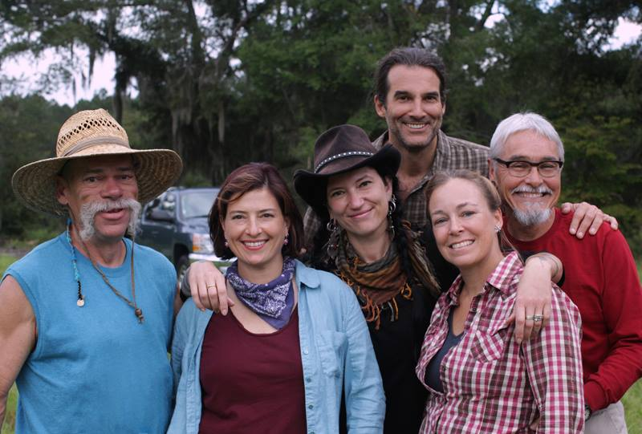
The Time Team (from left: Jeff Brown, Justine Shapiro, Chelsea Rose, Alan Maca, Meg Watters, and Joe Watkins) takes viewers back through time to help solve America’s greatest archaeological mysteries
Credit: Tracey Whitney
ARLINGTON, VA; [DATE], 2014 -- TIME TEAM AMERICA, the PBS series that combines archaeological discovery with good storytelling, is back for a gripping second season. Each of the four new episodes explores a different region and time in U.S. history through the eyes, ears and expertise of a team of adventurous archaeologists. The first two episodes of TIME TEAM AMERICA debut Tuesday, August 19, 2014, followed by the second two on August 26, 9:00 p.m. ET on PBS.

In each one-hour episode of TIME TEAM AMERICA, scientists Joe Watkins, Allan Maca, Meg Watters, Jeff Brown and Chelsea Rose join forces with host Justine Shapiro to uncover historical secrets buried beneath the soil. The series combines technologically advanced tools and old-fashioned elbow grease to take viewers on a journey into the earth and back in time.

“We’re thrilled to be back for a second season of this terrific series,” says co-executive producer David Davis. “There’s nothing else quite like it on TV. Viewers will feel they are right in the trenches with working archeologists as they uncover the artifacts of our past.”

Here’s what’s in store for the Time Team in season two:

• Tucked between upscale homes in suburban Maryland just outside Washington, DC, are the remains of an 1830’s plantation — once home to Josiah Henson, the slave who inspired Harriet Beecher Stowe’s famous novel Uncle Tom’s Cabin. What remains here of his life and legacy?

• In western Oklahoma, the bones of massive 10,000-year-old bison mingle with the remnants of early man-made weapons. What strategies did hunters use against these mammoth beasts before the advent of bows and arrows? What can these bison bones teach us about our ancient past?

• Camp Lawton, near Milan, Georgia, housed 10,000 Union prisoners at the end of the Civil War. The remains of the camp have long been lost to history. Can TIME TEAM AMERICA find the original site of the camp? What artifacts are buried beneath the ground and what do they tell us of the hellish experiences of the prisoners once held captive here?

• The site of what is believed to have been a 1,200-year-old village is located near Mesa Verde, Colorado, where ancient peoples built one of the first permanent settlements in North America. What did this settlement look like and how did life here shape human history?

The hosts of TIME TEAM AMERICA are:
- Justine Shapiro, documentary filmmaker and television host;
- Dr. Joe Watkins, lead archaeologist;
- Dr. Meg Watters, remote sensing and visualization specialist;
- Dr. Allan Maca, archaeologist;
- Chelsea Rose, archaeologist; and
- Jeff Brown, excavator.

View past episodes of TIME TEAM AMERICA online at pbs.org/time-team. TIME TEAM AMERICA is a co-production of Oregon Public Broadcasting and Videotext Communications, Ltd. and is supported by a grant from the National Science Foundation. The co-executive producer for OPB is David Davis and the co-executive producer for Videotext is Tim Taylor.

About OPB
OPB is the largest cultural and education institution in Oregon and southern Washington, delivering excellence in public broadcasting to 1.5 million people each week through television, radio and the Internet. Widely recognized as a national leader in the public broadcasting arena, OPB is a major contributor to the program schedule that serves the entire country. OPB is one of the most-used and most-supported public broadcasting services in the country and is generously supported by its members.

About PBS
PBS, with its over 350 member stations, offers all Americans the opportunity to explore new ideas and new worlds through television and online content. Each month, PBS reaches nearly 109 million people through television and over 28 million people online, inviting them to experience the worlds of science, history, nature and public affairs; to hear diverse viewpoints; and to take front row seats to world-class drama and performances. PBS’ broad array of programs has been consistently honored by the industry’s most coveted award competitions. Teachers of children from pre-K through 12th grade turn to PBS for digital content and services that help bring classroom lessons to life. PBS’ premier children’s TV programming and its website, pbskids.org, are parents’ and teachers’ most trusted partners in inspiring and nurturing curiosity and love of learning in children. More information about PBS is available at www.pbs.org, one of the leading dot-org websites on the Internet, or by following PBS on Twitter, Facebook or through our apps for mobile devices. Specific program information and updates for press are available at pbs.org/pressroom or by following PBS PressRoom on Twitter.

– PBS –

CONTACTS:
Kelsey Wallace, Oregon Public Broadcasting, 503-445-1893; kwallace@opb.org

Carrie Johnson, PBS, 703-739-5129; cjohnson@pbs.org

For images and additional up-to-date information on this and other PBS programs, visit PBS PressRoom at pbs.org/pressroom.

