

FOR IMMEDIATE RELEASE CONTACTS: George Hazimanolis
December 4, 2018 412-622-1366
ghaziman@wqed.org

Michaé Godwin
PBS
mmgodwin@pbs.org

WQED Production of Pittsburgh Symphony Orchestra
Tree of Life: A Concert for Peace and Unity
to Air Nationally on PBS
Tuesday, December 11 at 8:00 p.m. ET

Renowned Violinist Itzhak Perlman Joins the Pittsburgh Symphony Orchestra,
PSO Music Director Manfred Honeck, PSO Principal Clarinetist Michael Rusinek and the Mendelssohn Choir of Pittsburgh in Remembrance of Tree of Life Victims

PITTSBURGH, PA and ARLINGTON, VA -- PBS will broadcast nationally WQED’s locally-produced Tree of Life: A Concert for Peace and Unity, a free community event, presented and hosted by the Pittsburgh Symphony Orchestra to honor the Tree of Life Synagogue victims and first responders. The performance, featuring Itzhak Perlman at Pittsburgh’s Heinz Hall, was taped on November 27, one month after the tragedy, as part of the PSO’s “Music for the Spirit” series.
Made possible with support from the Corporation for Public Broadcasting (CPB), Tree of Life: A Concert for Peace and Unity, a one-hour special, will air nationwide on PBS stations on Tuesday, December 11 at 8:00 p.m. (*check local listings)

Thirty second promo: https://www.youtube.com/watch?v=D3JS9hNEKIQ

Tree of Life: A Concert for Peace and Unity will stream on PBS.org and on the PBS Facebook page concurrently with the broadcast. The concert will also be available for streaming after broadcast on station-branded PBS platforms, including PBS.org and PBS apps for iOS, Android, Roku, Apple TV, Amazon Fire TV and Chromecast.

The Pittsburgh Symphony Orchestra’s special concert evening of remembrance and reverence brought the Pittsburgh community together to find comfort, strength and solace through music, hope and unity.

“This was public media at its finest, celebrating community and hope over evil,” said CPB President and CEO Pat Harrison. “The voices of this community from the Chief of Police to those who were directly impacted by the attack on the Tree of Life Synagogue, affirmed that hatred can’t weaken the city of steel. Pittsburgh ‘strong’ is a reality and reflected through the partnership among WQED, the PSO, and local police, government and diverse religious leaders.”

“Through our production of this Pittsburgh Symphony Orchestra concert, we hope to inspire healing and to repay the kindness the world has shown Pittsburgh during the city’s darkest days in the aftermath of the tragedy,” said WQED President and CEO, Deborah L. Acklin. “The community collaboration on this project was extraordinary. The Corporation for Public Broadcasting was able to quickly fund this project so that the people of Pittsburgh, through the Pittsburgh Symphony Orchestra, could thank the world for their support and share an evening of solace with the nation.”
Renowned Israeli-American violinist Itzhak Perlman joins Music Director Manfred Honeck, the Pittsburgh Symphony Orchestra, PSO Principal Clarinetist Michael Rusinek and the Mendelssohn Choir of Pittsburgh. All artists graciously donated their services for this performance.
The performance features the following works:
Maurice Ravel: “Kaddish” from Deux Mélodies Hébraïques for Clarinet and String Orchestra
Dmitri Shostakovich: “Largo“ from Symphony No. 5 in D minor, Opus 47
David Zehavi (arr. Pigovat): Eli, Eli (“My God, My God”), A Walk to Caesarea
Felix Mendelssohn: "Lift Thine Eyes to the Mountains" from Elijah
Johannes Brahms: Ein deutsches Requiem (A German Requiem)
Opus 45 IV. Wie lieblich sind deine Wohnungen
John Williams: Three Pieces from Schindler's List for Violin and Orchestra
Edward Elgar: "Nimrod" from Variations on an Original Theme, “Enigma”, Opus 36

“It is our hope that the Concert for Peace and Unity brings a sense of peace and healing in the wake of unimaginable tragedy,” said Paula Kerger, President & CEO, PBS. “We thank the Corporation for Public Broadcasting and WQED for partnering with PBS to share this beautiful tribute with a national audience.”

“As advocates of peace, tolerance and understanding, the Pittsburgh Symphony Orchestra brings people together through the universal power of music to collectively grieve and heal after this horrific tragedy, both locally and across the country” added PSO Music Director Manfred Honeck.


Images are available on PBS PressRoom.

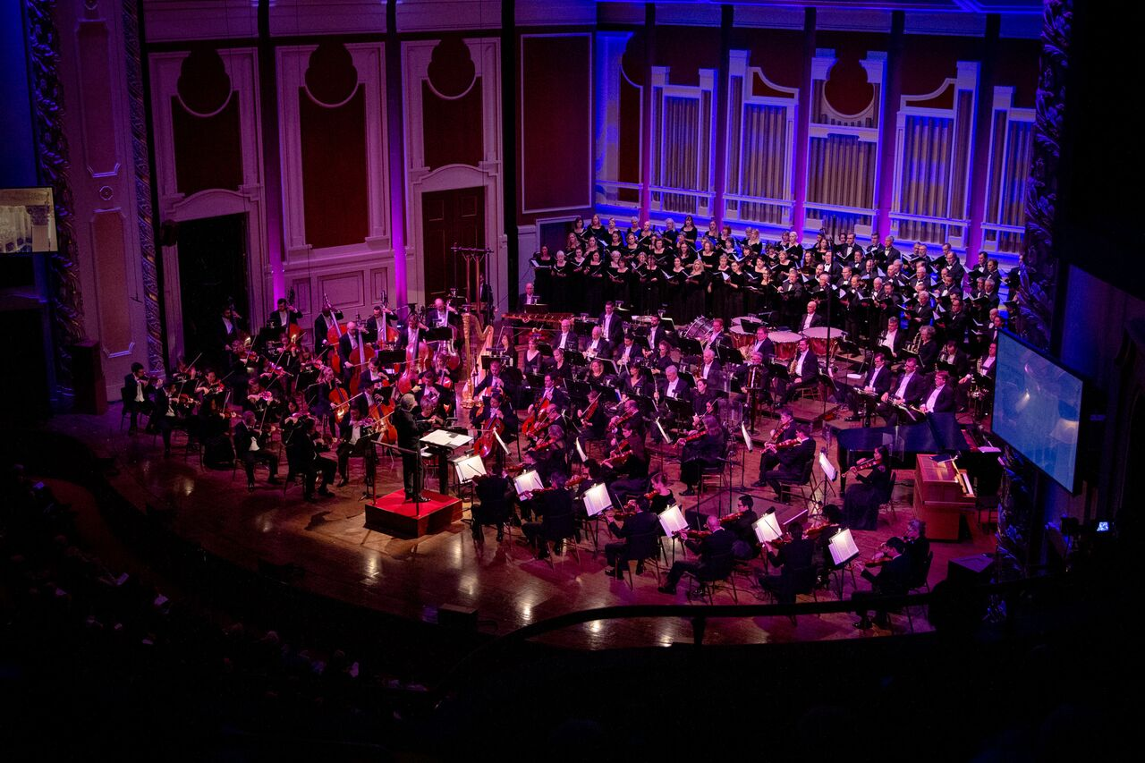
The Pittsburgh Symphony Orchestra and the Mendelssohn Choir of Pittsburgh take the stage at Heinz Hall in Pittsburgh for Tree of Life: A Concert for Peace and Unity, which airs Tuesday, December 11 at 8pm on PBS stations nationwide. Credit: Edward DeArmitt.
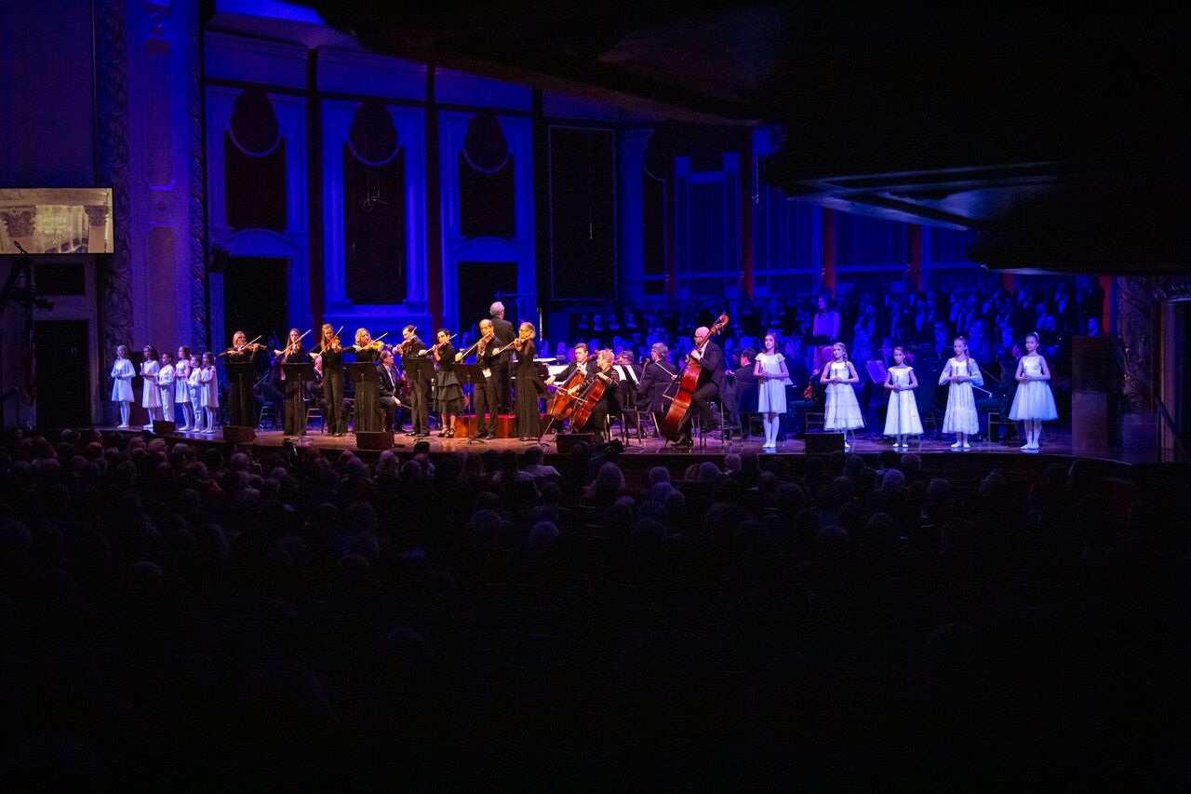
The names of the victims are read as children from the Pittsburgh Ballet Theatre enter the stage holding candles to represent each victim. The Pittsburgh Symphony Orchestra then performs “Eli Eli” by Israeli composer David Zehavi as the children remain onstage. Credit: Edward DeArmitt.

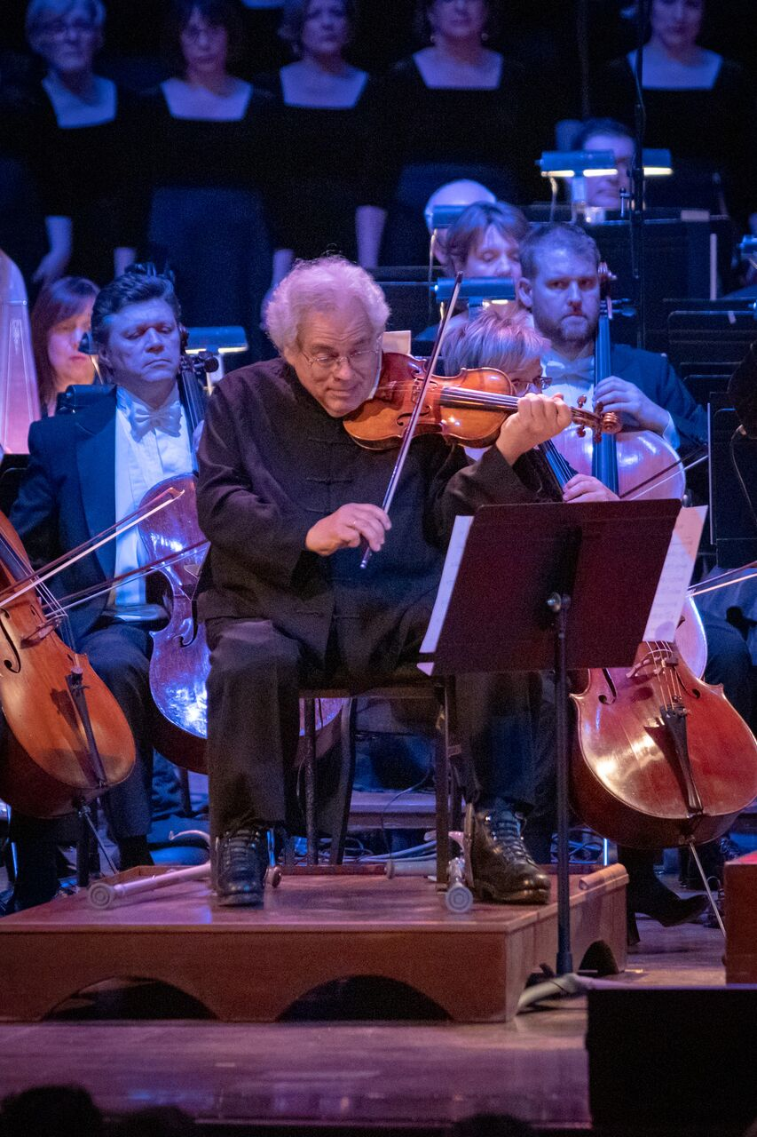
Renowned Israeli-American violinist Itzhak Perlman performs during Tree of Life: A Concert for Peace and Unity with the Pittsburgh Symphony Orchestra at Heinz Hall in Pittsburgh. Tree of Life: A Concert for Peace and Unity airs Tuesday, December 11 at 8pm on PBS stations nationwide. Credit: Edward DeArmitt.

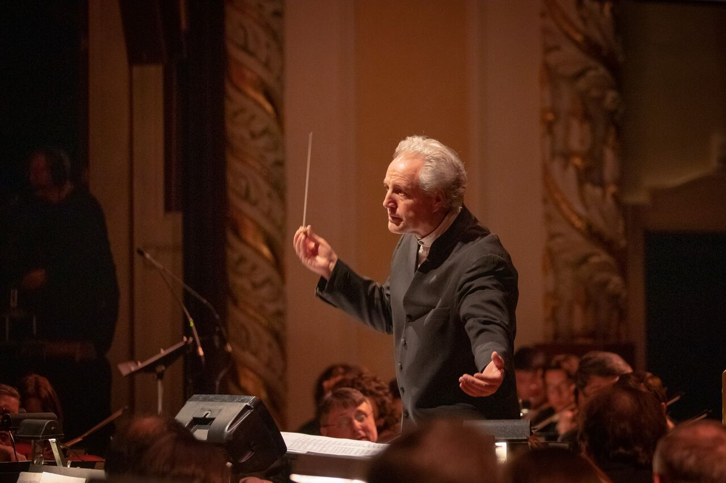
Pittsburgh Symphony Orchestra Music Director Manfred Honeck conducts during Tree of Life: A Concert for Peace and Unity, which airs Tuesday, December 11 at 8pm on PBS stations nationwide. Credit: Edward DeArmitt.

About WQED
WQED creates and shares public media that educates, entertains and inspires. It is the parent company of WQED-TV (PBS); WQED World; WQED Create; WQED Showcase; WQED PBS KIDS Channel; Classical WQED-FM 89.3/Pittsburgh; Classical WQEJ-FM 89.7/Johnstown; the Pittsburgh Concert Channel at WQED-HD2 (89.3-2FM) and online at www.wqed.org/fm; local and national television and radio productions; WQED Interactive (www.wqed.org) and WQED Education (www.wqed.org/edu).
About CPB
The Corporation for Public Broadcasting (CPB), a private, nonprofit corporation created by Congress in 1967, is the steward of the federal government’s investment in public broadcasting. It helps support the operations of more than 1,500 locally owned and operated public television and radio stations nationwide. CPB is also the largest single source of funding for research, technology and program development for public radio, television and related online services. For more information, visit cpb.org.org, follow us on Twitter @CPBmedia, Facebook and LinkedIn and subscribe for other updates.
About PBS
PBS, with nearly 350 member stations, offers all Americans the opportunity to explore new ideas and new worlds through television and digital content. Each month, PBS reaches over 90 million people through television and 30 million people online, inviting them to experience the worlds of science, history, nature and public affairs; to hear diverse viewpoints; and to take front row seats to world-class drama and performances. PBS’ broad array of programs has been consistently honored by the industry’s most coveted award competitions. Teachers of children from pre-K through 12th grade turn to PBS for digital content and services that help bring classroom lessons to life. Decades of research confirms that PBS’ premier children’s media service, PBS KIDS, helps children build critical literacy, math and social-emotional skills, enabling them to find success in school and life. Delivered through member stations, PBS KIDS offers high-quality educational content on TV – including a 24/7 channel, online at pbskids.org, via an array of mobile apps and in communities across America. More information about PBS is available at www.pbs.org, one of the leading dot-org websites on the internet, or by following PBS on Twitter, Facebook or through our apps for mobile and connected devices. Specific program information and updates for press are available at pbs.org/pressroom or by following PBS Pressroom on Twitter.

About the Pittsburgh Symphony Orchestra

The two-time 2018 Grammy Award-winning Pittsburgh Symphony Orchestra (PSO) is credited with a rich history of engaging the world’s finest conductors and musicians, and demonstrates a genuine commitment to the Pittsburgh region and its citizens. Known for its artistic excellence for more than 120 years, past music directors have included Fritz Reiner (1938-1948), William Steinberg (1952-1976), Andre Previn (1976-1984), Lorin Maazel (1984-1996) and Mariss Jansons (1997-2004). This tradition of outstanding international music directors was furthered in fall 2008, when Austrian conductor Manfred Honeck became music director of the Pittsburgh Symphony Orchestra. The PSO is continually at the forefront of championing new American works. They premiered Leonard Bernstein’s Symphony No. 1 “Jeremiah” in 1944 and John Adams’ Short Ride in a Fast Machine in 1986, and in the 2018-2019 season they premiered Mason Bates’ commission for Honeck’s 60th birthday celebration. The orchestra has a long and illustrious history in the areas of recordings and live radio broadcasts. Its recording of Shostakovich Symphony No. 5 / Barber Adagio for Srings won 2018 Grammy Awards for Best Orchestral Performance and Best Engineered Classical Album, and their “Pittsburgh Live!” series with Reference Recordings resulted in back-to-back Grammy nominations in 2015 and 2016. As early as 1936, the PSO has been broadcasted on the radio. Since 1982, the orchestra has received increased attention through national network radio broadcasts on Public Radio International, produced by Classical WQEDFM 89.3, made possible by the musicians of the Pittsburgh Symphony Orchestra.

About Manfred Honeck

Manfred Honeck has firmly established himself as one of the world’s leading conductors, renowned for his distinctive interpretations of a wide-range of repertoire. For more than a decade, Honeck has served as Music Director of the Pittsburgh Symphony Orchestra, continuing a great legacy of music-making that is celebrated at home, abroad and on recordings, including the 2018 Grammy Award for Best Orchestral Performance (Shostakovich Symphony No. 5 and Barber Adagio for Strings). Since 2008, Honeck and the PSO have served as cultural ambassadors for the city as one of the most frequently toured American orchestras. Together, they have performed at Carnegie Hall and Lincoln Center, and at major European music capitals and festivals. The PSO and Honeck return to Lincoln Center in May 2019 and have an extensive European Cities Tour planned for Fall 2019. Under Honeck’s leadership, the PSO has worked to preserve the orchestra’s celebrated sound, resulting in more than a dozen recordings with works by Beethoven, Bruckner, Dvořák, Mahler, Tchaikovsky, and Strauss. Additionally, Honeck has shown a deep commitment to the "Music for the Spirit” series, devoted to embracing music’s ability to promote dialogue across faiths. Beyond Pittsburgh, Honeck has appeared as a guest conductor with the world’s leading orchestras in the U.S. and abroad. He has received honorary doctorates from several North American universities. Most recently, he was awarded the honorary title of Professor by the Austrian Federal President, and selected as “Artist of the Year” 2018 by the International Classical Music Awards.

About Itzhak Perlman
Undeniably the reigning virtuoso of the violin, Itzhak Perlman enjoys superstar status rarely afforded a classical musician. Beloved for his charm and humanity as well as his talent, he is treasured by audiences throughout the world who respond not only to his remarkable artistry, but also to his irrepressible joy for making music.Having performed with every major orchestra and at concert halls around the globe, Perlman was granted a Presidential Medal of Freedom, the Nation’s highest civilian honor, by President Obama in 2015, a Kennedy Center Honor in 2003, a National Medal of Arts by President Clinton in 2000, and a Medal of Liberty by President Reagan in 1986. Perlman has been honored with 16 Grammy Awards, four Emmy Awards, a Kennedy Center Honor, a Grammy Lifetime Achievement Award, and a Genesis Prize. The 2018/19 season marks the 60th anniversary of Itzhak Perlman’s U.S. debut and appearance on the Ed Sullivan Show, which took place on November 2, 1958. This milestone was celebrated with a return to the Ed Sullivan Theater on November 2, 2018 in a special guest appearance on The Late Show with Stephen Colbert. Highlights of this season include performances with Gustavo Dudamel and the Los Angeles Philharmonic, Michael Tilson Thomas and the San Francisco Symphony, and duo concerts with Evgeny Kissin in Boston, Chicago, Washington D.C. and New York. A recent award-winning documentary on Mr. Perlman, titled “Itzhak," premiered in October 2017 as the opening film of the 25th Annual Hamptons International Film Festival. Directed by filmmaker Alison Chernick, it was released theatrically in over 100 cinemas nationwide in March 2018, with international releases that followed in Summer 2018. For more information, visit www.itzhakthefilm.com. Itzhak Perlman’s recordings have garnered 16 Grammy Awards and regularly appear on the best-seller charts. In 2008, Mr. Perlman was honored with a Grammy Lifetime Achievement Award for excellence in the recording arts.

# # #

