GROUNDBREAKING FETAL SURGERY BRINGS JOY AND HEARTBREAK IN
TWICE BORN Stories From the Special Delivery Unit
PREMIERING TUESDAY, MARCH 31 ON PBS

– Emotional three-part documentary series features unprecedented access to patients and doctors at The Children’s Hospital of Philadelphia –

Watch the trailer

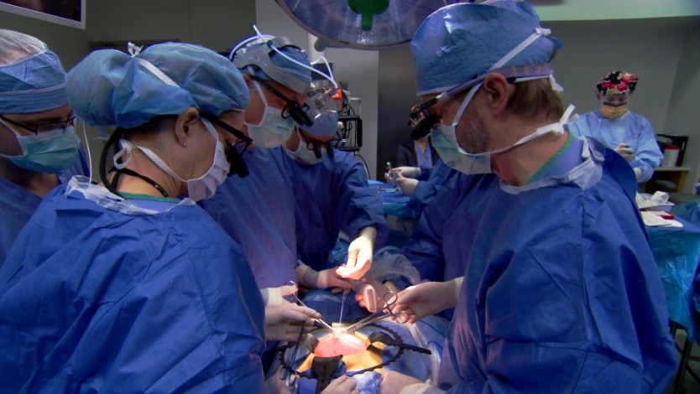
Arlington, VA, February XX, 2015 -- PBS presents the gripping three-part documentary series, TWICE BORN Stories From the Special Delivery Unit, premiering Tuesday, March 31, 2015, at 8:00 p.m. ET (check local listings) on PBS. The series spotlights the alternately heartbreaking and life-affirming stories from inside the world’s leading fetal surgery center at The Children’s Hospital of Philadelphia (CHOP).

Produced by Trailblazer Studios, TWICE BORN is the first series to be granted exclusive access to awe-inspiring stories that play out daily inside CHOP’s Center for Fetal Diagnosis and Treatment and its Special Delivery Unit. The series underscores how the unit has revolutionized prenatal care and how such delicate procedures come with serious considerations. The title refers to the center’s groundbreaking procedures that allow doctors to operate on fetuses.
Surgeons begin fetal surgery for spina bifida on a baby of 23 weeks gestation at The Children’s Hospital of Philadelphia’s Special Delivery Unit.
Credit: Erin Harvey

TWICE BORN follows several families from around the country as they go through the emotional process of learning about medical challenges facing their unborn children, assessing the options of prenatal surgery and making decisions once their options are clear. Intimate medical consultations, agonizing decisions and triumphant celebrations are abundant. The show also gives viewers a look at CHOP’s world-renowned and committed medical staff as they navigate surgical team meetings, patient consultations, operating room drama and their own sometimes-complicated home lives.

“PBS is breaking ground again with TWICE BORN,” said Bill Gardner, Vice President, Programming and Development for PBS. “Viewers will be drawn into a never-before-seen, life-and-death world of high stakes decision-making and cutting-edge medicine. But it’s the people on both sides of the story – the patients and the CHOP staff – who make truly memorable storytelling.”

Over the three-part series, viewers share in several touching stories: Lesly, a young, single mother, journeys to CHOP from California because her baby has developed an aggressive tumor in utero that threatens its ability to breathe or eat; Shelly and Bobby travel from Massachusetts after learning their baby has spina bifida, a debilitating condition that causes a range of problems including impaired mobility, hydrocephalus and a number of other lifelong challenges; Tina and Brion journey to the center from their home in Texas seeking hope for their unborn twins diagnosed with the rare and dangerous twin-twin transfusion syndrome; and Geneva and Reggie travel from North Carolina after their unborn child develops a life-threatening urinary tract obstruction.

CHOP’s team of highly regarded medical experts included in this documentary are surgeons Dr. Scott Adzick, Dr. Julie Moldenhauer, Dr. Holly Hedrick, Dr. Mark Johnson and Dr. Nahla Khalek, as well as many dedicated nurses, specialists, patient advocates and others who defy skeptics to perform groundbreaking medicine and who struggle to maintain a balance between their intense work and their lives at home. For more information about the Center for Fetal Diagnosis and Treatment at CHOP, visit fetalsurgery.chop.edu.

Emmy-winning documentary veterans Monica Lange and Bonnie Cutler-Shear together developed and created TWICE BORN, with Lange serving as producer/director and Cutler as co-producer/editor. During filming, which spanned 14 months, the TWICE BORN crew was fully embedded at the hospital, capturing moments, conversation and procedures that have never before been seen on television and that viewers will find nowhere else.
PBS Distribution will release the DVD version of TWICE BORN Stories From the Special Delivery Unit on April 28, 2015. The DVD will be available for a suggested retail price of $24.99. The running time is 180 minutes.

About PBS
PBS, with over 350 member stations, offers all Americans the opportunity to explore new ideas and new worlds through television and online content. Each month, PBS reaches more than 103 million people through television and over 33 million people online, inviting them to experience the worlds of science, history, nature and public affairs; to hear diverse viewpoints; and to take front row seats to world-class drama and performances. PBS’ broad array of programs has been consistently honored by the industry’s most coveted award competitions. Teachers of children from pre-K through 12th grade turn to PBS for digital content and services that help bring classroom lessons to life. PBS’ premier children’s TV programming and its website, pbskids.org, are parents’ and teachers’ most trusted partners in inspiring and nurturing curiosity and love of learning in children. More information about PBS is available at www.pbs.org, one of the leading dot-org websites on the Internet, or by following PBS on Twitter, Facebook or through our apps for mobile devices. Specific program information and updates for press are available at pbs.org/pressroom or by following PBS Pressroom on Twitter.

About Trailblazer Studios
North Carolina-based Trailblazer Studios is a production and post-production facility working with PBS, Discovery Communications, Scripps Networks and others.

– PBS –

CONTACTS:
Ellen Stanley Booth, PBS, 202-744-1762, esbooth@pbs.org
Maryellen Mooney, Goodman Media for PBS, 212-576-2700, mmooney@goodmanmedia.com

For images and additional up-to-date information on this and other PBS programs, visit PBS PressRoom at pbs.org/pressroom.

