UNLOCKING SHERLOCK
Premieres Sunday, January 12, 2014, 10:00 P.M. ET on PBS

Available for streaming on PBS.org on Wednesday, December 25, 2013, at 10:00 a.m. ET

− Go behind the scenes of the new “Sherlock” and watch interviews with Benedict Cumberbatch and Martin Freeman −

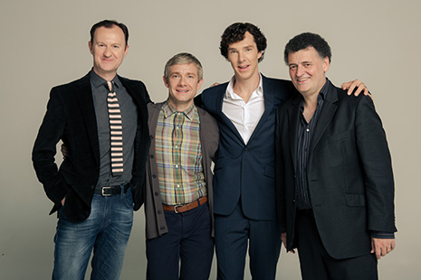
Shown from L-R: Mark Gatiss, Martin Freeman, Benedict Cumberbatch, Steven Moffat
Credit: ©Roger Viglasky/Hartswood Films
Arlington, VA; December 23, 2013 –Leading up to the long-awaited return of MASTERPIECE “Sherlock” (Season 3) on January 19 at 9:58 p.m. ET, PBS today announced the premiere of UNLOCKING SHERLOCK, a one-hour special that explores how writers Steven Moffat and Mark Gatiss created the hit television sensation. UNLOCKING SHERLOCK premieres Sunday, January 12, 2014, at 10:00 p.m. ET on PBS (check local listings). As a special holiday gift for Sherlock fans, PBS will make the program available for streaming on PBS.org beginning Wednesday, December 25, 2013, at 10:00 a.m. ET.

“As excitement builds for the new season of ‘Sherlock’ on MASTERPIECE, we invite viewers to join us as we delve into the writers’ inspiration for the modern-day Sherlock Holmes that has captivated fans nationwide,” said Beth Hoppe, Chief Programming Executive and General Manager of General Audience Programming for PBS. “This special highlights the transformation of Sir Arthur Conan Doyle’s most-portrayed character into a cultural phenomenon.”

UNLOCKING SHERLOCK takes viewers on a personal voyage through the versions of Holmes that have served as inspirations for the new series – the original stories, their factual origins, hundreds of film adaptations – to arrive at their thoroughly modern Sherlock. Moffat and Gatiss explain the challenges they encountered adapting the original adventures of the iconic super-sleuth. The special goes behind the scenes on the set of the hit television series, and includes interviews with actors Benedict Cumberbatch, Martin Freeman and Lara Pulver, who talk about the reinvention of their fictional characters.

Moffat and Gatiss describe the evolution of Dr. Watson, Inspector Lestrade, Mycroft, Jim Moriarty and Irene Adler, as well as Holmes, from Conan Doyle’s original characterizations, through numerous cinematic and televised versions to the contemporary “Sherlock.”

UNLOCKING SHERLOCK is a Midnight Oil Production in association with Hartswood Films for BBC Worldwide and PBS. The special is executive produced by Sue Vertue for Hartswood Films and Gillane Seaborne for Midnight Oil Productions.

About PBS
PBS, with its over 350 member stations, offers all Americans the opportunity to explore new ideas and new worlds through television and online content. Each month, PBS reaches nearly 120 million people through television and over 29 million people online, inviting them to experience the worlds of science, history, nature and public affairs; to hear diverse viewpoints; and to take front row seats to world-class drama and performances. PBS’ broad array of programs has been consistently honored by the industry’s most coveted award competitions. Teachers of children from pre-K through 12th grade turn to PBS for digital content and services that help bring classroom lessons to life. PBS’ premier children’s TV programming and its website, pbskids.org, are parents’ and teachers’ most trusted partners in inspiring and nurturing curiosity and love of learning in children. More information about PBS is available at www.pbs.org, one of the leading dot-org websites on the Internet, or by following PBS on Twitter, Facebook or through our apps for mobile devices. Specific program information and updates for press are available at pbs.org/pressroom or by following PBS Pressroom on Twitter.

– PBS –

CONTACT:
Jennifer R. Byrne, PBS, jrbyrne@pbs.org, 703-739-5487

For images and additional up-to-date information on this and other PBS programs, visit PBS PressRoom at pbs.org/pressroom.

