Celebrate Valentine’s Day with Lucy Worsley in
A VERY BRITISH ROMANCE
Sundays, February 9 and 16, 2020 on PBS

New Two-Part Series Hosted by the Popular British Historian Uncovers the Forces That Shaped Our Ideals of Romantic Love

ARLINGTON, VA – Celebrate Valentine’s Day with Lucy Worsley as she delves into the steamy and seductive history of British romance, uncovering the social, political and cultural forces that shaped ideals of romantic love during the Georgian and Victorian eras — ideals that surprisingly continue to resonate today. A VERY BRITISH ROMANCE WITH LUCY WORSLEY premieres Sundays, February 9 and 16, 2020, 8:00-9:00 p.m. ET (check local listings) on PBS, pbs.org and the PBS App, preceding episodes of MASTERPIECE’s new SANDITON.
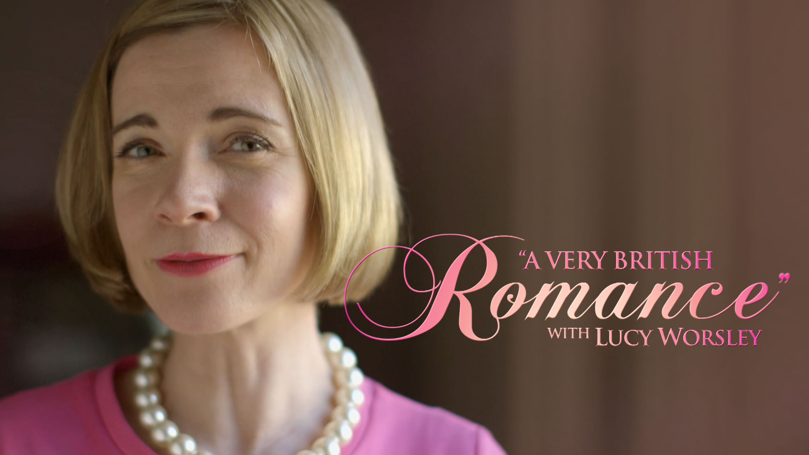
Credit: Courtesy of the BBC

In Episode 1 (February 9), Lucy's exploration of love's rituals begins in the Georgian age, when the old rules of courtship were being rewritten. Traditionally, marriage had been as much about business as love. Now, a glamorization of romantic love inspired women and men to make their own romantic choices — they could flirt in newly-built assembly rooms, or elope to Gretna Green as an act of romantic rebellion.

The main force of change, however, was the arrival of the novel. Samuel Richardson, Fanny Burney and Jane Austen didn't just map out women's changing desires; they made people seek out the feelings and emotions described in the books in their own lives, permanently changing how their readers felt about love.

In Episode 2 (February 16), Worsley discovers how medieval chivalry shaped Victorian courtship by defining the roles men and women were expected to play and explores the romantic gestures which emerged and continue today. With the arrival of the Industrial Revolution, Valentine’s cards were mass-produced in factories and the “penny post” made it affordable to send a written expression of love, cementing this as a customary romantic gesture.

Lucy also learns about the complicated Victorian language of flowers, where each bloom represented a particular idea or emotion, allowing lovers to communicate secretly through their choice of bouquet. Throughout the episode, Lucy dips into popular novels of the time, such as Jane Eyre by Charlotte Brontë and Ann Veronica by H.G. Wells, discovering that the passions explored in fiction were translating into real-life desires and actions.

The host of several popular PBS specials including 12 DAYS OF TUDOR CHRISTMAS, VICTORIA & ALBERT: THE WEDDING, TALES FROM THE ROYAL BEDCHAMBER, and more, Lucy Worsley is a royal historian, TV host, Chief Curator at Historic Royal Palaces (the charity which looks after the Tower of London, Hampton Court Palace, Kensington Palace and other historic places), and author of numerous books including Queen Victoria, Jane Austen at Home, Eliza Rose, A Very British Murder and more.

A VERY BRITISH ROMANCE WITH LUCY WORSLEY will stream (February 9) and be available on all station-branded PBS platforms, including PBS.org and the PBS Video App, available on iOS, Android, Roku, Apple TV, Amazon Fire TV and Chromecast. PBS station members will be available to view all episodes via Passport (contact your local PBS station for details).

A VERY BRITISH ROMANCE WITH LUCY WORSLEY is produced by the BBC. Executive producers are Michael Poole and John Das. The series producer is Sebastian Barfield, who also directed Episode 1. Episode 2 is produced and directed by Rachel Jardine.

About PBS
PBS, with nearly 350 member stations, offers all Americans the opportunity to explore new ideas and new worlds through television and digital content. Each month, PBS reaches over 120 million people through television and 26 million people online, inviting them to experience the worlds of science, history, nature and public affairs; to hear diverse viewpoints; and to take front row seats to world-class drama and performances. PBS’ broad array of programs has been consistently honored by the industry’s most coveted award competitions. Teachers of children from pre-K through 12th grade turn to PBS for digital content and services that help bring classroom lessons to life. Decades of research confirms that PBS’ premier children’s media service, PBS KIDS, helps children build critical literacy, math and social-emotional skills, enabling them to find success in school and life. Delivered through member stations, PBS KIDS offers high-quality educational content on TV – including a 24/7 channel, online at pbskids.org, via an array of mobile apps and in communities across America. More information about PBS is available at www.pbs.org, one of the leading dot-org websites on the internet, or by following PBS on Twitter, Facebook or through our apps for mobile and connected devices. Specific program information and updates for press are available at pbs.org/pressroom or by following PBS Pressroom on Twitter.

– PBS –

CONTACTS:
Cara White / Mary Lugo, CaraMar, Inc.
cara.white@mac.com; lugo@negia.net

For images and additional up-to-date information on this and other PBS programs, visit PBS PressRoom at pbs.org/pressroom.

