TCA Panelist Biographies

Derek Jacobi (Stuart Bixby)

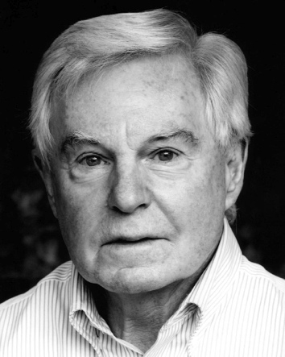
Derek Jacobi is one of the UK’s most celebrated actors, with award-winning, critically acclaimed roles in theater, TV and film.

He recently starred in the BAFTA-winning drama LAST TANGO IN HALIFAX. Jacobi received a BAFTA nomination for his performance as Alan and is filming the second series in the UK. His most recent TV credits also include the comedy VICIOUS with Ian McKellen, global sci-fi hit “Doctor Who” and acclaimed drama series “The Borgias.”

Jacobi has won numerous awards throughout his career, including a Tony Award for his role in Much Ado About Nothing and two Laurence Olivier Awards for stage adaptations of Twelfth Night (2009) and Cyrano de Bergerac (1983). He has also been recognized for his TV work with Emmy Awards for his roles in “Frasier” (2001) and “The Tenth Man” (1989).

He has starred in many feature films, including Grace of Monaco with Nicole Kidman, The King’s Speech, My Week with Marilyn, The Golden Compass, Nanny McPhee, Gladiator, Gosford Park and The Day of the Jackal.

Jacobi first achieved international recognition when he starred in the BBC’s award-winning production of Robert Graves’ “I, Claudius” in the mid 1970s, for which he won the BAFTA for Best Actor.

A Cambridge graduate, he began his acting career with the Birmingham Repertory Theatre before going on to win critical acclaim in some of theatre’s most iconic roles (Hamlet, Macbeth and King Lear) in London’s West End. He most recently starred as King Lear at the Donmar Warehouse in London, for which he received an Olivier nomination.

Knighted in 1994 for his services to theatre, Jacobi, with Laurence Olivier, is a founding member of the UK’s National Theatre. .

Ian McKellen (Freddie Thornhill)
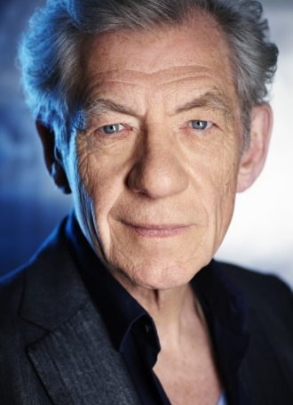
Ian McKellen has been honored with more than 50 international acting awards during his half-century on stage and screen. He has been leading man and producer of classic and modern plays for the Royal Shakespeare Company and the National Theatre. He is treasured worldwide as Magneto in the X-Men films and as Gandalf in The Lord of the Rings and The Hobbit trilogies.
For his extensive television work, McKellen is a five-time Emmy nominee, most recently for the PBS presentation of his monumental “King Lear” (2008), the miniseries “The Prisoner” (2009) and his comic guest spot on “Extras” (2006), with his viral catch-phrase: “How do I act so well?” He won a Golden Globe for his Tsar Nicholas II in the telefilm “Rasputin” (1996). He is most proud of his work as the mentally handicapped “Walter” (1982 Royal Television Award); in the “And the Band Played On” (1993 Cable Ace Award), about the origins of AIDS; and a short spell in “Coronation Street” (2005).
Like Freddy Thornhill, his character in VICIOUS, 73-year-old McKellen was born and raised in the north of England. He read English at Cambridge University, where he first acted with Derek Jacobi in undergraduate productions. Since 1961, he has worked non-stop in the British theatre. He holds the Evening Standard Award for Outstanding Contribution to British Theatre (2009).
In 2013 and 2014, he returned to Broadway in Pinter’s No Man’s Land in repertoire with a revival of Waiting for Godot.
In 1991, McKellen was knighted for his outstanding contribution to theatre. He is co-founder of Stonewall UK, which lobbies for legal and social equality for gay people. In 2008, Queen Elizabeth appointed him Companion of Honour for his services to drama and to equality.
Complete professional credits and personal writings are on www.mckellen.com.

Gary Janetti (Writer/Producer)

Gary Janetti is a four-time Emmy-nominated television writer and producer originally from Queens, New York. He served as executive producer and showrunner of “Will & Grace” and has been a writer/producer on “Family Guy” since 1999. He has worked under overall deals at 20th Century Fox and NBC Universal, where he wrote and produced pilots for Natasha Richardson, Molly Shannon, Cheri Oteri and Will Arnett. He also appeared on the Bravo reality series “It's a Brad, Brad World.”
Janetti recently co-created, wrote and executive produced the British comedy series VICIOUS, starring Ian McKellen and Derek Jacobi, which has been picked up by ITV for a second season. VICIOUS is scheduled to premiere on PBS in June 2014. Janetti currently writes for “Family Guy” and is working on the next season of VICIOUS.

