THE VIETNAM WAR, A New Film By Ken Burns and Lynn Novick,
to Air Fall 2017 on PBS

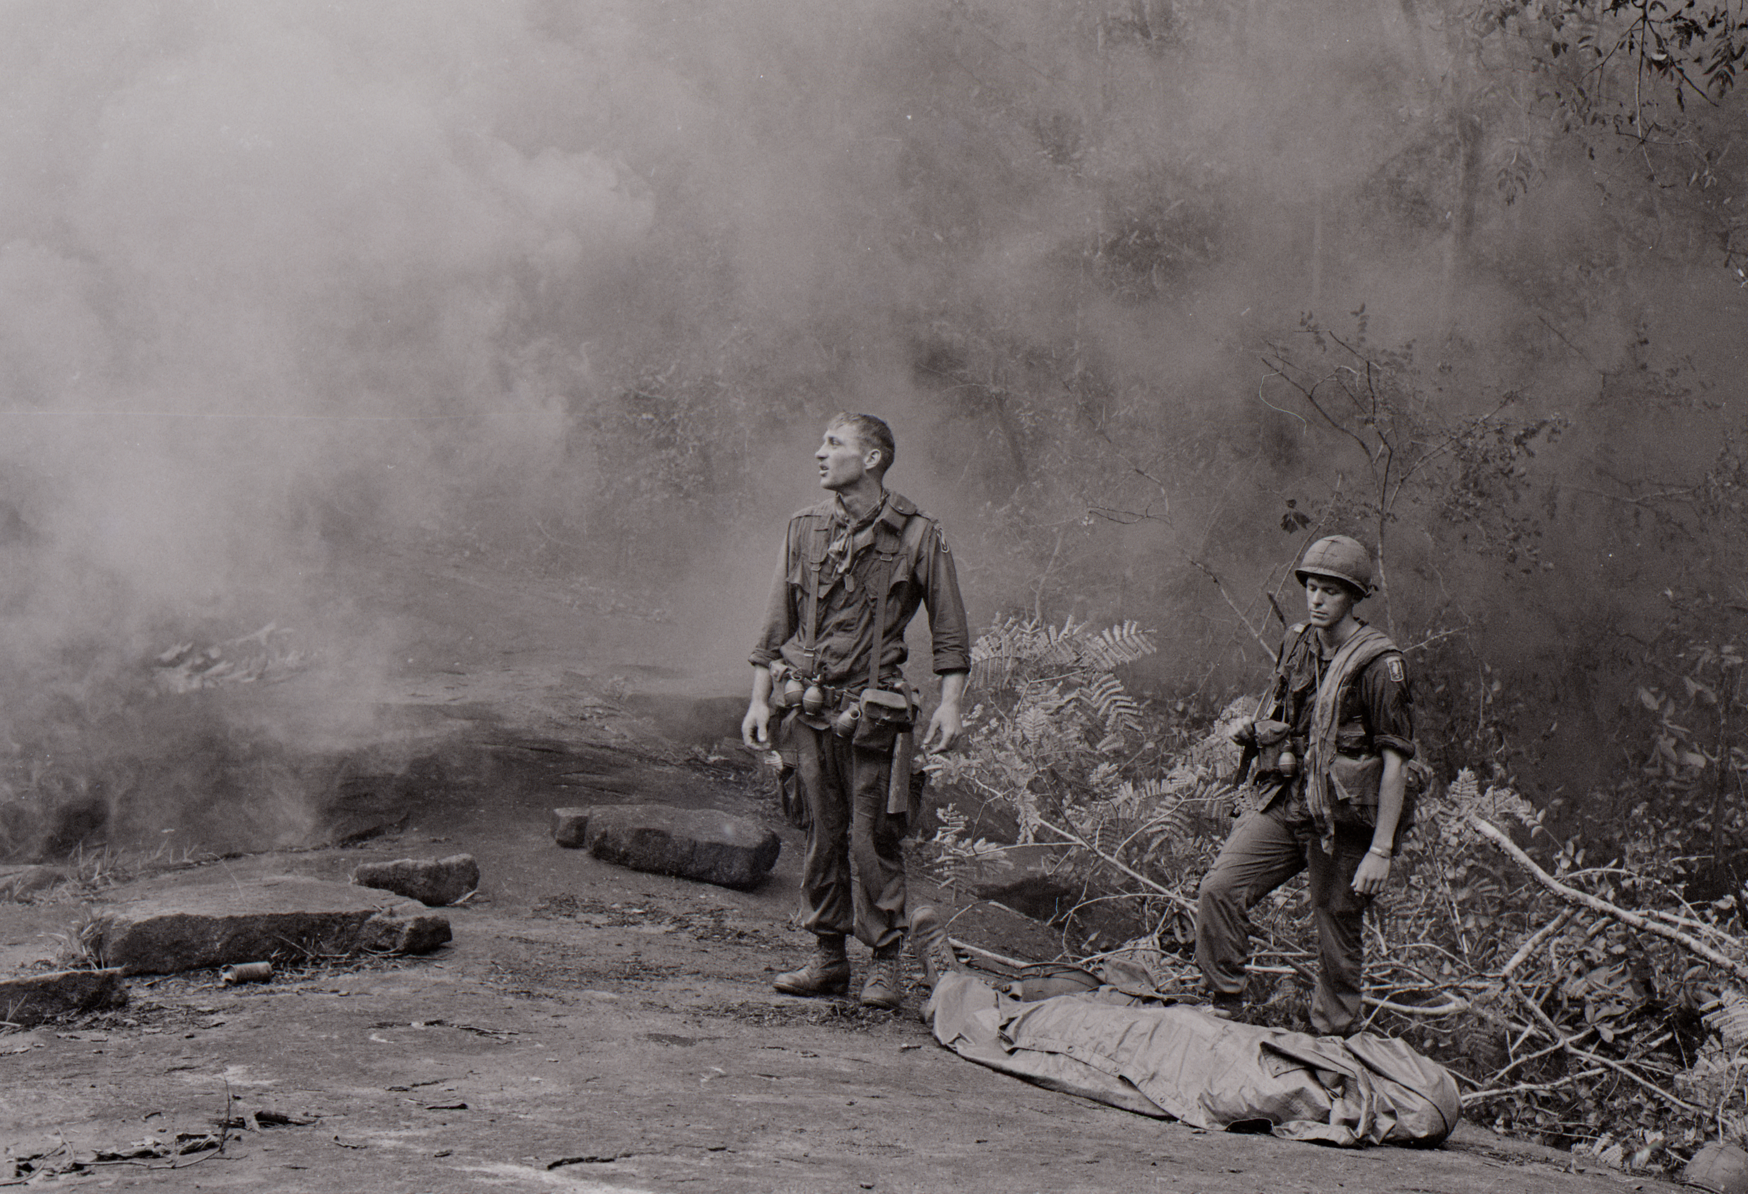
Credit: National Archives and Records Administration
ARLINGTON, VA; DECEMBER 6, 2016 -- THE VIETNAM WAR, a new 10-part, 18-hour documentary film series directed by Ken Burns and Lynn Novick, will air in September 2017 on PBS stations nationwide (watch the trailer).
In an immersive narrative, Burns and Novick tell the epic story of the Vietnam War as it has never-before been told on film. THE VIETNAM WAR features testimony from nearly 100 witnesses, including many Americans who fought in the war and others who opposed it, as well as Vietnamese combatants and civilians from both the winning and losing sides (see clips here).
“The Vietnam War was a decade of agony that took the lives of more than 58,000 Americans,” Burns said. “Not since the Civil War have we as a country been so torn apart. There wasn’t an American alive then who wasn’t affected in some way — from those who fought and sacrificed in the war, to families of service members and POWs, to those who protested the war in open conflict with their government and fellow citizens. More than 40 years after it ended, we can’t forget Vietnam, and we are still arguing about why it went wrong, who was to blame and whether it was all worth it.”

“We are all searching for some meaning in this terrible tragedy. Ken and I have tried to shed new light on the human dimensions of the war by looking at it from the bottom up, the top down and from all sides,” Novick said. “In addition to dozens of ‘ordinary’ Americans who shared their stories, we interviewed many ‘ordinary’ Vietnamese soldiers and non-combatants in the North and South, and we were surprised to learn that the war remains as painful and unresolved for them as it is for us.”

Six years in the making, the series brings the war and the chaotic epoch it encompassed viscerally to life. Written by Geoffrey C. Ward, produced by Sarah Botstein, Novick and Burns, it includes rarely seen, digitally re-mastered archival footage from sources around the globe, photographs taken by some of the most celebrated photojournalists of the 20th century, historic television broadcasts, evocative home movies, revelatory audio recordings from inside the Kennedy, Johnson and Nixon administrations and more than 100 iconic musical recordings by many of the greatest artists of the era.

“Ever since THE CIVIL WAR, Ken and Lynn have been behind some of the most important documentary films ever shown on television, films that have in fact made television history and created national conversations around who we are as Americans,” said Beth Hoppe, Chief Programming Executive and General Manager, General Audience Programming, PBS. “Yet even with this remarkable track record, THE VIETNAM WAR stands out as an unmatched achievement that will spark thought, questions and debate around one of the most transformative periods in modern American history.”

The film will be accompanied by an unprecedented outreach and public engagement program, providing opportunities — facilitated by public television stations — for communities to participate in a national conversation about what happened during the Vietnam War, what went wrong and what lessons are to be learned. In addition, there will be a robust interactive website and an educational initiative designed to engage teachers and students through multiple platforms, including PBS LearningMedia.

THE VIETNAM WAR rounds out a trilogy of Florentine Films’ exploration of American wars that began with Burns’s landmark series, THE CIVIL WAR (1990), followed by Burns and Novick’s acclaimed seven-part series about the World War II, THE WAR (2007).

Accompanying the series will be a companion book, written by Geoffrey C. Ward, with an introduction by Ken Burns and Lynn Novick, that will be published by Alfred A. Knopf, Burns’s longtime publisher.

Funding for THE VIETNAM WAR is provided by Bank of America; the Corporation for Public Broadcasting; PBS; The Park Foundation; The Arthur Vining Davis Foundations; The John S. and James L. Knight Foundation; The Andrew W. Mellon Foundation; The National Endowment for Humanities; The Pew Charitable Trusts; The Ford Foundation Just Films; The Rockefeller Brothers Fund; and members of The Better Angels Society.

THE VIETNAM WAR is a production of Florentine Films and WETA, Washington, DC. Directed by Ken Burns and Lynn Novick. Written by Geoffrey C. Ward. Produced by Sarah Botstein, Lynn Novick and Ken Burns.

PBS Distribution will release THE VIETNAM WAR on DVD, Blu-ray and Digital HD. The DVD and Blu-ray will be available for purchase at ShopPBS.org and other major retailers.

About PBS
PBS, with nearly 350 member stations, offers all Americans the opportunity to explore new ideas and new worlds through television and online content. Each month, PBS reaches nearly 100 million people through television and nearly 33 million people online, inviting them to experience the worlds of science, history, nature and public affairs; to hear diverse viewpoints; and to take front row seats to world-class drama and performances. PBS’ broad array of programs has been consistently honored by the industry’s most coveted award competitions. Teachers of children from pre-K through 12th grade turn to PBS for digital content and services that help bring classroom lessons to life. PBS’ premier children’s TV programming and its website, pbskids.org, are parents’ and teachers’ most trusted partners in inspiring and nurturing curiosity and love of learning in children. More information about PBS is available at www.pbs.org, one of the leading dot-org websites on the Internet, or by following PBS on Twitter, Facebook or through our apps for mobile devices. Specific program information and updates for press are available at pbs.org/pressroom or by following PBS Pressroom on Twitter.

About WETA
WETA Washington, D.C., is one of the largest producing stations of new content for public television in the United States. WETA productions and co-productions include PBS NewsHour, Washington Week, The Kennedy Center Mark Twain Prize, The Library of Congress Gershwin Prize, In Performance at the White House and documentaries by filmmaker Ken Burns, including The Civil War, Baseball, The War, The National Parks: America’s Best Idea, The Central Park Five, The Roosevelts: An Intimate History and Jackie Robinson. Sharon Percy Rockefeller is president and CEO. The WETA studios and administrative offices are located in Arlington, Virginia. More information on WETA and its programs and services is available at www.weta.org. On social media, visit www.facebok.com/wetatvfm on Facebook or follow @WETAtvfm on Twitter.

– PBS –

CONTACTS: Brian Moriarty, DKC Public Relations, Tel.: 212-981-5252; brian_moriarty@dkcnews.com

For images and additional up-to-date information on this and other PBS programs, visit PBS PressRoom at pbs.org/pressroom.

