Trent Reznor and Atticus Ross Compose and Perform Original Music for THE VIETNAM WAR

–Soundtrack Also Features New Music From Yo-Yo Ma and The Silk Road Ensemble–

–10-Part Series by Ken Burns and Lynn Novick to Air on PBS in September 2017–

–All-Star Soundtrack to Include Recordings from The Beatles, The Rolling Stones, Bob Dylan, Jimi Hendrix, Simon & Garfunkel, Janis Joplin, Ben E. King, Donovan, Johnny Cash, Buffalo Springfield, The Byrds, Otis Redding, Santana, Nina Simone, Booker T. and the M.G.s, Pete Seeger, Among Others–

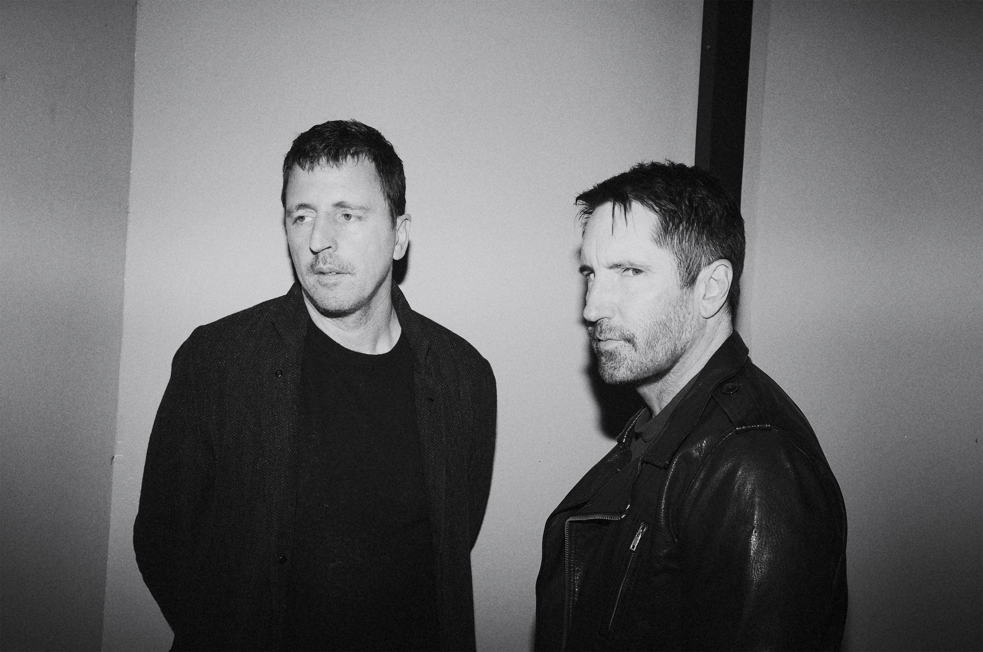
Caption: Atticus Ross (left) and Trent Reznor (right)
Credit: John Crawford
ARLINGTON, VA; JANUARY 12, 2017-- THE VIETNAM WAR, a new 10-part series directed by Ken Burns and Lynn Novick that will air on PBS in September 2017, will feature new, original music written and recorded by Academy Award-winning composers Trent Reznor and Atticus Ross. The film also features new music arranged and performed by Grammy Award-winning cellist Yo-Yo Ma and The Silk Road Ensemble. It is the first time Burns and Novick have worked with Reznor and Ross, as well as with Ma and The Silk Road Ensemble. Additional music in the film was composed by David Cieri and Doug Wamble, both of whom are longtime collaborators with Florentine Films.

A clip featuring new music composed by Trent Reznor and Atticus Ross is available here.

“From the beginning of this project, we dreamed of working with Trent and Atticus,” Novick said. “The profound, haunting, unsettling and deeply moving music they created for us does what great music does best — express the inexpressible. They miraculously evoked so many of the complicated feelings embedded in this painful and tragic story. It is no exaggeration to say that they completely transformed our film.”

“It has been a tremendous privilege to work with these brilliant artists,” Burns said. “The stirring and complex music they created for the series goes straight to the heart of the human condition in all of its subtleties and contradictions. Simultaneously melodic and discordant, propulsive and ethereal, their work was integral to bringing this history to life on screen.”

Over the course of several years, Burns, Novick and producer Sarah Botstein shared with Reznor and Ross raw interview footage and scenes from rough cuts of the film, and suggested a range of feelings they hoped the music would evoke — rage, courage, sadness, fear, chaos, loss, love, sacrifice, aggression, loneliness, anxiety. They also provided a collection of sound effects from the era for the composers to work with.

“We are incredibly honored to be a part of this project. With ‘The Vietnam War,’ Ken, Lynn and Sarah have created something of vital importance. To bear witness to their process was immensely inspiring.

“The sheer scale of the project combined with the magnitude of the subject matter was initially daunting for us, but the commitment, care and reverence they displayed made the experience deeply satisfying on many levels,” said Trent Reznor and Atticus Ross in a joint statement.

While music by Yo-Yo Ma and The Silk Road Ensemble has appeared in other films by Burns and Novick, including THE WAR, this is the first time the musicians have composed, arranged, and recorded original music for Florentine Films.

Combining Western instruments (cello, viola and violin), with a range of instruments from across Asia, including the bawu and the kamancheh, they improvised variations on a number of themes, some inspired by Vietnamese music.

“Collaborating with Yo-Yo Ma and The Silk Road Ensemble,” Burns said, “was one of the great joys of this enormous project. We have admired their work for years, and it was a dream come true to be in the studio with them. The beautiful and devastating music they created for the film truly is beyond category.”

“My wife and I eagerly anticipate each new Florentine Films series because we know that it will inform and transform our understanding of the world. So to be invited into the creative process, and to witness how they realize their work was a privilege for the Silk Road Ensemble and for me. The earnest curiosity and deep empathy that Ken, Lynn, and Sarah Botstein bring to their subjects is reflected in the films they make, and it was a joy to collaborate with and learn from them,” said Yo-Yo Ma.
"The depth of research and dedication to music the filmmakers brought to the series is truly astounding, so working to realize their vision was immensely rewarding. The Silk Road Ensemble's collaborative spirit and culture-crossing perspective shines through in the recorded tracks, bringing yet another narrative layer to a story that continues to affect all of us today,” said Johnny Gandelsman, violinist and producer.

“Yo-Yo Ma and Silk Road are some of the greatest musicians working in the world,” said Novick. “The luminous music they made for the film gives voice to something deep within us, something universal and ineffable.”

In addition to the original music, the series features more than 120 popular songs that define the era, including tracks from The Beatles, The Rolling Stones, Bob Dylan, Jimi Hendrix, Simon & Garfunkel, Janis Joplin, Ben E. King, Phil Ochs, Donovan, Johnny Cash, Barry McGuire, Buffalo Springfield, The Byrds, Otis Redding, Santana, Joni Mitchell, Nina Simone, The Temptations, Booker T. and the M.G.s, Pete Seeger and more.

Producer Sarah Botstein worked closely with record companies and music publishers to license the music. “We have never made a film with such a diverse soundtrack, and everyone in the industry was extremely collaborative,” Botstein said. “Ken, Lynn, and I knew we could not do justice to this complicated subject, or to the tumultuous epoch it encompassed, without the iconic music from the time. Even now, more than 40 years later, these recordings remain the most evocative popular music of the 20th century, and are the essential complement to the extraordinary music Trent and Atticus and The SRE recorded for the project.”

In an immersive narrative, Burns and Novick tell the epic story of the Vietnam War as it has never before been told on film. THE VIETNAM WAR features testimony from nearly 100 witnesses, including many Americans who fought in the war and others who opposed it, as well as Vietnamese combatants and civilians from both the winning and losing sides.

Ten years in the making, the series brings the war and the chaotic epoch it encompassed viscerally to life. Written by Geoffrey C. Ward, produced by Sarah Botstein, Novick and Burns, it includes rarely seen, digitally re-mastered archival footage from sources around the globe, photographs taken by some of the most celebrated photojournalists of the 20th century, historic television broadcasts, evocative home movies, revelatory audio recordings from inside the Kennedy, Johnson and Nixon administrations.
The film will be accompanied by an unprecedented outreach and public engagement program, providing opportunities — facilitated by public television stations — for communities to participate in a national conversation about what happened during the Vietnam War, what went wrong and what lessons are to be learned. In addition, there will be a robust interactive website and an educational initiative designed to engage teachers and students through multiple platforms, including PBS LearningMedia.

THE VIETNAM WAR rounds out a trilogy of Florentine Films’ exploration of American wars that began with Burns’s landmark series, THE CIVIL WAR (1990), followed by Burns and Novick’s acclaimed seven-part series about World War II, THE WAR (2007).

Accompanying the series will be a companion book, written by Geoffrey C. Ward, with an introduction by Ken Burns and Lynn Novick, that will be published by Alfred A. Knopf, Burns’s longtime publisher.

PBS Distribution will release THE VIETNAM WAR on DVD, Blu-ray and Digital HD. The DVD and Blu-ray will be available for purchase at ShopPBS.org. and other major retailers.

Funding for THE VIETNAM WAR is provided by Bank of America; Corporation for Public Broadcasting; PBS; Park Foundation; The Arthur Vining Davis Foundations; The John S. and James L. Knight Foundation; The Andrew W. Mellon Foundation; National Endowment for the Humanities; The Pew
Charitable Trusts; Ford Foundation Just Films; Rockefeller Brothers Fund; and Members of The Better Angels Society.

THE VIETNAM WAR is a production of Florentine Films and WETA, Washington, DC. Directed by Ken Burns and Lynn Novick. Written by Geoffrey C. Ward. Produced by Sarah Botstein, Lynn Novick and Ken Burns.

About PBS
PBS, with nearly 350 member stations, offers all Americans the opportunity to explore new ideas and new worlds through television and online content. Each month, PBS reaches nearly 100 million people through television and nearly 33 million people online, inviting them to experience the worlds of science, history, nature and public affairs; to hear diverse viewpoints; and to take front row seats to world-class drama and performances. PBS’ broad array of programs has been consistently honored by the industry’s most coveted award competitions. Teachers of children from pre-K through 12th grade turn to PBS for digital content and services that help bring classroom lessons to life. PBS’ premier children’s TV programming and its website, pbskids.org, are parents’ and teachers’ most trusted partners in inspiring and nurturing curiosity and love of learning in children. More information about PBS is available at www.pbs.org, one of the leading dot-org websites on the Internet, or by following PBS on Twitter, Facebook or through our apps for mobile devices. Specific program information and updates for press are available at pbs.org/pressroom or by following PBS Pressroom on Twitter.

About WETA
WETA Washington, D.C., is one of the largest producing stations of new content for public television in the United States. WETA productions and co-productions include PBS NewsHour, Washington Week, The Kennedy Center Mark Twain Prize, The Library of Congress Gershwin Prize, In Performance at the White House and documentaries by filmmaker Ken Burns, including The Civil War, Baseball, The War, The National Parks: America’s Best Idea, The Central Park Five, The Roosevelts: An Intimate History and Jackie Robinson. Sharon Percy Rockefeller is president and CEO. The WETA studios and administrative offices are located in Arlington, Virginia. More information on WETA and its programs and services is available at www.weta.org. On social media, visit www.facebok.com/wetatvfm on Facebook or follow @WETAtvfm on Twitter.

– PBS –

CONTACTS: Brian Moriarty, DKC Public Relations, Tel.: 212-981-5252; brian_moriarty@dkcnews.com

For images and additional up-to-date information on this and other PBS programs, visit PBS PressRoom at pbs.org/pressroom.

