VOCES “The Pushouts”
TCA Panelists

Dr. Victor Rios (Participant) is Associate Dean of Social Science and Professor of Sociology at the University of California, Santa Barbara. He is the author of five books, including Punished: Policing the Lives of Black and Latino Boys, Project GRIT: Generating Resilience to Inspire Transformation and Human Targets: Schools, Police, and the Criminalization of Latino Youth. Based on over a decade of research, Rios created Project GRIT (Generating Resilience to Inspire Transformation), a human development program that works with educators to refine leadership, civic engagement, and personal and academic empowerment in young people placed at risk. He has worked with local school districts to develop programs and curricula aimed at improving the quality of interactions between authority figures and youths. Using his personal experience of living on the streets, dropping out of school and being incarcerated as a juvenile — along with his research findings — he has developed interventions for marginalized students aimed at promoting personal transformation and civic engagement. These programs have been implemented in Los Angeles, juvenile detention facilities and alternative high schools. Dr. Rios has been featured in the Chronicle of Higher Education, the Oprah Winfrey Network, and on NPR. His TED Talk, “Help for kids the education system ignores,” has garnered over 1.3 million views.
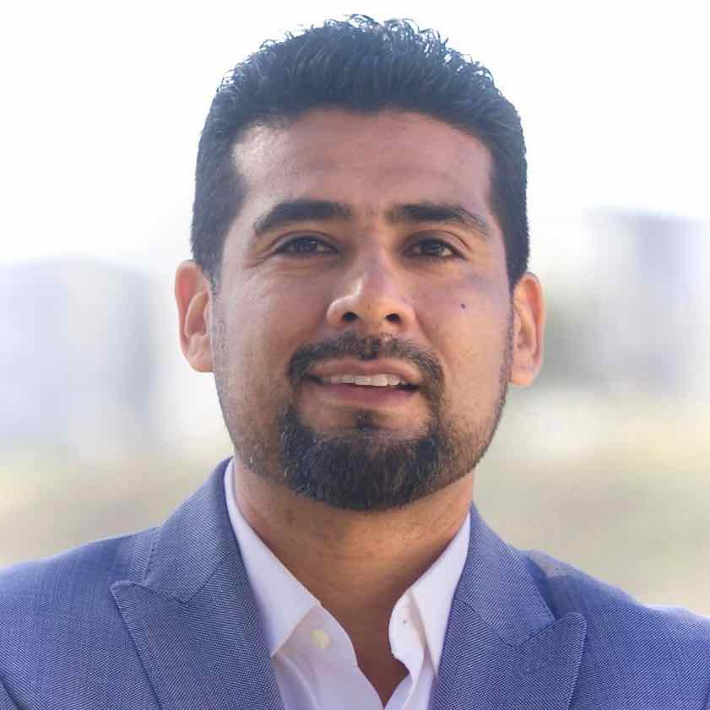

Martin M. Flores (Participant) was born and raised in the Boyle Heights community of East Los Angeles. At age 16, he participated in the Chicano Youth Leadership Program led by civil rights and Chicano Walks organizer Sal Castro. He attended the University of California at Berkeley, where he was the Director of Recruitment for the Raza Recruitment and Retention Center. It was there that Flores and Victor Rios connected. Following the tragic death of his youngest brother in a drive-by shooting, Flores established the Rogelio Flores Foundation in his memory and a program called Si Se Puede! Tutoring Program. He has over 25 years of experience working with children, youth and families and advocating for educational, employment and training services. Flores currently works as a gang expert on criminal and immigration cases throughout the state of California.
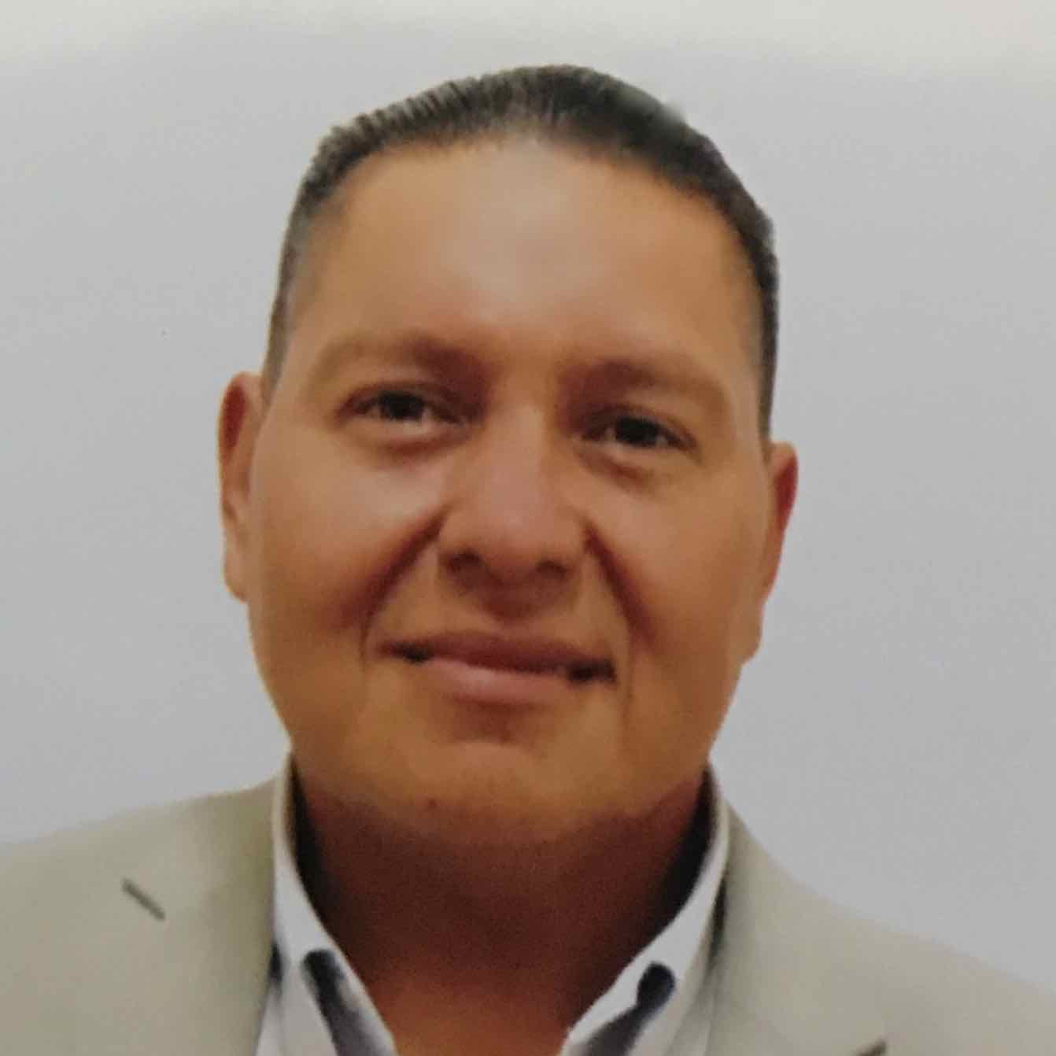

Katie Galloway (Director/Producer/Writer), founder and principal of BIG PICTURES, is a documentary filmmaker, investigative reporter and impact producer whose work explores the intersections of institutional power, civil and human rights, and political activism. Her feature documentary “The Return” (POV, 2016) is the third in her trilogy on the 21st century American justice system, which also includes “Better This World” (POV, 2011) and “Prison Town, USA” (POV, 2007). Galloway also produced and reported an award-winning trilogy of feature documentaries on the U.S. justice system for FRONTLINE in the late 1990s: “Snitch,” “The Case for Innocence” and “Requiem for Frank Lee Smith.” Galloway’s feature documentaries have been shown at New York’s MoMA and Lincoln Center and at festivals internationally, and have been awarded many top prizes including the Writers Guild of America’s Best Documentary Screenplay Award, Gotham Independent Film’s Best Documentary Award, an IDA Creative Achievement Award, Imagen’s Best Documentary prize, and top doc prizes from Tribeca and SF International. Her work has been nominated for five national Emmys, IDA’s Best Doc prize and a Peabody. Her short films have run in The New York Times Op-Docs, Field of Vision, The Marshall Project’s View Finder Series, PBS FRONTLINE, Mother Jones and USA Today. A three-time Sundance Fellow, Galloway has also held fellowships at Fledgling Fund, Film Independent and HBO, and she was named Filmmaker in Residence at UC Berkeley’s Investigative Reporting Program. She holds a Master’s from Columbia University Graduate School of Journalism, where she later taught Documentary Production, and a Ph.D. in Politics from UC Berkeley, where she also taught Documentary History and Theory in the Department of Media Studies.
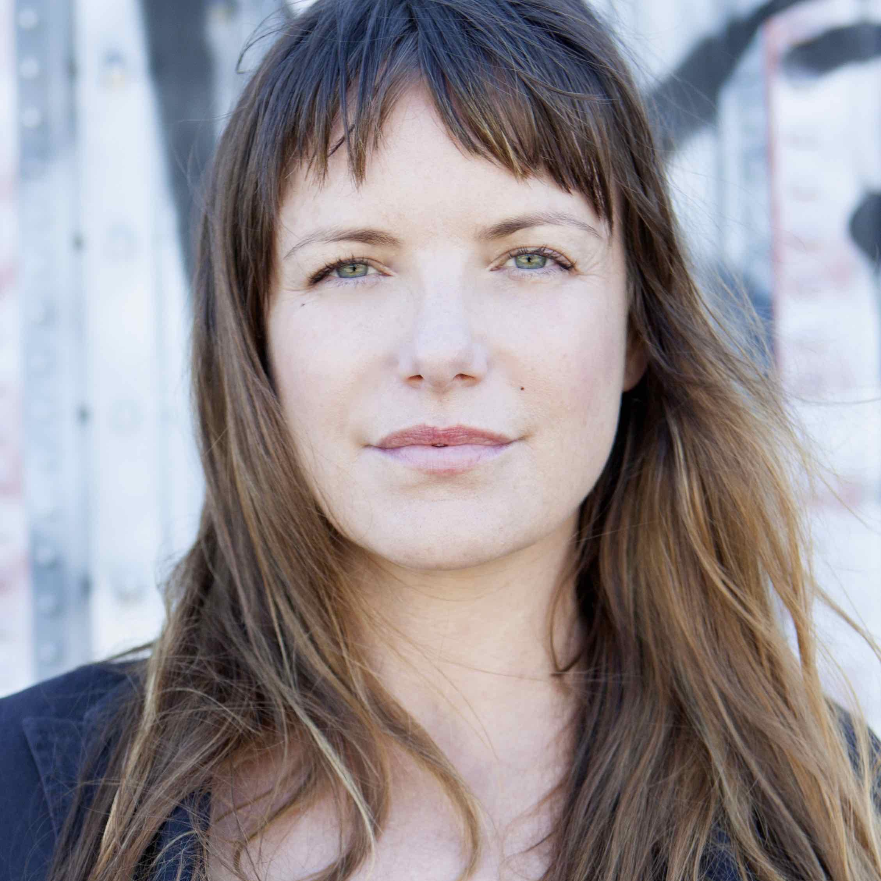

Dawn Valadez (Producer/Co-Director) is a filmmaker, social worker, artist, youth development specialist, resource wrangler and impact strategist. Her award-winning feature documentary Going on 13 premiered at the Tribeca Film Festival and has screened worldwide. In addition to co-helming “The Pushouts” impact campaign with Galloway, Valadez is directing and producing “Teacher Like Me,” a multi-media project coming in 2020 that will complete Valadez's trilogy on race, class, education and coming of age in 21st century America. Valadez’s work has been awarded numerous awards and honors, including the Al Bendich Award from the Berkeley Film Foundation (2016), the Saul Zaentz Artist Award (2017) and the Imagen Awards Best Documentary Award (2018). Valadez is on the producing team of Vivien Hillgrove’s personal documentary, Vivien’s Wild Ride. On the board of the Bay Area Video Coalition (BAVC), Valadez advises on documentary films and public engagement campaigns, and acts as a review panelist for a range of public documentary and other media funders. Raised by a Mexican farmworker/medical assistant single mother, Valadez attended L.A. public schools and was the first person in her family to graduate high school and college. She holds a Master’s of Social Welfare degree from UC Berkeley and lives and works in Oakland, California.
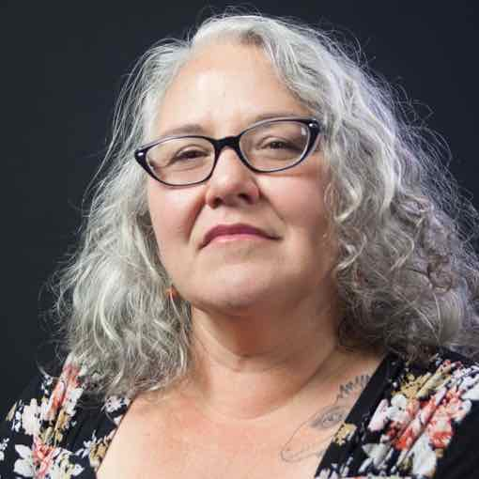

Edward James Olmos (Co-Founder and Chairman, Latino Public Broadcasting) has achieved extraordinary success as an actor, producer and humanitarian. The Tony, Emmy and Academy Award-nominated actor is probably best known to young audiences for his work on the SYFY series “Battlestar Galactica.” In 1988, the actor was nominated for an Academy Award and won the Golden Globe for his portrayal of Jaime Escalante in Stand and Deliver. Other notable films include Blade Runner, The Ballad of Gregorio Cortez and Selena. After recurring roles on “Miami Vice” and “The West Wing,” Olmos can now be seen on “Mayans, M.C.,” currently in its second hit season on FX.
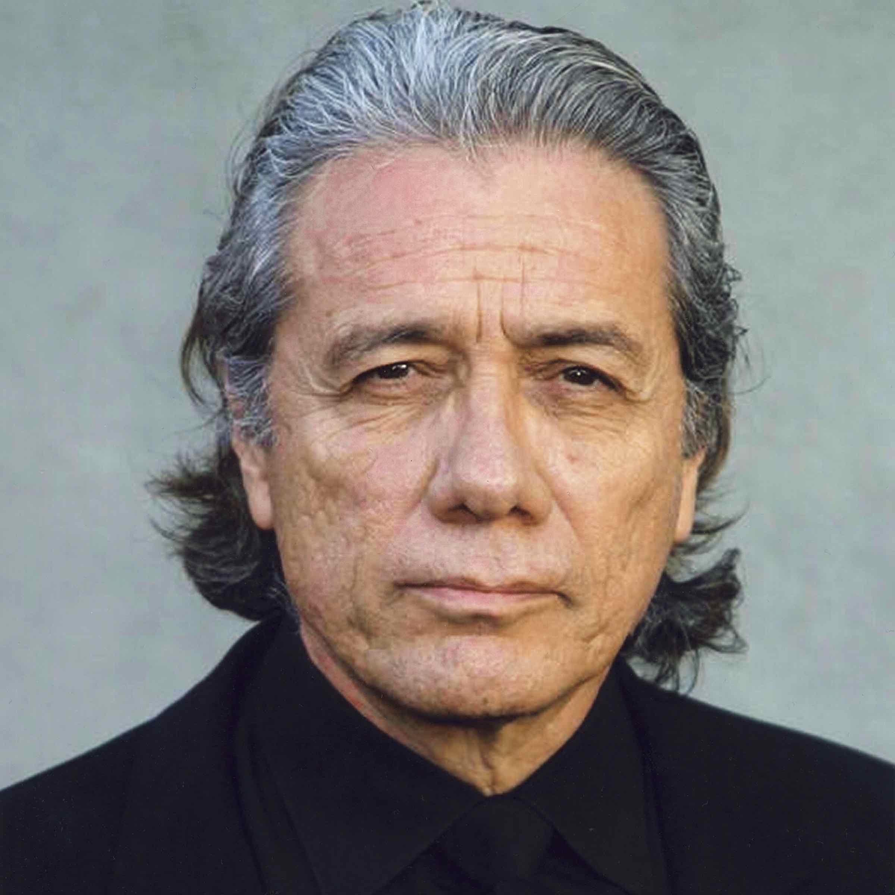

Olmos’ passion for the arts grows every year, but he never forgets to give back to the communities that support him with their dedication and support. He is an international advocate, spokesman and humanitarian working with organizations such as Thank You Ocean, Project Hope Foundation, Children’s Hospital of Los Angeles, The Boys and Girls Club of America and more.

