“Adios Amor: The Search for Maria Moreno” Premieres on VOCES
Friday, September 27, 2019 on PBS

The Haunting and Forgotten Story of Maria Moreno, an Eloquent Migrant Mother Who Became an Outspoken Leader for Farmworker Rights

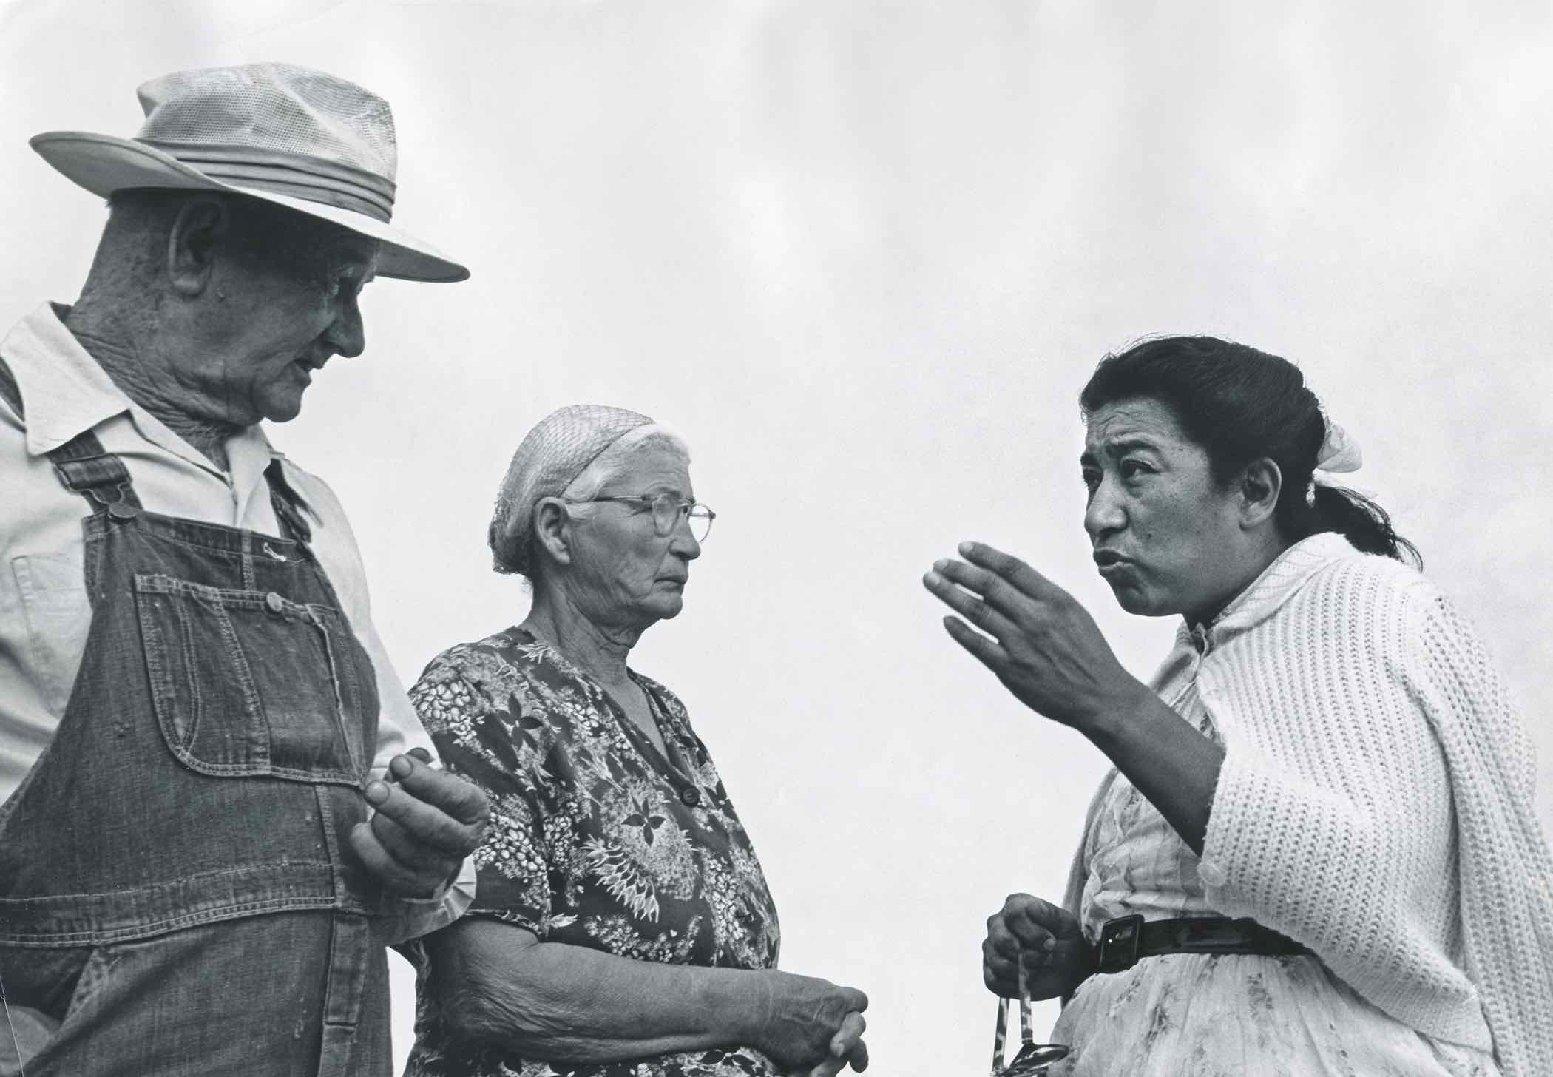
Moreno, right, talks to Okie farmworkers who were Dust Bowl migrants during the Great Depression.
Credit: © George Ballis/Take Stock
(LOS ANGELES, CA) — “Adios Amor: The Search for Maria Moreno,” a film by Laurie Coyle, premieres on VOCES, Latino Public Broadcasting’s arts and culture series, on Friday, September 27, 2019, 10:00-11:00 p.m. ET (check local listings), on PBS, PBS.org and the PBS Video App.

Before Dolores Huerta and Cesar Chavez, there was Maria Moreno. In “Adios Amor,” the discovery of lost photographs taken more than 50 years ago sparks the search for a hero who history forgot: Maria Moreno, a migrant mother who sacrificed everything but her 12 kids in the passionate pursuit of justice for farmworkers. Haunted by a personal tragedy and blessed with a gift for oratory, Maria rolled up her sleeves, collected signatures and electrified audiences. Elected to represent her fellow Mexican American, Filipino, Black and Okie farmworkers, she became the first female farmworker in America to be hired as a union organizer.

Filmmaker Coyle first saw photos of Maria Moreno 20 years ago, when she was the lead researcher and associate producer for the groundbreaking documentary The Fight in the Fields — Cesar Chavez and the Farmworkers’ Struggle. While searching for images of Chavez, she came across hundreds of photographs of a migrant mother organizing with her children at her side. Far from snapshots, these were master images taken by the leading photographer of the farmworker movement, George Ballis.

But aside from the well-known UFW leader Dolores Huerta, women farmworkers were usually anonymous and relegated to the background in press coverage. Coyle wondered about the woman in the photographs, but it would be another two decades before she could return to the story.

“When my search began, I didn’t know what I would find or whether Maria Moreno would still be living,” Coyle said. “With a measure of luck and a lot of work, I traced her life and legacy.”

From California’s great Central Valley to the Arizona desert and U.S.-Mexico border, the search for Maria yields a deeply human drama about Mexican American farmworkers living in dire poverty at a time of unprecedented abundance, whose faith, family values and working-class culture sustained them. Featuring photographers, reporters, radio producers, labor activists, historians and Maria’s children, “Adios Amor: The Search for Maria Moreno” pays tribute to the people whose hard work feeds the nation and celebrates the courageous woman who told their story to the world.

Also premiering in this season of VOCES are “Raúl Juliá: The World’s a Stage” (a co-presentation of VOCES and AMERICAN MASTERS) on September 13, “The Pushouts” on September 20 and “Porvenir, Texas” on October 4. For complete information, visit VOCES website.

* * *

About the Filmmaker

Laurie Coyle (Director/Producer) is a documentary filmmaker and writer. “Adios Amor” premiered at the Cinequest Film Festival in 2018. Her film “OROZCO: Man of Fire” aired on the PBS series AMERICAN MASTERS and was nominated for the Imagen Award and National Council of La Raza ALMA Award. Laurie’s writing credits include the award-winning “hillbilly,” the PBS specials “Speaking in Tongues,” “The Slanted Screen,” “Life on Four Strings” and “The Journey of the Bonesetter’s Daughter — The Making of an Opera.” Her work has been supported by the National Endowment for the Arts, National Endowment for the Humanities, Latino Public Broadcasting, San Francisco Arts Commission and Creative Work Fund, among others. She associate-produced “The Fight in the Fields, Cesar Chavez and the Farmworkers’ Struggle,” “The Good War and Those Who Refused to Fight It,” and AMERICAN MASTERS “Ralph Ellison: An American Journey.” Before becoming a filmmaker, Laurie majored in political theory at UC Berkeley and worked as an oral historian, focusing on the untold stories of women workers.

Says Coyle: “‘Adios Amor’ represents a homecoming for me. The year that Maria Moreno was pushed out of the labor movement, my parents uprooted our family of nine from the East Coast and moved to the Bay Area. In those days, there were still traces of the farms that had been the heart of the Santa Clara Valley. The public library in our town was built in the middle of an apricot orchard, and we would collect the apricots that fell to the ground. But we knew nothing about the lives and struggles of the workers who grew the food on our table—not until the California grape strike started and Dad began volunteering at the farmworker clinic in Delano. Although our lives were so different, I felt an immediate connection when I met the Morenos, having also grown up in a big family. My search for Maria became their search —sharing childhood memories, visiting their mother’s birthplace, embarking on a pilgrimage to the desert that had sustained them during their mother’s exile from the labor movement. I hope that ‘Adios Amor’ will inspire viewers to launch their own journeys of discovery, and to ask how history is shaped and whose voices are represented.”

About VOCES
Produced by Latino Public Broadcasting, the acclaimed PBS documentary series VOCES features the best of Latino arts, culture and history and shines a light on current issues that impact Latino Americans. Devoted to exploring the rich diversity of the Latino experience, VOCES presents new and established filmmakers and brings their powerful and illuminating stories to a national audience — on TV, online and on the PBS app. VOCES is presented by PBS SoCal and supported in part by the National Endowment for the Arts. Luis Ortiz is Series Producer; Sandie Viquez Pedlow is Executive Producer. Follow us on Facebook and Twitter.

About Latino Public Broadcasting
Latino Public Broadcasting (LPB) is the leader in the development, production, acquisition and distribution of non-commercial educational and cultural media that is representative of Latino people, or addresses issues of particular interest to Latino Americans. These programs are produced for dissemination to public broadcasting stations and other public telecommunication entities. Latino Public Broadcasting provides a voice to the diverse Latino community throughout the United States and is funded by the Corporation for Public Broadcasting. Latino Public Broadcasting produces VOCES, the signature Latino arts and culture documentary series on PBS devoted to exploring the rich diversity of the Latino cultural experience. Between 2009 and 2019, LPB programs won over 125 awards, including two prestigious George Foster Peabody Awards as well as Emmys, Imagen Awards and the Sundance Film Festival Award for Best Director, Documentary. In addition, LPB has been the recipient of the Norman Lear Legacy Award and the NCLR Alma Award for Special Achievement – Year in Documentaries. Sandie Viquez Pedlow is Executive Director of LPB; Edward James Olmos is Co-founder and Chairman.

About PBS SoCal
PBS SoCal delivers content and experiences that inspire, inform and entertain – over the air, online, in the community and in the classroom. We offer the full slate of beloved PBS programs including MASTERPIECE, NOVA, PBS NewsHour, Frontline, Independent Lens, a broad library of documentary films including works from Ken Burns; and educational PBS KIDS programs including Daniel Tiger’s Neighborhood and Curious George. Our programs are accessible for free through four broadcast channels, and available for streaming at pbssocal.org, on the PBS mobile apps, and via connected TV services Android TV, Roku, Apple TV and Amazon Fire TV. PBS SoCal is a donor-supported community institution that is a part of Public Media Group of Southern California, the flagship PBS station for 19 million diverse people across California.

###

Press Contacts:
CaraMar, Inc.
Mary Lugo 770-623-8190 lugo@negia.net
Cara White 843-881-1480 cara.white@mac.com
Abbe Harris 908-244-5516 abbe.harris@caramar.net

For downloadable images, visit pbs.org/pressroom/

