Latino Public Broadcasting’s
VOCES American Exile
Premieres Tuesday, November 16, 2021 on PBS
In Conjunction with Veteran’s Day

New Documentary Explores the Plight of U.S. Veterans
Living Under the Threat of Deportation

(LOS ANGELES, CA) — As teenagers, Valente Valenzuela and his brother Manuel volunteered and were sent to fight in Vietnam. They came home decorated but also physically and psychologically scarred. Now, some 50 years later, they’ve received deportation notices. Shocked and confused, the brothers soon learn they are not alone; thousands of American military veterans have been or are in danger of being deported because of misdemeanor offenses committed after completing their service. Valente and Manuel decide to don their uniforms for one last fight — to “leave no soldier behind” and bring deported veterans and their families back home. Filmed over seven years, American Exile is a deeply personal film about two men seeking justice for themselves and the thousands of others in their situation. Produced by John J. Valadez and Carleen L. Hsu, American Exile premieres as part of Latino Public Broadcasting’s VOCES on Tuesday, November 16, 2021, 10:00-11:00 p.m. ET (check local listings) on PBS, pbs.org and the PBS Video app as part of PBS’s commemoration of Veteran’s Day.
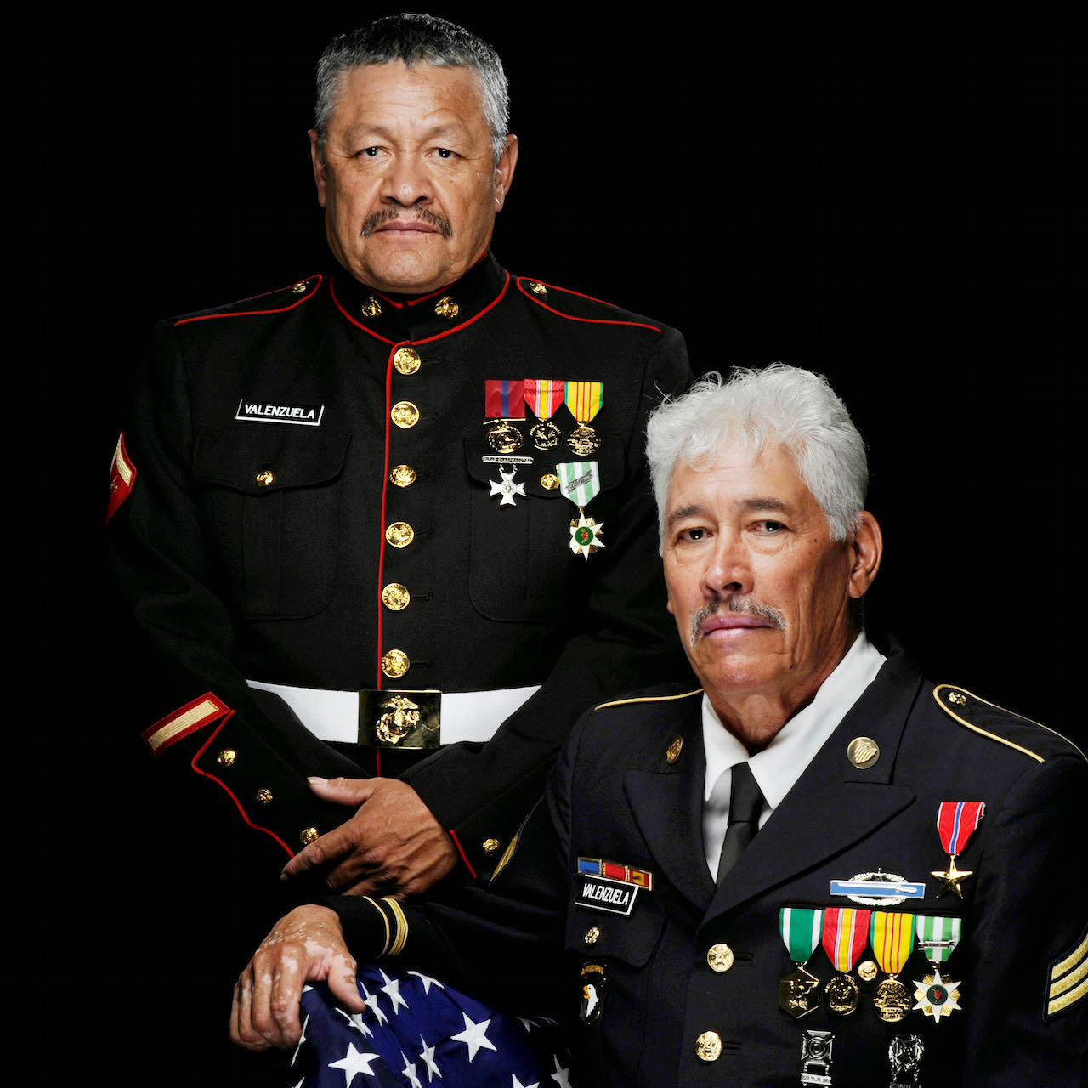
Manuel and Valente Valenzuela.
Credit: Courtesy of the Valenzuela brothers.

For Valente, who has crippling PTSD, the anxiety of being under the constant threat of deportation is destroying his life. Manuel, however, is determined not to give up without a fight. A grandfather and teacher of Tae Kwon Do, he embarks on a cross-country road trip from his home in Colorado to Washington, DC, to ask President Trump for an executive order ending the deportation of military veterans and their families. Along the way, he meets other veterans impacted by deportation; people like Zahid Chaudhry, a Pakistani immigrant whose military injuries left him wheelchair-bound and in chronic pain, and Olivia Segura, whose daughter was killed in the Gulf War. Her husband —a Gold Star father — developed a drinking problem after the devastating loss of his daughter, was pulled over by the police and has been incarcerated for three years awaiting deportation.

Valente and Manuel didn’t know it at the time, but their problems were set into motion almost 30 years ago. The 1980s and early 1990s saw the largest wave of immigration in the nation’s history. Twenty-two million people, both with and without documentation, came into the country, mostly from Mexico and Latin America.

President Clinton responded in 1996 by signing the Illegal Immigration and Immigrant Responsibility Act. But the new law had unexpected consequences for veterans. With some 50,000 foreign nationals serving in the U.S. armed forces at any given time, and with over half a million foreign-born veterans living in the United States, many of them found themselves suddenly vulnerable to deportation.

The new law took away judicial discretion and banned judges from considering factors like service to country, family, medals of honor, disability due to military service, and longevity in the country. The law also made minor offenses like shoplifting, driving with an expired license, or possession of marijuana deportable violations. Some veterans, like the Valenzuela brothers, had minor run-ins with the law decades ago, some committed serious offenses and served jail time, others were simply the victims of bureaucratic errors, but all became deportable. According to immigration scholars, before the 1996 law went into effect, there had never been an American military veteran deported. Today exiled veterans probably number in the tens of thousands, but because no government agency tracks deported veterans, the exact number is unknown.

But the voices of veterans facing deportation has finally been heard. On July 2, 2021, President Biden, ordered the Department of Homeland Security (DHS) to immediately create a process for deported veterans and their families to return home to the United States.

American Exile is produced by John J. Valadez and Carleen Hsu, directed by John J. Valadez and edited by Carleen Hsu. American Exile is a co-production of Burning Box Studio and WKAR Public Media/East Lansing in association with Latino Public Broadcasting (LPB) with funding provided by the John D. and Catherine T. MacArthur Foundation, Michigan State University, WKAR, the New York State Council for the Arts, ITVS and the National Association of Latino Arts and Culture. Major funding for VOCES is provided by the National Endowment for the Arts (NEA) and the Corporation for Public Broadcasting (CPB). American Exile is presented by PBS SoCal and WKAR Public Media/East Lansing.

American Exile will be available for streaming concurrent with broadcast on all station-branded PBS platforms, including PBS.org and the PBS Video App, available on iOS, Android, Roku streaming devices, Apple TV, Android TV, Amazon Fire TV, Samsung Smart TV, Chromecast and VIZIO. PBS station members can view many series, documentaries and specials via PBS Passport. For more information about PBS Passport, visit the PBS Passport FAQ website.

About the Filmmakers

John J. Valadez (Writer/Director/Producer) is a Peabody Award-winning filmmaker who has directed a dozen nationally broadcast films for PBS and CNN over the past 25 years. His work explores themes of race and power, particularly regarding Latinx Americans. They tackle such diverse subjects as the false imprisonment of a leader of the Black Panther Party (Passin’ It On, POV/PBS), Latino gangs in Chicago (Making Peace, ITVS/PBS), Latinos in World War II (Latino Americans, WETA/PBS), the birth of Latino civil rights (The Longoria Affair, INDEPENDENT LENS/PBS), the evolution of Chicano music (Latin Music USA, WGBH/PBS), genocide, art and Native Americans in the southwest (The Last Conquistador, POV/PBS), the Chicano movement of the 1960s and 1970s (Latino Americans, WETA/PBS), segregation in a small southern town (Matters of Race, PBS/ITVS), and the lynching of Mexican Americans (The Head of Joaquin Murrieta, PBS). His films have garnered top prizes at festivals from San Francisco to Chicago to Mumbai and have been broadcast across the U.S., Canada, and Europe. He has a BFA from NYU's Tisch School of the Arts and an MFA from the Vermont College of Fine Arts. John is the Director of the Documentary Film Program (the DOC LAB) at Michigan State University.

Carleen L. Hsu (Producer, Editor) has produced and co-produced long-form non-fiction films for HBO, PBS, the Learning Channel, BBC, CBC, and Channel 4 UK, with subjects ranging from the obesity epidemic in America to gender identity in Thailand to faith healing in Africa. The documentaries have been recognized for their exceptional storytelling and original content with two George Foster Peabody Awards, a Royal Television Society Award, a Grierson Award, a Foreign Press Association Award for Best Documentary, and a nomination for a national News and Documentary Emmy. Themes of health, science, and the environment permeate much of her work. She has received grants from the MacArthur Foundation, ITVS, the New York State Council for the Arts, the National Endowment for the Humanities, Latino Public Broadcasting, the Knight Center for Environmental Journalism and Michigan State University. Currently, she is a Professor of Practice in the School of Journalism and the Film Studies Program at Michigan State University. Carleen is a graduate of NYU’s Tisch School of the Arts and Columbia University’s Graduate School of Journalism.

About VOCES
Produced by Latino Public Broadcasting, the acclaimed PBS documentary series VOCES features the best of Latino arts, culture and history and shines a light on current issues that impact Latino Americans. Devoted to exploring the rich diversity of the Latino experience, VOCES presents new and established filmmakers and brings their powerful and illuminating stories to a national audience — on TV, online and on the PBS app. VOCES is supported in part by the National Endowment for the Arts. Luis Ortiz is series producer; Sandie Viquez Pedlow is executive producer. Follow us on Facebook and Twitter.
About Latino Public Broadcasting
Latino Public Broadcasting (LPB) is the leader in the development, production, acquisition and distribution of film and digital cultural media that is representative of Latino people or addresses issues of particular interest to Latino Americans. These programs are produced for dissemination to public broadcasting stations and other public media entities. Providing a voice for the diverse Latino community throughout the United States, Latino Public Broadcasting is funded by the Corporation for Public Broadcasting. LPB also produces the acclaimed PBS documentary series VOCES, exploring the rich diversity of the Latino experience. VOCES presents new and established filmmakers and brings their powerful and illuminating stories to a national audience — on TV, online and on the PBS app.
Between 2009 and 2020, LPB programs won over 130 awards, including three prestigious George Foster Peabody Awards as well as Emmys, Imagen Awards and the Sundance Film Festival Award for Best Director, Documentary. LPB has been the recipient of the Norman Lear Legacy Award and the NCLR Alma Award for Special Achievement – Year in Documentaries. Sandie Viquez Pedlow is executive director of LPB; Edward James Olmos is co-founder and chairman.

###
Press Contacts:
CaraMar, Inc.
Mary Lugo 770-851-8190 lugo@negia.net
Cara White 843-881-1480 cara.white@mac.com
Abbe Harris 908-244-5516 abbe.harris@caramar.net

For downloadable images, visit pbs.org/pressroom/

