Latino Public Broadcasting’s VOCES Presents
“Building the American Dream”
Tuesday, September 15, 2020

New Documentary Chronicles the Plight of Immigrant Construction Workers Fighting for Fair Working Conditions

(LOS ANGELES, CA) — Latino Public Broadcasting (LPB) today announced that the new VOCES special, “Building the American Dream,” premieres Tuesday, September 15, 2020, 10:00-11:00 p.m. ET on PBS, pbs.org and the PBS Video app. Produced and directed by Chelsea Hernandez, “Building the American Dream” tells the powerful story of immigrant construction workers fighting for justice in an industry rife with exploitation.
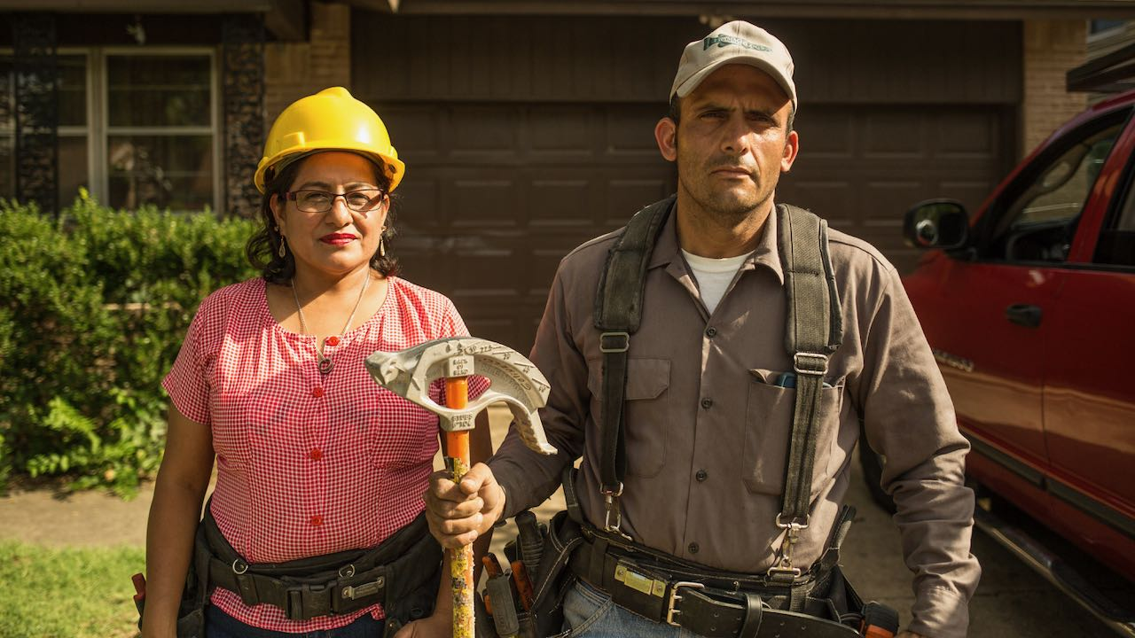
Claudia and Alex, electricians from El Salvador now living in Texas. Credit: Moyo Oyelola

“Building the American Dream” takes viewers to Texas, the site of a massive construction boom heralded as the “Texas Miracle.” Its dirty secret: the abuse of immigrant workers. The film captures the rise of a workers’ movement, fighting widespread construction industry injustices – from non-payment of wages to deadly work conditions.

Grieving their son who died a heat-related death on a construction site, the Granillo family campaigns for a much-needed safety law that would allow workers 10-minute breaks for every four hours of labor. Claudia and Alex, a Salvadoran couple, are skilled electricians owed thousands in back pay who fight for their children’s future. And Christian, a bereaved son, hopes to protect others from his family’s preventable tragedy. Through their stories of courage, resilience and community, the film reveals eye-opening truths about the hardworking immigrants who build our American Dream.

“We’re proud to present this timely documentary about Latino essential workers who are advocating for more equitable working conditions,” said Sandie Viquez Pedlow, executive director of LPB and executive producer of VOCES. “As we hear about the Latino workers whose jobs are considered essential and are bearing a disproportionate burden during this pandemic, this film is a stark reminder of all the Latinos who work in dangerous conditions to keep our nation running during good times and bad.”

“Building the American Dream” is a production of Panda Bear Films in association with Latino Public Broadcasting. Major funding was provided by the Ford Foundation, Tribeca Film Institute, Firelight Media, Seed & Spark, Adaptive Studios, City of Austin, BAVC National Mediamaker Program, Austin Film Society, Marcy Garriott, the Corporation for Public Broadcasting and is a presentation of Austin PBS.

About the Filmmaker
Chelsea Hernandez (Producer/Director) is an Emmy® Award-winning Mexican-American filmmaker based in Austin, Texas, named one of Texas Monthly’s “10 Filmmakers on the Rise.” Chelsea began her career in media at the ripe age of nine, hosting and co-producing a local children’s educational TV program with her mother. Chelsea received a B.S. from the University of Texas, the first in her Latino family to earn a college degree. She began her documentary career right out of college, as associate producer and assistant editor of the national PBS special, Fixing the Future, hosted by David Brancaccio and directed by Ellen Spiro, and the national six-part series Ancient Roads from Christ to Constantine directed by Hector Galán. From 2013 to 2016, Chelsea was the primary editor and co-producer of Arts in Context, a documentary series produced at KLRU-TV and distributed by NETA. Chelsea has directed and produced various documentary films, including See the Dirt (Austin Film Festival Short Documentary Winner) and, most recently, An Uncertain Future (SXSW Texas Jury Winner, AspenShorts Youth Jury Winner, CineFestival Short Winner). Chelsea is a NALIP Latino Media Market fellow, Firelight Media Doc Lab Fellow, Tribeca Storylab Fellow, Tribeca All Access Recipient, BAVC National Mediamaker Fellow and UC Berkeley Investigative Reporting Workshop Fellow.

About PBS
PBS, with more than 330 member stations, offers all Americans the opportunity to explore new ideas and new worlds through television and digital content. Each month, PBS reaches over 126 million people through television and 26 million people online, inviting them to experience the worlds of science, history, nature and public affairs; to hear diverse viewpoints; and to take front row seats to world-class drama and performances. PBS’ broad array of programs has been consistently honored by the industry’s most coveted award competitions. Teachers of children from pre-K through 12th grade turn to PBS for digital content and services that help bring classroom lessons to life. Decades of research confirms that PBS’ premier children’s media service, PBS KIDS, helps children build critical literacy, math and social-emotional skills, enabling them to find success in school and life. Delivered through member stations, PBS KIDS offers high-quality educational content on TV – including a 24/7 channel, online at pbskids.org, via an array of mobile apps and in communities across America. More information about PBS is available at www.pbs.org, one of the leading dot-org websites on the internet, or by following PBS on Twitter, Facebook or through our apps for mobile and connected devices. Specific program information and updates for press are available at pbs.org/pressroom or by following PBS Pressroom on Twitter.

About VOCES
Produced by Latino Public Broadcasting, the acclaimed PBS documentary series VOCES features the best of Latino arts, culture and history and shines a light on current issues that impact Latino Americans. Devoted to exploring the rich diversity of the Latino experience, VOCES presents new and established filmmakers and brings their powerful and illuminating stories to a national audience — on TV, online and on the PBS app. VOCES is supported in part by the National Endowment for the Arts. Luis Ortiz is series producer; Sandie Viquez Pedlow is executive producer. Follow us on Facebook and Twitter.

About Latino Public Broadcasting
Latino Public Broadcasting (LPB) is the leader in the development, production, acquisition and distribution of non-commercial educational and cultural media that is representative of Latino people, or addresses issues of particular interest to Latino Americans. These programs are produced for dissemination to public broadcasting stations and other public telecommunication entities. Latino Public Broadcasting provides a voice to the diverse Latino community throughout the United States and is funded by the Corporation for Public Broadcasting. Latino Public Broadcasting produces VOCES, the signature Latino arts and culture documentary series on PBS devoted to exploring the rich diversity of the Latino experience. Between 2009 and 2020, LPB programs won over 125 awards, including three prestigious George Foster Peabody Awards as well as Emmys, Imagen Awards and the Sundance Film Festival Award for Best Director, Documentary. In addition, LPB has been the recipient of the Norman Lear Legacy Award and the NCLR Alma Award for Special Achievement – Year in Documentaries. Sandie Viquez Pedlow is executive director of LPB; Edward James Olmos is co-founder and chairman.

###
Press Contacts:
CaraMar, Inc.
Mary Lugo 770-623-8190 lugo@negia.net
Cara White 843-881-1480 cara.white@mac.com
Abbe Harris 908-244-5516 abbe.harris@caramar.net

For downloadable images, visit pbs.org/pressroom/

