“CHILDREN OF GIANT” KICKS OFF NEW SEASON
OF VOCES ON APRIL 17, 2015 ON PBS

60 Years Later, Filmmaker Hector Galán Revisits the Making of George Stevens’ Classic “Giant” in Marfa, Texas, Exploring How the Film Reflected and Transformed the Lives of the Town’s Anglo- and Mexican-American Residents

(LOS ANGELES, CA) —“Children of Giant,” a new documentary that explores how the making of a classic Hollywood movie transformed the lives of the residents of a small Texas town, will premiere on Friday, April 17, 2015 on PBS. Directed by Hector Galán, “Children of Giant” is the season opener for VOCES, Latino Public Broadcasting’s arts and culture series on PBS, presented by PBS SoCaL.
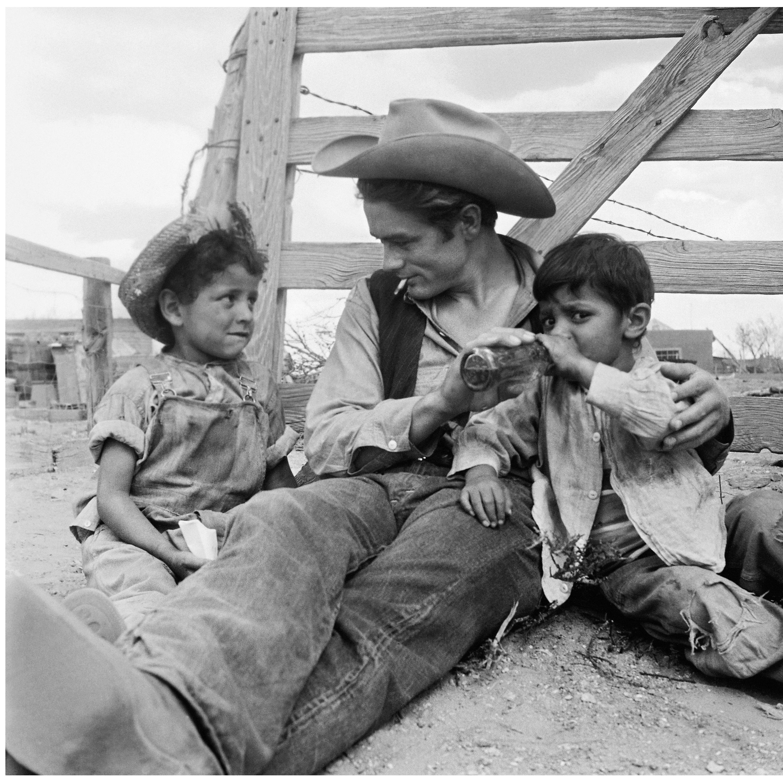
James Dean on location in Marfa, Texas, in 1955.
Credit: Richard C. Miller

In the summer of 1955, it seemed as if all of Hollywood had descended on the dusty West Texas town of Marfa as production began on the highly anticipated movie Giant. The film starred a legendary trio — Elizabeth Taylor, Rock Hudson and James Dean — along with the young actor Earl Holliman and 16-year-old Elsa Cardenas, who portrayed Juana, the Mexican-American girl who marries into the powerful Benedict ranching dynasty. Based on Edna Ferber’s controversial novel, Giant was a different kind of western, one that took an unflinching look at feminism and class divisions and one of the first films to explore the racial divide between Anglos and Mexican Americans in the Southwest.

Now, 60 years later, “Children of Giant” returns to Marfa to explore the dramatic story behind the making of the film and its enduring legacy. The program combines interviews with the surviving cast and crew of Giant —including George Stevens, Jr., Earl Holliman and Elsa Cardenas — with the recollections of residents who participated in the production, many of whose lives mirrored the controversial themes of racism and segregation explored in the film. Featuring rare behind-the-scenes footage and never-before-seen photos, “Children of Giant” includes interviews with several noted film historians.

Giant earned 10 Academy Award nominations, with a win for George Stevens as Best Director. The film is included on the American Film Institute’s list of the top 100 films of all time, but for Latino historians, poets and filmmakers, the appreciation for Giant runs far deeper. “Children of Giant” celebrates a film classic that remains as powerful and relevant today as when it was first released.

* * *
About the Participants, in Alphabetical Order
Charles Ramirez Berg, professor at the University of Texas, Austin, and author of Latino Images in Film: Stereotypes, Subversion, and Resistance
Elsa Cardenas, actor, Giant
Boyd Elder, artist
Wanda Garcia, daughter of Mexican-American civil rights activist Dr. Hector P. Garcia
Robert Hinkle, dialogue coach on Giant
Earl Holliman, actor, Giant
Victoria Looseleaf, journalist/author
M.G. Lord, author of The Accidental Feminist
Marilyn Ann Moss, author of Giant: George Stevens, a Life on Film
Chale Nafus, director of programming, Austin Film Society
Jaime Jimenez Pons, film producer
Ramon Renteria, El Paso Times journalist and extra in Giant
Jim Silke, film journalist
J.E. Smyth, author, Edna Ferber’s Hollywood
George Stevens, Jr., son of Giant director George Stevens
Cecilia Thompson, Presidio County historian

Current and former Marfa residents Joe Cabezuela, Zaide Cabezuela, Tony Cano, Wally Cech, Jane Crockett, Lucy and Mando Garcia, Brenda Garcia, Maggie Marquez, Linda Howard McKnight, Mateo Quintana, William Quintana and Olivia Roman.

About Filmmaker Hector Galán (Executive Producer/Director)
Multi-award-winning documentarian Hector Galán has a long history of almost 25 years with PBS, having produced numerous specials as well as productions for AMERICAN EXPERIENCE and FRONTLINE. In 2014, Galán completed a six-part global television series, “The Road From Christ to Constantine,” filmed in Israel, Turkey, Italy, North Africa, Greece and England. Galán was a founding board member of ITVS, has served on the PBS Content Committee and has mentored at the CPB Producers Academy.

Credits
Narrated by |  | Henry Cisneros
Produced and directed by |  | Hector Galán
Producers |  | Evelyn Ledesma Galan and Karen Bernstein
Executive producers |  | Carolyn Pfeiffer and Hector Galán
Original music by |  | Joseph Julian Gonzalez
VOCES executive producer |  | Sandie Viquez Pedlow

About VOCES
Produced by Latino Public Broadcasting, VOCES is PBS’ signature Latino arts and culture documentary showcase and the only ongoing national television series devoted to exploring and celebrating the rich diversity of the Latino cultural experience. The series is presented by PBS SoCaL and supported in part by the National Endowment for the Arts, the National Association of Latino Arts and Cultures, the Ford Foundation, and the Surdna Foundation through a grant from the NALAC Fund for the Arts Grant Program. More information about VOCES is available at VOCES on Facebook or Twitter.

About Latino Public Broadcasting
Latino Public Broadcasting (LPB) is the leader in the development, production, acquisition and distribution of non-commercial educational and cultural media that is representative of Latino people, or addresses issues of particular interest to Latino Americans. These programs are produced for dissemination to public broadcasting stations and other public telecommunication entities. Latino Public Broadcasting provides a voice to the diverse Latino community throughout the United States and is funded by the Corporation for Public Broadcasting. Latino Public Broadcasting produces the series VOCES, PBS’ signature Latino arts and culture documentary showcase and the only ongoing national television series devoted to exploring and celebrating the rich diversity of the Latino cultural experience. Between 2009 and 2014, LPB programs won 85 awards, including the prestigious George Foster Peabody Award, two Emmys, two Imagen Awards and the Sundance Film Festival Award for Best Director, Documentary. In addition, LPB has been the recipient of the Norman Lear Legacy Award and the NCLR Alma Award for Special Achievement – Year in Documentaries.

About PBS SoCaL
PBS SoCaL is the only station in the Greater Los Angeles area providing the full PBS schedule to Southern California and is home to all PBS program premieres as they are released nationally. As Southern California’s full-service PBS station, PBS SoCaL provides early education, access to a broad array of arts and culture, and programs for, about and by the people of Southern California.

PBS SoCaL is the parent to three unique broadcast channels, PBS SoCaL/KOCE-HD, PBS SoCaL Plus and PBS SoCaL World, which are dedicated to educating, entertaining and enlightening viewers throughout Southern California. PBS SoCaL offices are located in downtown LA, Century City and Costa Mesa. PBS SoCaL is proudly our communities’ largest classroom, largest stage for the arts and trusted source of information. Explore the future of PBS in Southern California at www.pbssocal.org.
###
Press Contacts:
CaraMar, Inc.
Mary Lugo 770-623-8190 lugo@negia.net
Cara White 843-881-1480 cara.white@mac.com
Abbe Harris 908-233-7990 abbe@caramar.net

For downloadable images, visit pbs.org/pressroom/



