Latino Public Broadcasting’s
VOCES “Letters to Eloisa”
Premieres Friday, October 15, 2021 on PBS

New Documentary by Adriana Bosch Tells the Tragic Story of
Cuban Writer José Lezama Lima

(LOS ANGELES, CA) — Told through the haunting letters written by the acclaimed Cuban writer José Lezama Lima to his sister living in exile, Letters to Eloísa tells the remarkable story of one of Latin America’s most revered writers. Weaving together the public and the private, the literary and the political, the film reveals how Lezama’s voice, at first amplified by the revolution’s cultural policies, was ultimately silenced by the absence of creative freedom in Cuba during its most tumultuous decades. A film by Adriana Bosch, Letters to Eloisa features Alfred Molina as the voice of Lezama and music by Arturo Sandoval. The film premieres as part of Latino Public Broadcasting’s VOCES on Friday, October 15, 2021, 10:00-11:00 p.m. ET (check local listings) on PBS, pbs.org and the PBS Video app.
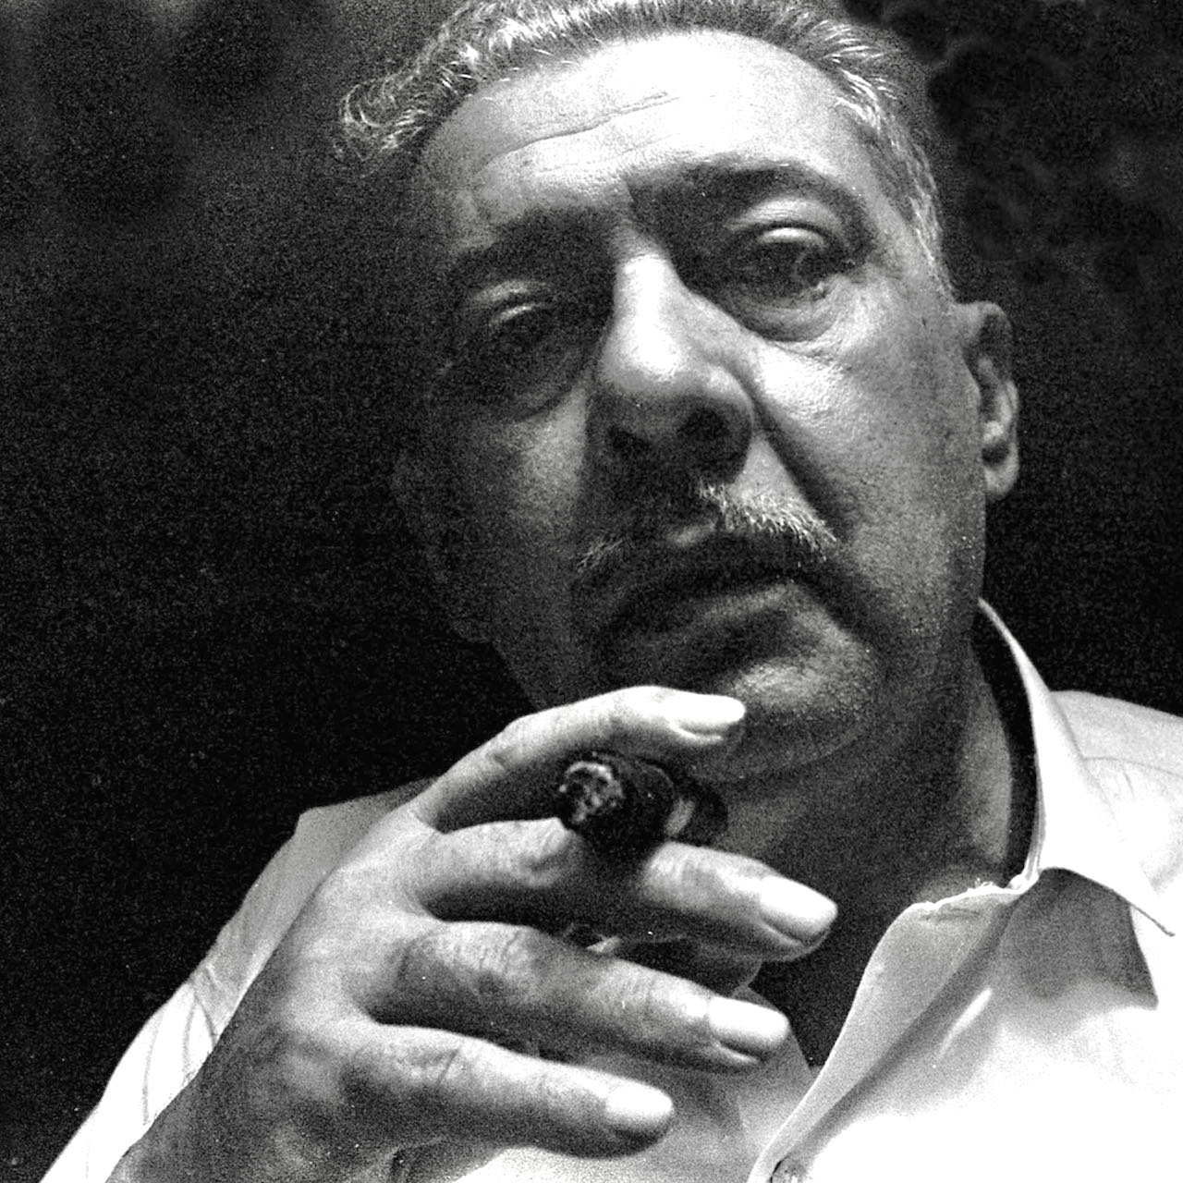
Credit: Ivan Cañas

Arguably the most influential Cuban writer of the 20th century, Lezama was part of the mid-century Latin American literary boom that included Julio Cortázar, Gabriel García Márquez, Octavio Paz and Mario Vargas Llosa. His semi-autobiographical opus, Paradiso, was considered a masterwork, but it also included graphic homoerotic scenes which sent shockwaves throughout the Spanish-speaking literary world. “Never had such an openly homosexual novel, so extraordinary in its use of images, so Cuban, and so Latino American been written,” Reinaldo Arenas, author of Before Nightfall, observes. Its publication would set Lezama on a collision course with the Cuban Revolutionary government.

José Lezama Lima was born in 1910 and grew up in an aristocratic family that eventually fell into genteel poverty. Passionate about literature, he became a celebrated poet and founded an influential literary journal, Orígenes. As its editor, he became the leader of a group of Cuban intellectuals determined to save their culture by reaffirming its identity against America’s modernizing influence and the corruption prevalent in the Cuban Republic of the 1940s and 50s.

When Castro assumed power in 1959 Lezama saw the revolution as “the triumph of Cuba’s finest aspirations,” as it promised to affirm the universality and strength of Cuban culture that Orígenes had promoted. Lezama contributed to the cultural flourishing of the revolution’s early years, but he soon fell out of step with Cuba’s growing revolutionary zeal, its macho, militaristic aesthetics, and its crackdown on dissent.

With the publication of Paradiso, Lezama clashed with the government’s virulent homophobia that included the separation of thousands from their careers. Homosexuals were even interned in concentration camps—the infamous UMAPs—where they were subjected to forced “rehabilitation” that included hard labor and even physical torture, as recent research has revealed.

A closeted homosexual, Lezama avoided the worst of the repression. But his book provoked a scandal unprecedented in Cuban literature and was temporarily removed from bookstores.

Influential friends outside of Cuba helped Lezama survive this first confrontation with the revolution’s leaders. The novel was soon published in Mexico and Spain and translated into Italian, French and English, catapulting Lezama to the heights of the literary world during the heady period known as the Latin American Boom. Finally, the book returned to bookshelves in Cuba, but the book would not be reissued in Cuba for 25 years, and Lezama was never again trusted by the government.

Then, on March 20, 1971, dissident poet Heberto Padilla was jailed on vague charges of “having plotted against the powers of the state.” After weeks of physical and psychological torture, Padilla publicly “confessed his crimes.” In what came to be known as “The Padilla Affair,” he named names of other intellectuals disaffected with the Revolution, among them Lezama, whom he accused of “being ungrateful to the revolution and making private jokes against it.”

Lezama’s world ended on that day. He was censored and ostracized, his books removed from libraries and bookstores. His name was never again mentioned in journals or in the Cuban classroom. And old friends, fearing political consequences, no longer visited. Despite numerous invitations to collect literary prizes and speak at conferences, Lezama was never allowed to leave the island and remained a virtual prisoner in his Havana home for the next six years. His pain and desolation filled the pages of letters to his sister Eloisa.

His death on August 9, 1976, was mourned on the front pages of newspapers across the world, but in his native Cuba, only a few lines would note his passing in the official national newspaper: “A Regrettable Loss to Cuban Letters.” Says filmmaker Bosch, “Lezama was elitist in a mass revolution, Catholic in a Marxist country, and homosexual in a homophobic regime. He was also a writer who deeply believed in freedom as a necessity to art, poetry and truth.”

“Letters to Eloisa tells the story of a remarkable artist who was tragically silenced in the midst of what was a brilliant career,” says Sandie Viquez Pedlow, Executive Producer of VOCES. “We hope this film will lead to a rediscovery of his work and remind us of the importance of creative and personal freedom and the plight of present-day artists who are working under oppressive regimes.”

Letters to Eloisa is produced and directed by Adriana Bosch. María Burés is co-producer and director of recreations. The film is edited by Julio Rodríguez and Mario Venerio and Carlos Alvarez, Tim Cragg, Alfredo de Lara and Roberto Pérez Chile served as cinematographers. Luis Ortiz is series producer and Sandie Viquez Pedlow is executive producer. Major funding for Letters to Eloisa was provided by the National Endowment for the Humanities (NEH), ITVS, and Hispanics in Philanthropy. Funding for VOCES is provided by the National Endowment for the Arts (NEA) and the Corporation for Public Broadcasting (CPB). Letters to Eloisa is presented by PBS SoCal.

Letters to Eloisa will be available for streaming concurrent with broadcast on all station-branded PBS platforms, including PBS.org and the PBS Video App, available on iOS, Android, Roku streaming devices, Apple TV, Android TV, Amazon Fire TV, Samsung Smart TV, Chromecast and VIZIO. PBS station members can view many series, documentaries and specials via PBS Passport. For more information about PBS Passport, visit the PBS Passport FAQ website.

About the Participants, in Order of Appearance

Antonio Jose Ponte is a writer.

Jose Prats Sariol is a Cuban writer.

Enrique Sainz is a Cuban writer and literary critic and member of the Real Academia Española.

Emilio Bejel is a literary critic and writer and Distinguished Professor Emeritus of Spanish at UC Davis.

Jesus Barquet is a poet Emeritus Professor, Languages and Linguistics, at New Mexico State University.

Roberto Mendez is a Cuban poet and writer.

Enrico Mario Santí is a research professor in the English Department at Claremont Graduate University’s School of the Arts & Humanities and is the William T. Bryan Endowed Chair in Hispanic Studies at University of Kentucky.

César A. Salgado is Associate Professor in the Department of Spanish and Portuguese and Graduate Adviser in the Program in Comparative Literature at The University of Texas at Austin.

Mario Vargas Llosa is a Peruvian writer and winner of the Nobel Prize in Literature.

Reynaldo Gonzalez is a Cuban writer.

Lillian Guerra is a professor of history at the University of Florida.

César López was a poet and writer (deceased.)

Margarita Mateo is a Cuban professor and essayist.

About the Filmmaker

Adriana Bosch (Producer/Director) is an independent documentary filmmaker with more than 30 years of experience. She was Series Producer of Latino Americans (2013), a Peabody Award-winning series produced by Bosch and Company, Latino Public Broadcasting and WETA in Washington, DC. She spent much of her professional career at WGBH in Boston, where she was Senior Producer for the PBS series Latin Music USA, (2009) and producer of numerous films for the PBS series AMERICAN EXPERIENCE, where she produced and wrote several acclaimed presidential biographies, including films on Ronald Reagan, Jimmy Carter, Dwight Eisenhower and Ulysses S. Grant. She also produced and wrote a documentary on the Rockefeller family, an award-winning documentary on Fidel Castro (2005), and a one-hour documentary on Cuban scientist Carlos Finlay (2007).

Her films have received many of the industry’s highest awards, including two Peabody Awards, an Emmy Award, an Erik Barnouw Award, and three Writers Guild nominations. Born in Cuba, Bosch holds a Ph.D. in International Affairs from the Fletcher School of Law and Diplomacy at Tufts University. Her most recent documentary “American Comandante” aired in 2015 on AMERICAN EXPERIENCE.

About VOCES
Produced by Latino Public Broadcasting, the acclaimed PBS documentary series VOCES features the best of Latino arts, culture and history and shines a light on current issues that impact Latino Americans. Devoted to exploring the rich diversity of the Latino experience, VOCES presents new and established filmmakers and brings their powerful and illuminating stories to a national audience — on TV, online and on the PBS app. VOCES is supported in part by the National Endowment for the Arts. Luis Ortiz is series producer; Sandie Viquez Pedlow is executive producer. Follow us on Facebook and Twitter.
About Latino Public Broadcasting
Latino Public Broadcasting (LPB) is the leader in the development, production, acquisition and distribution of film and digital cultural media that is representative of Latino people or addresses issues of particular interest to Latino Americans. These programs are produced for dissemination to public broadcasting stations and other public media entities. Providing a voice for the diverse Latino community throughout the United States, Latino Public Broadcasting is funded by the Corporation for Public Broadcasting. LPB also produces the acclaimed PBS documentary series VOCES, exploring the rich diversity of the Latino experience. VOCES presents new and established filmmakers and brings their powerful and illuminating stories to a national audience — on TV, online and on the PBS app.
Between 2009 and 2020, LPB programs won over 130 awards, including three prestigious George Foster Peabody Awards as well as Emmys, Imagen Awards and the Sundance Film Festival Award for Best Director, Documentary. LPB has been the recipient of the Norman Lear Legacy Award and the NCLR Alma Award for Special Achievement – Year in Documentaries. Sandie Viquez Pedlow is executive director of LPB; Edward James Olmos is co-founder and chairman.

###
Press Contacts:
CaraMar, Inc.
Mary Lugo 770-851-8190 lugo@negia.net
Cara White 843-881-1480 cara.white@mac.com
Abbe Harris 908-244-5516 abbe.harris@caramar.net

For downloadable images, visit pbs.org/pressroom/

