“NOW EN ESPAÑOL” PREMIERES AS PART OF THE NEW SEASON
OF VOCES ON APRIL 24, 2015 ON PBS

Five Latina Actresses in Hollywood Pursue Their Dreams Against All Odds

(LOS ANGELES, CA) — A fascinating look at a rarely seen side of Hollywood, “Now en Español” follows the trials and travails of five hard-working Latina actresses who dub Desperate Housewives for Spanish language audiences in the U.S. “Now en Español” premieres on Friday, April 24, 2015, 10:00-11:00 p.m. ET (check local listings) as part of VOCES, Latino Public Broadcasting’s arts and culture series on PBS, presented by PBS SoCaL.
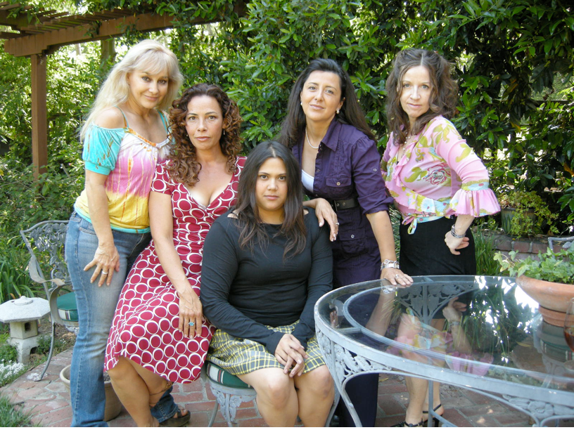
Left to right: Marcela Bordes, Marabina Jaimes, Natasha Perez, Ivette Gonzalez and Gabriela Lopetegui.
Credit: Courtesy: Now En Español/Migratory Patterns

With real lives that are often as dramatic and desperate as those of their onscreen counterparts, the five dynamic women featured in “Now en Español” struggle to pursue their Hollywood dreams while balancing the responsibilities of paying rent and raising children. The film chronicles their lives as they audition for parts and work in the dubbing studio while striving for a career that offers more prominent — and on-screen roles. Each actress is at a different stage on the path to success but they all have to confront the precarious nature of their careers when the dubbing of Desperate Housewives is cancelled and their jobs come to an end.

Shot over the course of several years by Latina filmmaker Andrea Meller, “Now en Español” offers an inside look at the challenges faced by many Latino actors while offering a warm and engaging portrait of five gutsy women as they follow their dreams against all odds.

* * *

About the Women of “Now en Español”

Originally from Mexico City and raised in a family of artists, Marcela Bordes started her career as a dancer, model, and singer in a rock band. She has worked as an actress for many years on TV, in films, and in theater, working with such notables as Veronica Castro, El Loco Valdez, Chabelo, and Enrique Cuenca “El Polivoz.” In the U.S., she has acted in films, soap operas such as Te Amara En Silencio and the daily TV show Uno Nunca Sabe, and has performed as the Spanish voice of Barbie, Minnie Mouse, and countless anime characters for TV and movies. Marcela has also worked as a dubbing director and casting director and had her own business coaching and teaching voiceover and dubbing. Marcela was the Spanish voice of Edie Britt on Desperate Housewives.

Born in Mexico into a family of actors, musicians, dancers and singers, Ivette Gonzalez grew up around sets and cameras. She began her career at age ten, working on a television program in Guadalajara, Jalisco. Years later, she began her theater career in Oliver Twist, clocking more than 600 performances in her role as Nancy. From there, she began to work on live shows, telenovelas, comedies and movies. She moved to the U.S. in 1992 and quickly started work in Spanish language television as a host, reporter and comedian. At the same time, she entered the world of dubbing and has since worked on more than a thousand programs, such as Tom & Jerry, The Little Mermaid, Lost, Grey’s Anatomy, and The Bold & The Beautiful. In 1995, she crossed over to American television and movies, with roles in Taken, Borderland, In The Flesh, The Mentalist, and 90210. Ivette was the Spanish voice of Gabrielle Solis on Desperate Housewives.

An Emmy winner and Imagen award nominated host and actress, Marabina Jaimes is half Mexican and half Puerto Rican. She won an Emmy Award for hosting the hit PBS show Storytime! and has done over 300 commercials in English and Spanish. She has been either seen or heard on Law & Order, Beverly Hills 90210, Fixing Paco, Melrose Place, CSI Miami, The Good Wife, Weeds, and Dexter. Her movie credits include Machete, Crazy Heart, Wall Street, and Beverly Hills Chihuahua. She starred in the Latin-centric animated series Santo Bugito on CBS; hosted and co-produced “Let’s Talk,” an Internet based Latina-led talk show, and is also a vocalist and lyricist. Marabina was the Spanish voice of Mary Alice Young, the narrator of Desperate Housewives.

In Montevideo, Uruguay, Gabriela Lopetegui worked professionally as a dancer and starred in the hit television show Horacio y Gabriela, becoming a well-known star throughout the country. She is a huge fan of Woody Allen and while still living in Uruguay, Gabriela had visions of moving to Allen’s New York. Instead she found herself in Los Angeles, where she has lived for more than 15 years. In the U.S., Gabriela started performing as a stand-up and improv comedian and doing dubbing work. She dubbed Dr. Bailey on Grey’s Anatomy, Callie on CSI Miami, and Salma Hayek’s character on Ugly Betty. Gabriela has also directed numerous dubbing and voiceover sessions, worked as a language coach, and taught voiceover through AFI. She was the Spanish voice of Lynette Scavo on Desperate Housewives.

Natasha Perez is the youngest of the “desperate” ladies. From a family of artists and advertising legends in Venezuela, Natasha won the Best Supporting Actress Award at the World Music and International Film Festival and performed with Channing Tatum in a famous skit on the Jimmy Kimmel Show. Natasha has been a spiritual girl in Shyamalan’s Lady in the Water, a gangster on The District, and a patient on ER, She sings and plays guitar around the world and has written songs for Entourage, Jonny Zero and several Latin American movies. She dubbed Kate on Lost, Violet on Private Practice, and was the Spanish voice of Susan Meyer on Desperate Housewives.

About the Filmmaker

Andrea Meller (Director/Producer) is an L.A. based filmmaker, born and raised in New York after her parents emigrated from Santiago, Chile. She most recently co-directed the Emmy-nominated Hard Road Home (Independent Lens/PBS) and directed 156 Rivington (Sundance Channel). Her films have screened at SXSW, SilverDocs, and the New York International Latino Film Festival, among others. Her shorter work has screened at the Netherlands Architecture Biennale, the Museum of the City of New York, Storefront for Art and Architecture, and she has worked for National Geographic, MTV, TLC, Food Network, WE and Style. Andrea is a fellow of the Film Independent Documentary Lab and the PBS/CPB and NALIP Latino Producers Academies.

Credits
Directed, Written, and Produced by Andrea Meller
Written and Edited by Ondine Rarey
Music by Camara Kambon
Narrated by Marabina Jaimes
Consulting Producer Aaron Woolf
Camera by Charlie Gruet & Andrea Meller
VOCES Executive Producer Sandie Viquez Pedlow

About VOCES
Produced by Latino Public Broadcasting, VOCES is PBS’ signature Latino arts and culture documentary showcase and the only ongoing national television series devoted to exploring and celebrating the rich diversity of the Latino cultural experience. The series is presented by PBS SoCaL and supported in part by the National Endowment for the Arts, the National Association of Latino Arts and Cultures, the Ford Foundation, and the Surdna Foundation through a grant from the NALAC Fund for the Arts Grant Program. More information about VOCES is available at VOCES on Facebook or Twitter.

About Latino Public Broadcasting
Latino Public Broadcasting (LPB) is the leader in the development, production, acquisition and distribution of non-commercial educational and cultural media that is representative of Latino people, or addresses issues of particular interest to Latino Americans. These programs are produced for dissemination to public broadcasting stations and other public telecommunication entities. Latino Public Broadcasting provides a voice to the diverse Latino community throughout the United States and is funded by the Corporation for Public Broadcasting. Between 2009 and 2014, LPB programs won 85 awards, including the prestigious George Foster Peabody Award, two Emmys, two Imagen Awards and the Sundance Film Festival Award for Best Director, Documentary. In addition, LPB has been the recipient of the Norman Lear Legacy Award and the NCLR Alma Award for Special Achievement – Year in Documentaries.

About PBS SoCaL
PBS SoCaL is the only station in the Greater Los Angeles area providing the full PBS schedule to Southern California and is home to all PBS program premieres as they are released nationally. As Southern California’s full-service PBS station, PBS SoCaL provides early education, access to a broad array of arts and culture, and programs for, about, and by the people of Southern California.

PBS SoCaL is the parent to three unique broadcast channels, PBS SoCaL/KOCE-HD, PBS SoCaL Plus and PBS SoCaL World, which are dedicated to educating, entertaining and enlightening viewers throughout Southern California. PBS SoCaL offices are located in downtown LA, Century City and Costa Mesa. PBS SoCaL is proudly our communities’ largest classroom, largest stage for the arts and trusted source of information. Explore the future of PBS in Southern California at www.pbssocal.org.

###

Press Contacts:
CaraMar, Inc.
Mary Lugo 770-623-8190 lugo@negia.net
Cara White 843-881-1480 cara.white@mac.com
Abbe Harris 908-233-7990 abbe@caramar.net

For downloadable images, visit pbs.org/pressroom/

