WE’LL MEET AGAIN
Season 2

Juan Diaz
Bio

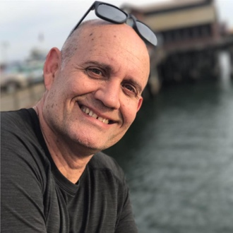
Fifty-two-year-old Juan Diaz grew up under the Communist regime in Cuba. His father had been a policeman during President Fulgencio Batista’s administration, but when Batista was overthrown in 1959, Fidel Castro’s regime viewed Juan’s family with suspicion. His father found it difficult to find a job that would support the family, and Juan and his siblings grew up poor in Havana.
In the Spring of 1980, the opportunity to leave Cuba arose when 10,000 Cubans stormed the Peruvian Embassy seeking asylum. Juan’s father gathered the family, and they jumped the walls just before government troops closed it off. The Peruvian Embassy took a protective stance towards those who sought refuge within its walls, refusing to release them. Castro responded by announcing the opening of the port of Mariel; those who wanted to leave could, but it wouldn’t be made easy. Cubans who left were marked as traitors to the revolution.
Within six months, 125,000 Cubans made the treacherous 90-mile journey across the sea to Key West aboard fishing vessels and yachts, a mass migration for which the U.S. was not prepared. Juan and his family endured Cuban soldiers, a dangerous deportation camp, being harassed at sea by Cuban Coast Guards, and a treacherous sea voyage marked by storms and sharks in their quest for a better life.
On Juan’s journey from Cuba, one person stood out: Captain George Hooper, the skipper of a 50-foot shrimping boat, the “Sun Hippie,” who safely brought Juan and his family to America despite the odds. Captain Hooper embodied hope and security at a time when everything was uncertain. Juan never forgot the man who brought him safely to this country, where he has thrived.
After arriving in Miami, Juan’s uncle suggested the family move to California. Within six months they had relocated to the San Francisco Bay Area. Juan went to Santa Clara High School and later got involved in the volunteer fire department there. In 1989, he joined the San Jose Fire Department and rose through the ranks. Today he is Fire Chief of Mountain View, California, and has three children.

