WE’LL MEET AGAIN Season 2
Premieres Tuesdays, October 30-December 25, 2018

TCA Panelists

Ann Curry (executive producer and reporter) is an award-winning journalist and photojournalist, former NBC News Network anchor and international correspondent. She has reported on conflicts in Syria, Afghanistan, Iraq, Somalia, Darfur, Congo, the Central African Republic, Serbia, Lebanon and Israel; on nuclear tensions from North Korea and Iran; and on numerous humanitarian disasters, including the tsunamis in Southeast Asia and Japan, and the massive 2010 earthquake in Haiti, where her appeal via Twitter (@AnnCurry) is credited for helping to speed the arrival of humanitarian planes.
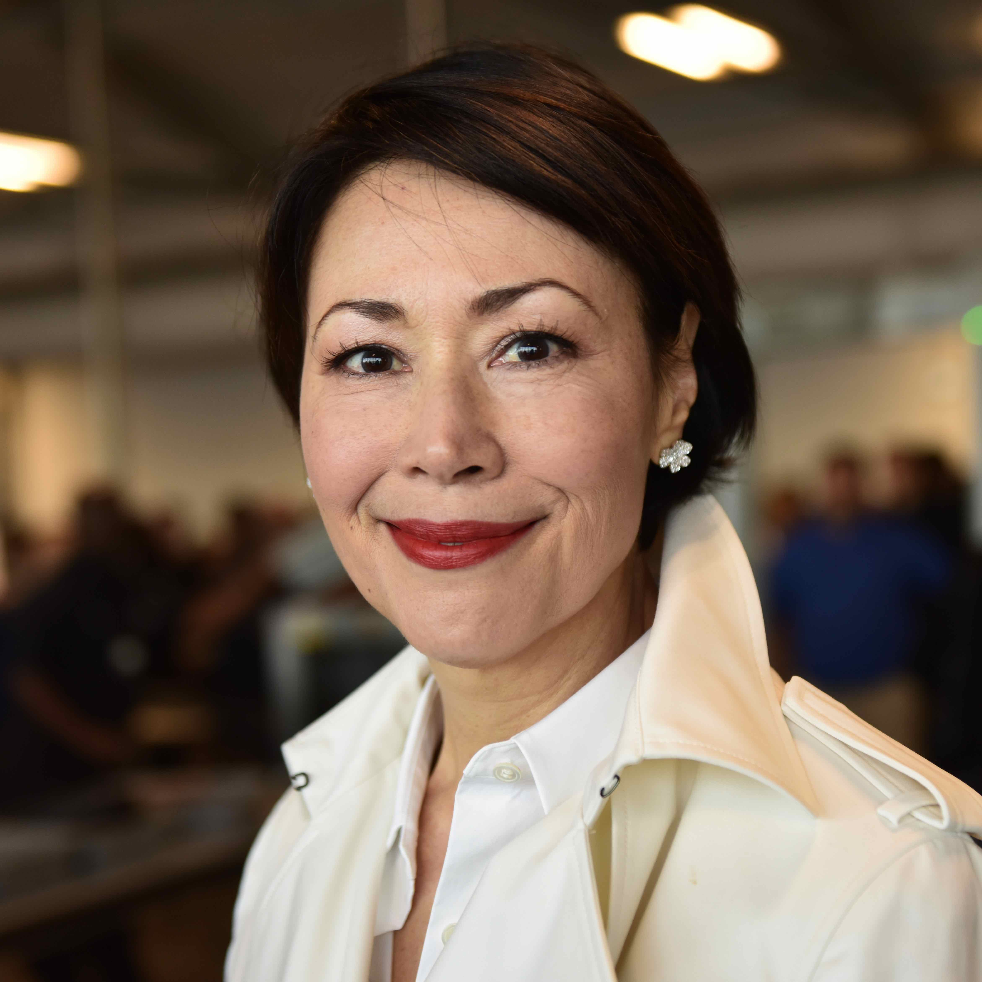

She has contributed groundbreaking journalism on climate change, interviewing scientists and native peoples, documenting glacial melt in the Arctic, the Antarctic (where she spent time inside an expedition hut left by Shackleton) and on Mount Kilimanjaro, as well as covering the deepening drought in the American West. Ann is also known for her focused reporting from inside Iran, giving voice to its women, human rights activists and young people, including Green Revolution activists. She also first broke the news of Iran's interest in negotiating a nuclear agreement with the outside world.

For her stories, Ann has also traveled to the South Pole (from where she delivered the first live news report to an American audience), South Africa and Botswana (where she tracked the AIDS epidemic), Somalia and Kenya (where she documented Al Qaeda's link to Al Shabaab terrorists), as well to Syria, Chad, Liberia and Pakistan, among other places.

Ann has conducted a long list of exclusive and news breaking interviews, including Iran's President Hassan Rouhani, President Ahmadinejad, President Khatami and Foreign Minister Zarif; Syria's President Bashar al-Assad and First Lady Asma al-Assad; Pakistan's Benazir Bhutto, President Ali Zadari and President Musharraf; Turkey's President Erdogan; Sudan's President Omar Bashir and South Sudan's President Salva Kiir; Liberia's President Ellen Johnson Sirleaf; Chad's President Idriss Deby; as well as U.S. Presidents George H.W. Bush, Bill Clinton, George Walker Bush and Barack Obama; Secretaries of State John Kerry and Hillary Clinton; First Lady Laura Bush, the Dalai Lama, Sir Edmund Hillary, George Clooney, Maya Angelou, Angelina Jolie, Brad Pitt and Archbishop Desmond Tutu, among others.

Ann has won seven national news Emmys and numerous Edward R. Murrow Awards, Gracie Allen Awards and National Headliner Awards. The NAACP honored her with an Excellence in Reporting award, and Women in Communications awarded her a Matrix. Ann has also been given numerous humanitarian awards, including from Refugees International, Americares, Save the Children and the Simon Wiesenthal Center, which awarded her a Medal of Valor for her dedication to reporting about genocide.
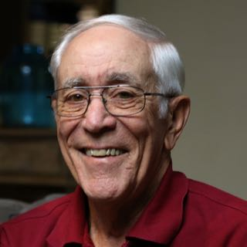
Dave Johnson (Participant) was born in 1940 in Hannibal, Missouri, grew up on a farm near Hull, Illinois, and graduated from the University of Illinois. He was commissioned a Second Lieutenant of Infantry through the Army ROTC program in June 1963. Dave expected to only serve three years in the army before becoming an engineer, but two years later, he was on his way to the first of three tours of duty in Vietnam.

Dave was assigned to the famous 101st Airborne Division at Fort Campbell, Kentucky, and married his beloved wife Judy in November 1964. A few months later, Dave and Judy learned that his brigade might be called for duty in Vietnam; in July 1965, Dave began his first Vietnam tour.

Upon Dave’s return, Judy found him to be a different man, changed by what he had witnessed and deeply affected by the deaths of some of his fellow soldiers. During his second Vietnam tour in 1968, Dave was a Captain and served as a Rifle Company Commander. After six months, he injured his foot when he stepped on an improvised anti-personnel land mine in a rice paddy and was sent back home.

In 1971, President Nixon declared that the U.S. was drawing back from Vietnam and would soon be out altogether. Dave was surprised to then receive orders to return for a third tour to help advise the South Vietnamese forces stationed in the vicinity of Moc Hoa near the Cambodian border. This time, he would not just be leaving Judy, but would also be saying goodbye to his three-year-old daughter, Laurie, and one-year old son, Jeff.

While flying in a helicopter on a reconnaissance mission over Cambodia in July 1972, Dave and five other servicemen found themselves under attack. When the helicopter was hit, they were forced to make an emergency landing. Thankfully, they survived the crash, but once on the ground, they struggled to avoid increasing enemy gunfire. Dave and his team sent a Mayday call, which was received by Bruce Grable, a Chinook helicopter pilot who put his life on the line to rescue the men. Without Grable’s act of heroism and generosity, Dave believes he wouldn’t be alive.

After returning from Vietnam, Dave went on to serve on active duty in the U.S. Army for over 26 years, and was deployed on many assignments around the U.S. and in Australia.

In their happily married life, Dave and Judy have lived in 28 different houses and are now enjoying retirement in The Villages in Florida. They have two grandsons — one studying at the University of Oregon, one working in Portland — and a granddaughter at dentistry school in Washington, DC. Dave has written a book for his grandchildren about his experiences in Vietnam, which he describes as the most defining event of his life. After viewing season one of WE’LL MEET AGAIN, Dave reached out to PBS and the series producers to ask for help in finding Bruce.

Justine Kershaw (Blink co-founder and executive producer) is a BAFTA Award-winning producer with more than 20 years of experience in television. She started her career in television news, traveling to Romania, Moscow, Turkey, Slovenia and the Gulf. In 1992 she moved to the BBC Natural History Unit to make wildlife programs. Between 1995 and 2002, she directed and produced for the celebrity wildlife series IN THE WILD for Tigress Productions, working with John Cleese, Ewan McGregor, Holly Hunter, Whoopi Goldberg and Richard Dreyfuss. Justine also devised, directed and series produced MONKEY BUSINESS for Tigress Productions, ITV’s Granada and executive produced programs for Channel 4, National Geographic, Discovery and PBS, including JOURNEY OF MAN and SECRETS OF THE DEAD.
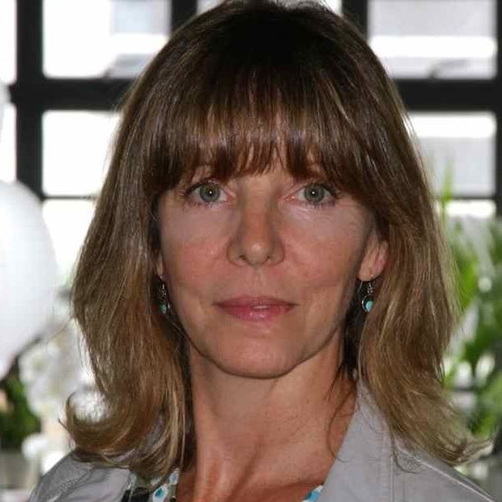

In 2002 Justine became Channel 5’s Controller of Science and commissioned more than 80 hours of programming a year, including EXTRAORDINARY PEOPLE, THE GADGET SHOW, STRANGER THAN FICTION, HOW WILLIAM SHATNER CHANGED THE WORLD and THE BIG QUESTION WITH STEPHEN HAWKING. In 2006 she was made Controller of Factual, covering the channel’s science, history and arts output.

Since founding Blink with Dan Chambers in 2007, Justine has overseen several series and specials including THE GREAT SPERM RACE, MUMMIFYING ALAN: EGYPT’S LAST SECRET, APE MAN and THE BRAIN WITH DAVID EAGLEMAN. Her work has won several awards, including two Emmy Awards, a Peabody, an RTS (Royal Television Society) and a BAFTA. She devised the initial idea for WE’LL MEET AGAIN in 2014 in Greece after tracking down the person who had had saved her life back in 1994.

Roger Wagner (Participant), now 71 years old, was born and raised in Osakis, Minnesota. By the age of 20, he had been transported from the Great Lakes of the Midwest to the war in Vietnam.
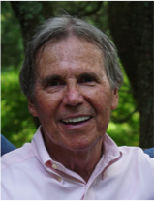

Roger had poor eyesight but scored well in his Army testing during basic training. That enabled him, after training, to be assigned as a finance clerk at Redstone Arsenal in Huntsville, Alabama, responsible for paying the wages of his fellow servicemen. Wanting to do more and with a sense of duty, he volunteered to go to Vietnam and arrived there in October 1967. Roger had expected his low-risk occupation to keep him out of the line of fire, but that all changed close to Christmas, just a month after his 21st birthday.

Roger and his fellow clerks spent about one night every two weeks pulling guard duty watching the perimeter of their compound. Without ever receiving any training on the weapons used in their foxholes, many of them became concerned about being easy targets should any hostility occur. On a weekend morning of familiarization training, designed to teach the clerks about the weapons, Roger and his counterparts came under fire from the jungle. He was struck above the knee by a bullet that tore apart his artery. With no feeling in his lower left leg, Roger headed into surgery after being told that he was about to have his leg amputated.

When he awoke later that day, he was overjoyed to discover that a young surgeon named Dr. Katz had performed something of a miracle, taking a vein from Roger’s right leg and grafting it into the split artery, thereby saving his leg. Roger has spent 50 years wondering about that doctor, and if he would ever be able to find him and thank him for what he did.

Roger returned to America and, following his recovery, has gone on to enjoy a successful and very active life and career. Before entering the Army, he had played varsity tennis at Minnesota State University, Moorhead in 1965; upon his return to college after being discharged, he once again played varsity tennis in 1969 and 1970. After graduating, he went on to run his own photography business for 12 years, working with “The Ice Follies” and “Sesame Street Live” shows while living in Chicago and Portland, Oregon. Roger later went to work with the United States Postal Service in Portland, then transferred to the Las Vegas area, where he eventually retired. Roger now lives in Nevada.

Roger was watching the first season of WE’LL MEET AGAIN and responded to the request for viewer stories. The producers were intrigued and decided to help Roger on his quest to find Dr. Katz.

