WHEN WHALES WALKED: JOURNEYS IN DEEP TIME
Premieres Wednesday, June 19
on PBS and Smithsonian Channel™

Join Top Scientists on a Global Adventure to Unlock
the Evolutionary Secrets of Four Iconic Creatures

Broadcast Timed to Opening of the New
Deep Time Hall at the Smithsonian’s National Museum of Natural History

Narrated by Actor Lee Pace

ARLINGTON, VA – May 6, 2019 – Created in a first-ever partnership between PBS and Smithsonian Channel, WHEN WHALES WALKED: JOURNEYS IN DEEP TIME is a two-hour film tracing the epic origin stories of some of the world’s most spectacular creatures. From Abu Dhabi to Argentina, Kenya to China, the program takes viewers on a global adventure as top scientists investigate clues from the fossil record and use 21st-century technology to unlock the evolutionary secrets of crocodiles, birds, whales and elephants. Using innovative storytelling techniques, 3D graphics and CGI to bring ancient beasts to life, WHEN WHALES WALKED offers surprising insights into the evolution of these magnificent animals, exploding myths about the path these species took over millions of years. Narrated by actor Lee Pace (Guardians of the Galaxy, The Hobbit), the film premieres Wednesday, June 19 at 9:00 p.m. ET (check local listings) on both PBS and Smithsonian Channel and will also be available for simultaneous streaming on PBS.org.
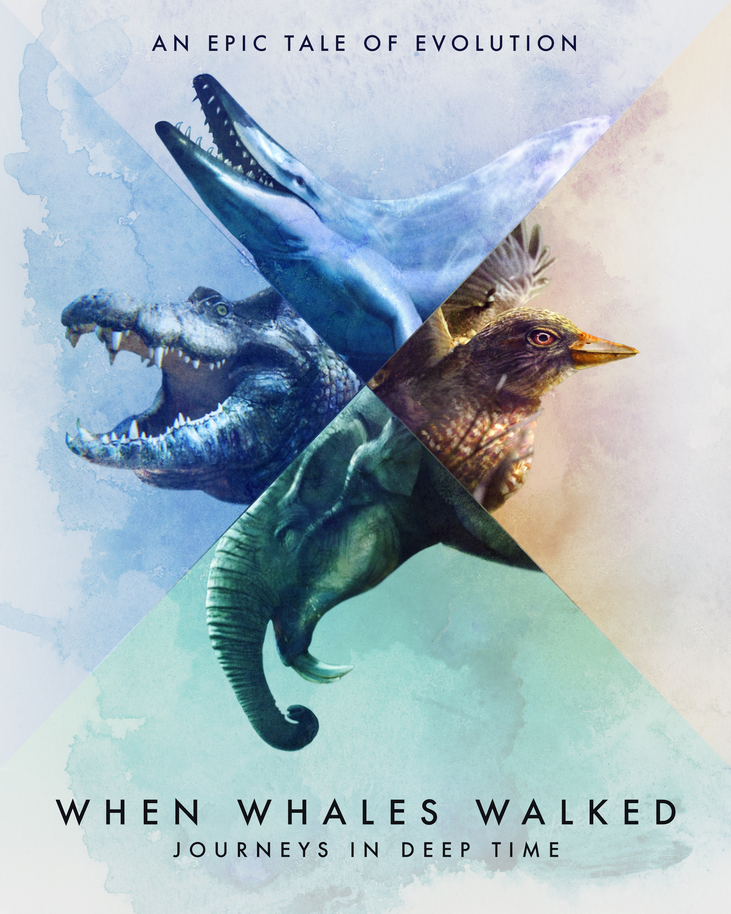
Evoking awe and wonder, WHEN WHALES WALKED contains startling revelations about the ancient ancestors of animals still alive today. One early croc relative was built like a greyhound, ancient whales really did walk on four legs and the earliest ancestor of the elephant was the size of a rabbit. Birds arose from feathered dinosaurs — in fact, they are dinosaurs — and went on to colonize the natural world as well as the urban spaces created by humans. But the end of the story has yet to be written, and the film sounds an alarm about the dangers each of these survivors faces. Exploring the mystery and majesty of these amazing animals, WHEN WHALES WALKED reminds us that their future lies in the hands of humans.

“WHEN WHALES WALKED: JOURNEYS IN DEEP TIME dives deep into the fascinating origins of some of the world’s most incredible creatures,” said Bill Gardner, Vice President, PBS Programming & Development. “By exploring the latest scientific discoveries, we bring millions of years of natural history alive in some very unexpected ways. As America’s home for documentary film and the market leaders in science and natural history content, we’re thrilled to partner with an institution like the Smithsonian to showcase these spectacular new breakthroughs in evolutionary history.”

“When we marvel at the wonders of the natural world, like an elephant’s trunk or the size of a blue whale, we rarely ask, ‘Where did that come from?’ It turns out, scientists are finding some truly extraordinary answers,” said Charles Poe, SVP of Production, Smithsonian Channel. “This film will introduce viewers to the surprising ancestors of animals we know and love. We’re very excited to be launching our first partnership with PBS to take viewers on an utterly unique journey to the deep past.”

“WHEN WHALES WALKED: JOURNEYS IN DEEP TIME takes us to the frontiers of science,” said Michael Rosenfeld, Vice President of National Production for Twin Cities PBS, who originated the project. “It shows how researchers are using not just paleontology, but genetics, climate science and ecology to fill in the gaps in the story of life. And it’s not just a story of the past—these discoveries carry important lessons for today and even the future.”

WHEN WHALES WALKED: JOURNEYS IN DEEP TIME is a major initiative in collaboration with the Smithsonian’s National Museum of Natural History, which will open the David H. Koch Hall of Fossils – Deep Time on June 8, 2019. The project will feature an extensive educational outreach program produced by the National Museum of Natural History and shared with affiliated science museums around the country. Three museums and their partner organizations will host Family Fossil Festivals, which feature the film, a virtual reality game and standards-based educational activities. Additionally, educational outreach professionals at PBS stations nationwide will be provided access to activities on 3d.si.edu, as well as videos on PBS Learning Media, and share them in their own community-based STEM initiatives.

PBS and Smithsonian Channel will also broadcast a special live event on Facebook from the National Museum of Natural History’s new Deep Time exhibit on Friday, June 14 at 9:30 PM ET. Viewers who tune in will have special after-hours access and an up-close look at unique fossils in the hall, including the Nation’s T-Rex. The livestream will be hosted by PBS Digital Studios’ Kallie Moore and Hans Sues, the museum’s Senior Curator of Vertebrate Paleontology, who will be on hand to answer audience questions in real time. Viewers can stream the event on the Facebook pages of Smithsonian Channel (facebook.com/SmithsonianChannel), PBS (facebook.com/PBS), the National Museum of Natural History (Facebook.com/NMNH) and PBS Digital Studios (www.facebook.com/PBSDigitalStudios/.

Major funding for WHEN WHALES WALKED is provided by The National Science Foundation and The Arthur Vining Davis Foundations.

WHEN WHALES WALKED: JOURNEYS IN DEEP TIME is produced by Twin Cities PBS and Shining Red Productions for PBS and Smithsonian Channel. Michael Rosenfeld is executive producer for Twin Cities PBS. Bill Gardner is executive in charge for PBS. Executive producers for Smithsonian Channel are Charles Poe and David Royle.

About Smithsonian Channel
Smithsonian Channel™, owned by Smithsonian Networks™, a joint venture between Showtime Networks Inc. and the Smithsonian Institution, is where curiosity lives, inspiration strikes and wonders never cease. This is the place for awe-inspiring stories, powerful documentaries and amazing factual entertainment, available in HD and 4K Ultra HD across multiple platforms. Smithsonian Channel, winner of Emmy® and Peabody awards for its programming, combines the storytelling prowess of SHOWTIME® with the unmatched resources and rich traditions of the Smithsonian, to create programming that shines new light on popular genres such as air and space, travel, history, science, nature and pop culture. Among the network’s offerings are series including Aerial America, America in Color, The Lost Tapes, Mighty Ships, Million Dollar American Princesses, The Pacific War in Color and Air Disasters, as well as critically-acclaimed specials that include The Coronation, The Mountain Lion and Me, Earth from Outer Space and Titanoboa: Monster Snake. Smithsonian Networks also operates Smithsonian Channel Plus™, a subscription video streaming service delivering over a thousand hours of the Channel’s stunning and diverse library of documentaries and series in HD and 4K Ultra HD. Smithsonian Channel is also available internationally in Canada, Singapore, Latin America and the UK. To learn more, go to www.smithsonianchannel.com, or connect with us on Facebook, Twitter, and Instagram.

About Twin Cities PBS
Twin Cities PBS, the PBS affiliate for Minneapolis/St. Paul, is a prominent content producer for the national public television system. TPT’s most recent documentaries for PBS include Going to War and The Dictator’s Playbook. Other films include the Emmy Award-winning The Forgetting: A Portrait of Alzheimer’s, Peabody Award recipient Depression: Out of the Shadows, and 2012 Sundance Film Festival selection Slavery by Another Name. TPT co-produced the classic feature documentary Hoop Dreams, a Peabody and Sundance Film Festival winner. For more than 30 years, TPT has also produced award winning STEM education programs for children and families, including the Emmy Award winning series SciGirls, now in production on its sixth season. More information at www.tpt.org/national.

About The National Science Foundation
The National Science Foundation is an independent federal agency that supports education and research across all fields of science, technology, engineering and math (STEM). In addition to providing major support for SciGirls, the NSF supports other science and math programs on PBS and pbskids.org, including DragonflyTV, Peg + Cat, Design Squad Nation and Plum Landing. Visit here for more information on NSF activities.

About the National Museum of Natural History
The National Museum of Natural History is connecting people everywhere with Earth’s unfolding story. The museum is one of the most visited natural history museums in the
world. Opened in 1910, the museum is dedicated to maintaining and preserving the world’s most extensive collection of natural history specimens and human artifacts. The
museum is open daily from 10 a.m. to 5:30 p.m. (closed Dec. 25). Admission is free. For more information, visit the museum on its website and on Facebook and Twitter.

About PBS
PBS, with more than 330 member stations, offers all Americans the opportunity to explore new ideas and new worlds through television and digital content. Each month, PBS reaches over 120 million people through television and 26 million people online, inviting them to experience the worlds of science, history, nature and public affairs; to hear diverse viewpoints; and to take front row seats to world-class drama and performances. PBS’ broad array of programs has been consistently honored by the industry’s most coveted award competitions. Teachers of children from pre-K through 12th grade turn to PBS for digital content and services that help bring classroom lessons to life. Decades of research confirms that PBS’ premier children’s media service, PBS KIDS, helps children build critical literacy, math and social-emotional skills, enabling them to find success in school and life. Delivered through member stations, PBS KIDS offers high-quality educational content on TV – including a 24/7 channel, online at pbskids.org, via an array of mobile apps and in communities across America. More information about PBS is available at www.pbs.org, one of the leading dot-org websites on the internet, or by following PBS on Twitter, Facebook or through our apps for mobile and connected devices. Specific program information and updates for press are available at pbs.org/pressroom or by following PBS Pressroom on Twitter.

###

SMITHSONIAN CHANNEL CONTACTS:
Joanna Brahim
(212) 708-8014
Joanna.Brahim@smithsonianchannel.com

Matthew Sinsheimer
(212) 708-1578
Matthew.Sinsheimer@smithsonianchannel.com

Erin Smyth
(212) 708-8089
Erin.Smyth@smithsonianchannel.com

PBS CONTACTS:
Cara White Meredith Wohl
(843) 881-1480 (703) 739-5186
cara.white@mac.com mawohl@pbs.org

