WHITE WITH FEAR To Broadcast
Tuesday, March 24 on PBS and PBS.org

Documentary Explores How Racial Division Has Been Used as a Political Strategy for Decades

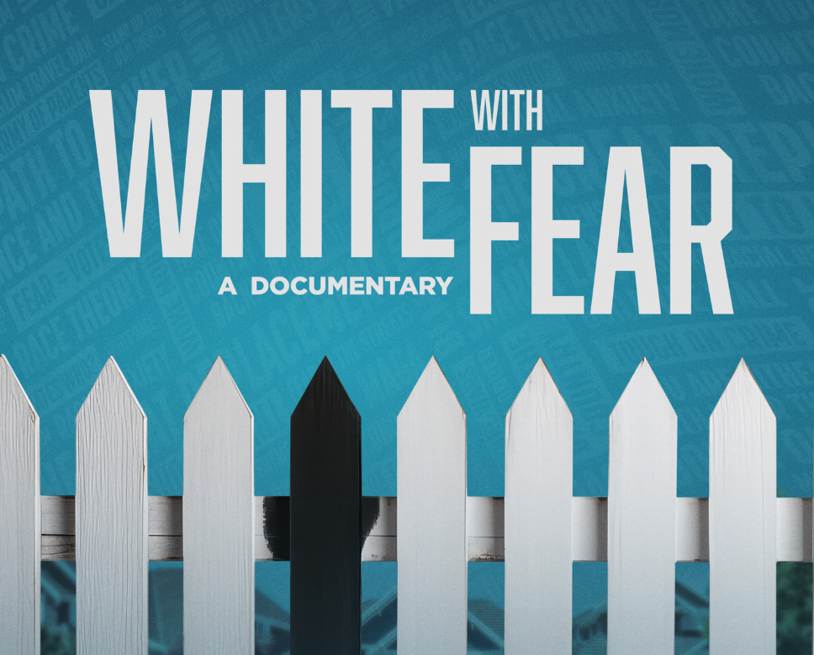
ARLINGTON, VA (February 09, 2026) – Coming to PBS this Spring, WHITE WITH FEAR is an eye-opening documentary film examining how some American conservatives and political operatives have successfully weaponized racism and fear for decades. Written, produced and directed by Emmy Award-winning filmmaker Andrew Goldberg, WHITE WITH FEAR premieres Tuesday, March 24, 10:00-11:30 p.m. ET (check local listings) on PBS, PBS.org and the PBS app.

Recently nominated by the Writers Guild for Best Documentary Screenplay and described by critics as “riveting,” “masterful,” and “absolutely required viewing,” the film uncovers the real-world consequences of deploying tactics that seek to demonize immigrants, spread Islamophobia, and devise a strategic media campaign of racist rhetoric with real-world effects.

Tracing the strategy from former President Nixon’s call for “law and order” during his 1968 presidential campaign, through 9/11, various other presidential campaigns, hate crimes and the insurrection at the Capitol on January 6, 2021, the film includes the voices of Steve Bannon, Hillary Clinton, former Fox News reporter Carl Cameron, The Lincoln Project founder Stuart Stevens, Rep. Jamie Raskin, Rick Gates, former Breitbart writer Katie McHugh, and many more.

WHITE WITH FEAR pulls back the curtain for a first-hand look at the strategies and tactics that have shaped some conservative political playbooks for decades. The film explores how divisive narratives and policies were strategically implemented by some politicians and media outlets to earn power and profit.

“I’m grateful to PBS for giving WHITE WITH FEAR such a prestigious platform with an extensive reach of loyal viewers,” said Andrew Goldberg, writer, producer, and director. “It’s the ideal home for the film — timely, relevant, and deeply connected to where our country stands today.”

WHITE WITH FEAR will stream simultaneously with broadcast and be available on all station-branded PBS platforms, including PBS.org and the PBS app, which is available on iOS, Android, Roku, Apple TV, Amazon Fire TV, Android TV, Samsung Smart TV, Chromecast and VIZIO.

WHITE WITH FEAR is written, produced and directed by Andrew Goldberg, produced and edited by Diana Robinson, co-produced by Eric Ward, with cinematography by Robert Hanna.

About the Filmmakers

Andrew Goldberg (Writer, Producer, and Director), an Emmy Award-winning investigative producer, has directed 14 prime-time documentary specials for PBS, and both long and short-form segments for CBS Sunday Morning, ABC News, Live From Lincoln Center, NPR and others. His films include The Armenian Genocide, Anti-Semitism in the 21st Century: The Resurgence, and The Iranian Americans. His work has appeared on major networks on every continent and has been supported by more than 250 foundations, corporations and major donors around the world.

Diana Robinson (Producer and Editor) started her journalism career covering multiple presidential campaigns in Pennsylvania, the swing state to end all swing states, and had a front-row seat to the rise of the Tea Party, the backlash to President Obama, the post-industrial economic depression, and the election of President Trump. Her work has been supported by the Corporation for Public Broadcasting, the Ford Foundation, and many others.

About PBS
PBS, with more than 330 member stations, offers all Americans the opportunity to explore new ideas and new worlds through television and digital content. Each month, PBS reaches over 36 million adults on linear primetime television, 16 million users on PBS-owned streaming platforms, 56 million viewers on YouTube, and 10 million followers on social media, inviting them to experience the worlds of science, history, nature, and public affairs and to take front-row seats to world-class drama and performances. PBS’s broad array of programs has been consistently honored by the industry’s most coveted award competitions. As the number one educational media brand, PBS KIDS helps children 2-8 build critical skills, enabling them to find success in school and life. Delivered through member stations, PBS KIDS offers high-quality content on TV — including a PBS KIDS channel — and streaming free on pbskids.org and the PBS KIDS Video app, games on the PBS KIDS Games app, and in communities across America. Teachers of children from pre-K through 12th grade turn to PBS LearningMedia for digital content and services that help bring classroom lessons to life. More information about PBS is available at PBS.org, one of the leading dot-org websites on the internet, Facebook, Instagram, or through our apps for mobile and connected devices. Specific program information and updates for press are available at pbs.org/pressroom or by following PBS Communications on X.

– PBS –

CONTACTS:

Stephanie Kennard, PBS, skkennard@pbs.org

Cara White / Mary Lugo, CaraMar, Inc.
cara.white@mac.com; lugo@negia.net

For images and additional up-to-date information on this and other PBS programs, visit PBS PressRoom at pbs.org/pressroom.

