WILDERNESS: THE GREAT DEBATE
April 2013 (check local listings)
– Documentary Presents the Debate Over Wilderness Preservation in the West –

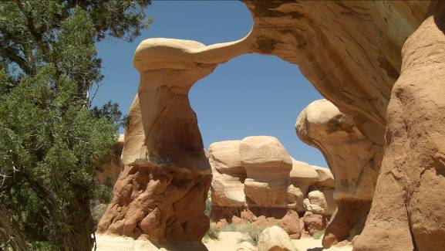
Landscape in southern Utah.
Credit: John Howe
For 40 years, the American West has been the nation’s battleground for the preservation of wild lands. But have 21st-century growth and energy demands relegated wilderness to the pages of history? Robert Redford joins a group of diverse voices in debating the need and purpose of wilderness in WILDERNESS: THE GREAT DEBATE, a visually stunning documentary by KUED’s John Howe. The program airs in April 2013 (check local listings) on PBS.

The scope of the film ranges from the Arctic to the Amazon, with a focus on environmental issues of the American West. “Is the West going to be reduced to just photos and films to show young people how it used to be, or are there going to be places where they can go and see the way it used to be, like wilderness and like national parks?” Redford asks. On the other hand, Commissioner Mark Habbeshaw of Kane County, Utah, says, “This is a war for rural people, for state and local sovereignty, to protect what little sovereignty we have left as a rural people; to protect our traditions, our culture our ability to manage our lives with a diversified economy.”

Narrated by actor Peter Coyote, WILDERNESS: THE GREAT DEBATE features some of the issue’s biggest stars: Robert Redford, Page Stegner, President Obama’s Secretary of the Interior Ken Salazar, President Clinton’s Secretary of the Interior Bruce Babbitt, President Kennedy’s Secretary of the Interior Stewart Udall and William Meadows of the Wilderness Society, with cameo appearances from President Obama, President Clinton, former Vice President Al Gore, Wallace Stegner and former Supreme Court Justice Sandra Day O’Connor.

“Much of the debate is about access to public land and competition for it,” says Howe. “The discussion concerns how public land should be used. Issues include the creation of national monuments, national wildlife refuges and parks, energy development, off-road access and ranching. The role of government is questioned regarding federal versus local control.”

“The wilderness advocates say that we need to protect those lands for future generations,” says Habbeshaw. “What they’re actually doing is locking those lands up from future generations, and there are other designations that can keep those lands open and still protect them from abuse.”

Mike Swenson, who heads Utah’s Shared Access Alliance, is concerned about the lack of a local voice. “The people of the United States own the land, and I think a lot of time the citizens of our great country forget that the power lies in the people.”

Environmentalist Page Stegner counters, “I think the public land belongs to the public and that means all of the public, not just the people who live there.”

Adds Redford, “It goes back to what are we going to preserve, and what are we going to develop, considering we are a development-oriented society. You’re probably not going to take that away, but the question is, what are you going to have left to develop if you don’t preserve something?”

The 1996 creation of Utah’s Grand Staircase-Escalante National Monument provoked immediate and lasting controversy, encapsulating the debate over federal versus local control of the land. Howe interviewed those on both sides and captured the rally organized by local residents at Paria Canyon in the Grand Staircase-Escalante National Monument to protest closure of the road through the canyon.

“Every time a president has set aside a conservation area, the reaction from the West has been negative,” says Babbitt. “There’s always been controversy, and it’s always been kind of a question of the extractive interests — miners, the ranchers, the timber industry, looking at their short-term return and saying, ‘Our short-term interest is what counts.’”

Former Utah Senator Robert Bennett sees it differently. “The folks that lived there felt abused by people who did not live there, who, nonetheless, wanted to come into their backyard and say, ‘We’re going to take this land and we’re going to lock it off from you and for any activity that you might want to undertake.’”

Other segments of WILDERNESS: THE GREAT DEBATE include the Native-American perspective, the wilderness of Yellowstone and the reintroduction of wolves, the plight of wild horses in the West and concerns about the Colorado River, which runs dry in the sands of Mexico.

The film also examines the debate over gas and oil leases in Utah, including the case of national news monkey-wrencher Tim DeChristopher, who falsely bid on oil and gas leases in Utah approved by the Bush administration. President Obama’s administration postponed some of these leases, calling for more study.
Mike Noel, a rancher and state representative from Kanab, Utah, worries about the effect on local economies if the leases are lost. “We need every dime we can get,” he says. He sees oil shale development as a big issue for Utah. “We’ve got some of the most important deposits in the entire country … and to be able to develop those in an environmentally responsible manner would be huge for the economy of Utah.”

“Powerful forces, all of whom think right is on their side, compete for the land,” says Howe. “Stewardship is questioned as to who loves the land most and to whom should it be entrusted. Ultimately, wilderness of the West belongs to the American people, who should control its fate. Can anything wild survive overwhelming population? The great debate is really about planet Earth. The answers hold its future.”

Underwriters: George S. and Dolores Doré Eccles Foundation and Lawrence T. Dee-Janet T. Dee Foundation
Producer: KUED Salt Lake City
Filmmaker: John Howe
– PBS –

CONTACTS: Mary Dickson, KUED, 801-581-3263; mdickson@kued.org

For images and additional up-to-date information on this and other PBS programs, visit PBS PressRoom at pbs.org/pressroom.

